Enhanced Parameter

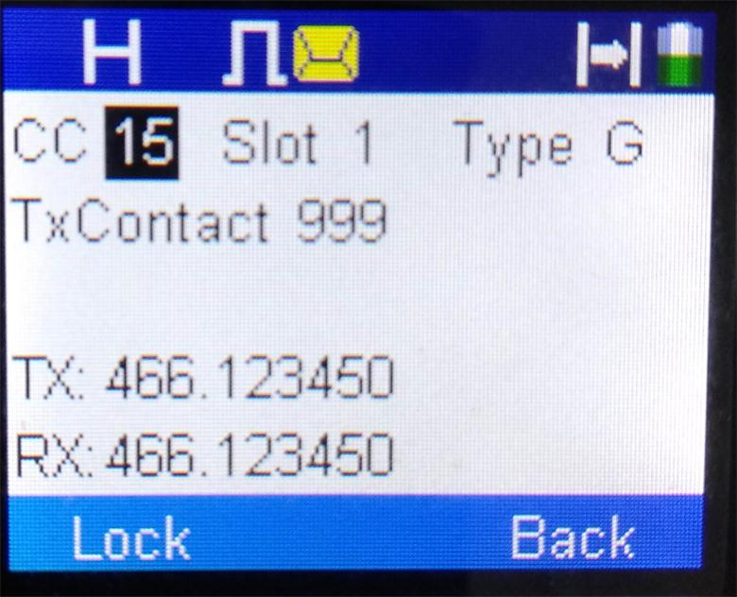

While in this mode, the left and right selection keys will scroll through
the parameters and the numbers will enter the data. However, if you are at the “Private location, the up and down selection keys will scroll Private, Group, and All.

When you are happy with the data entered, pressing the “Lock” soft key will store the data and pressing the “Back” soft key will get you into the standard screen with the display showing the standard information except the Rx Frequency and Tx Frequency will be updated to what was programmed into the system. If you press Back before you press Lock, then there will be no changes.

Storing the data in the channel is only temporary when the Lock soft key is pressed. When you change the channel or turn off the power, the parameters revert back to whatever was stored in that channel from the CPS

After the “lock” soft key is pressed, you get the screen shown on the next page to allow you to save what is programmed. However, pressing the PTT without pressing the “Save” key will allow you to communicate with the parameters already on the screen.

Any frequency that is valid should be able to be entered from this mode irrespective of what the channel spacing parameter is.

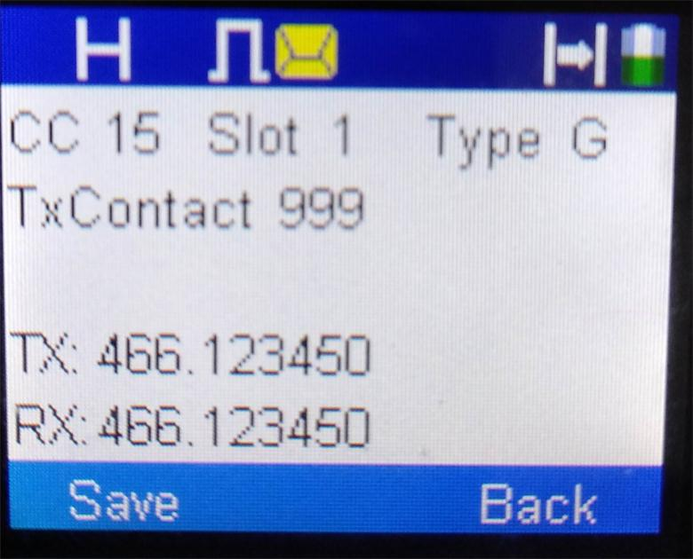
Pressing the save key will store it permanently in data memory where it can be accessed even after the power is turned off and the channel is changed. It will store it at the zone your radio is currently set to.
Pressing the Save key will now give you two choices as shown in the picture on the next page

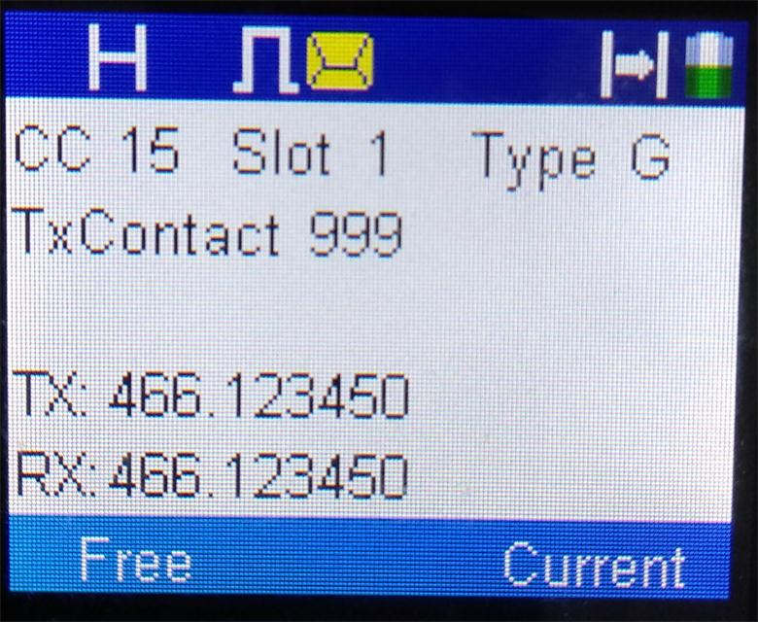
Pressing the Free key will save it in the first free channel of the current zone and if there is no free channels it will give you error screen as shown below. Pressing the Current key will save it on the channel it is on.

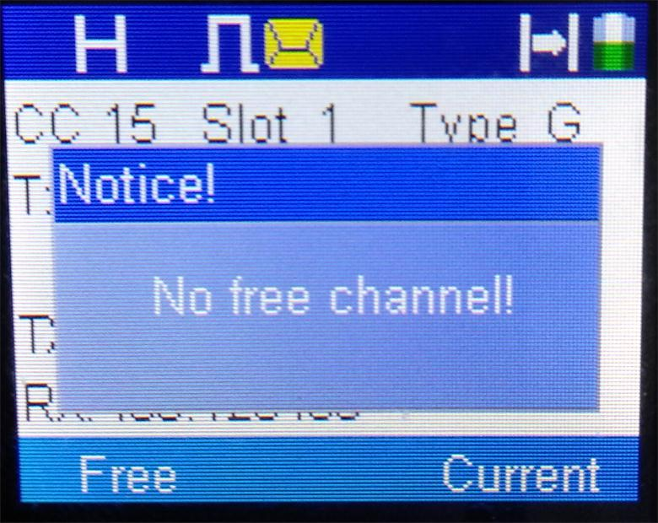

If the save is successful, the following screen will appear.
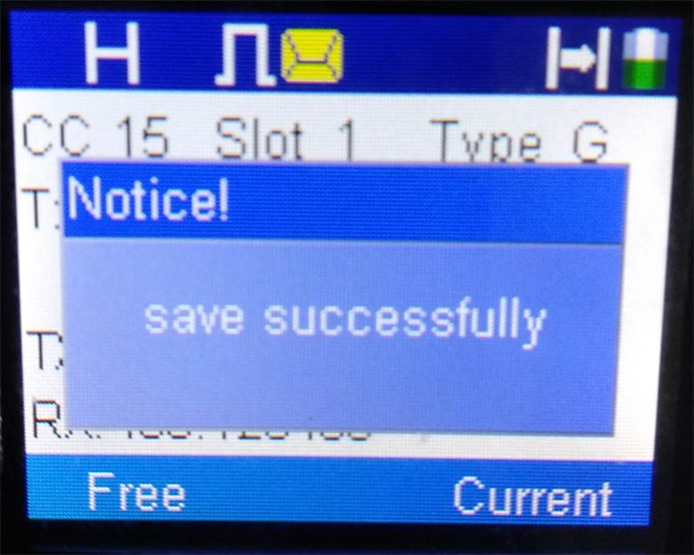

Enhanced Monitor

Pressing the Enhanced Monitor side button will get you to the screen below if the incoming signal is digital

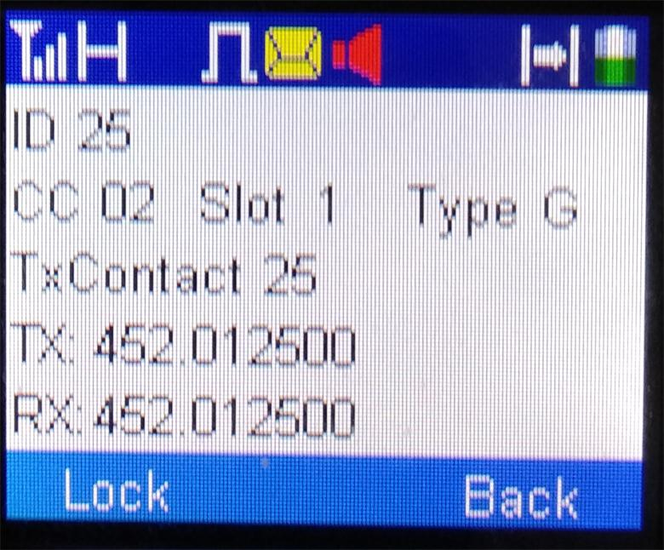

Pressing the Lock soft button will lock these parameters in and allow the PTT to transmit back to who called them.

After the “lock” soft key is pressed, you get the screen shown on the next page to allow you to save what is received. However, pressing the PTT without pressing the “Save” key will allow you to communicate with the parameters already on the screen.
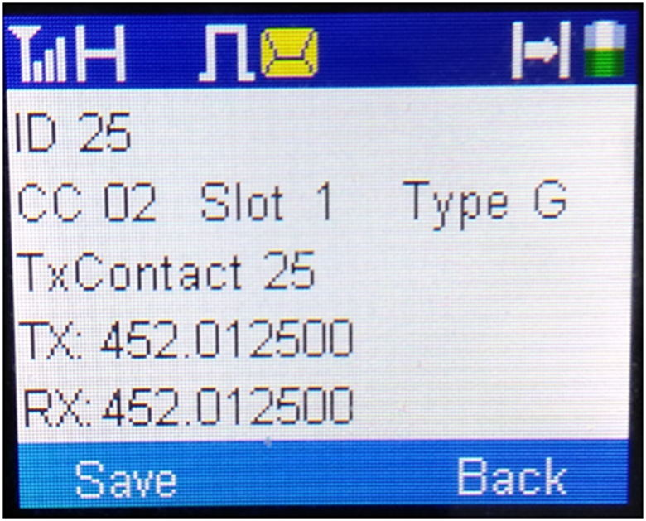
Pressing the save key will store it permanently in data memory where it can be accessed even after the power is turned off and the channel is changed. It will store it at the zone your radio is currently set to.
Pressing the Save key will now give you two choices as shown in the picture below:
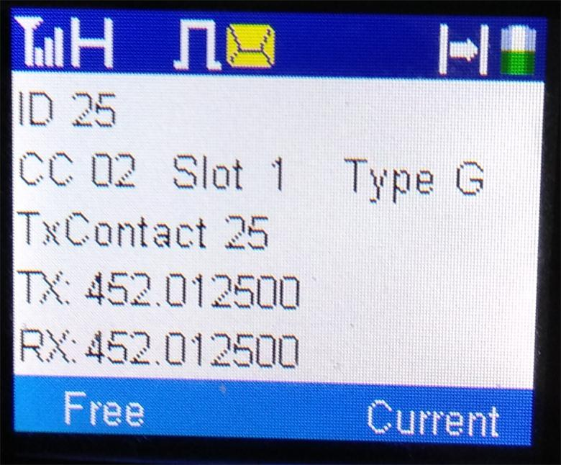
Pressing the Free key will save it in the first free channel of the current zone and if there is no free channels it will give you error screen as shown on the next page. Pressing the Current key will save it on the channel it is on.
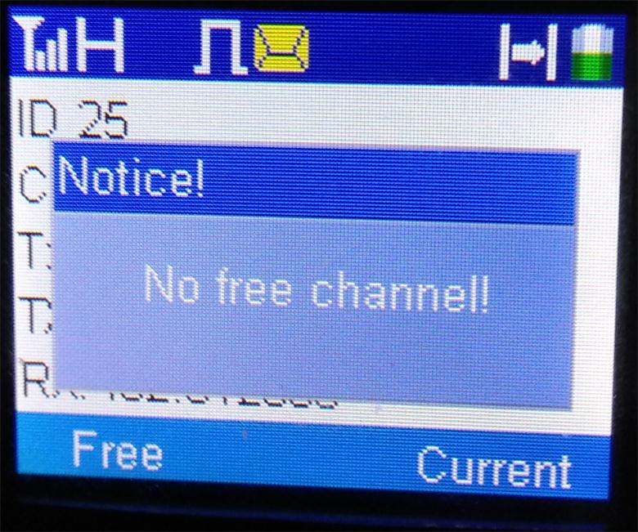
If the channel is saved, you get the following screen.
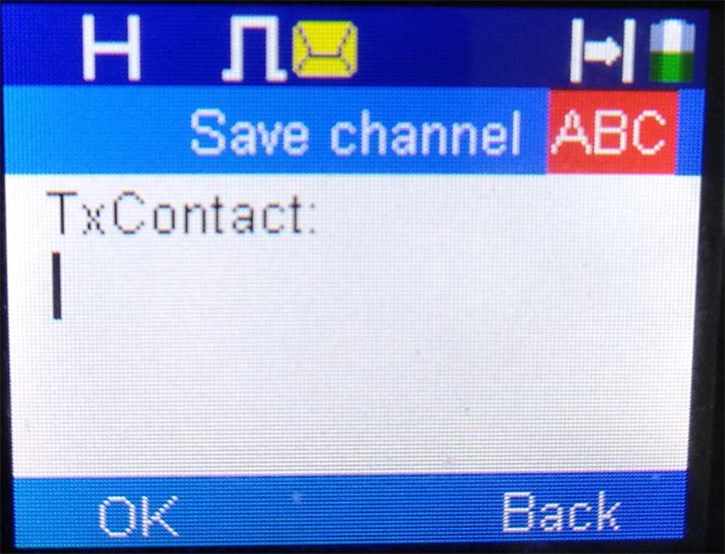
It is now up to the user to give the TxContact a name as shown on the next page.
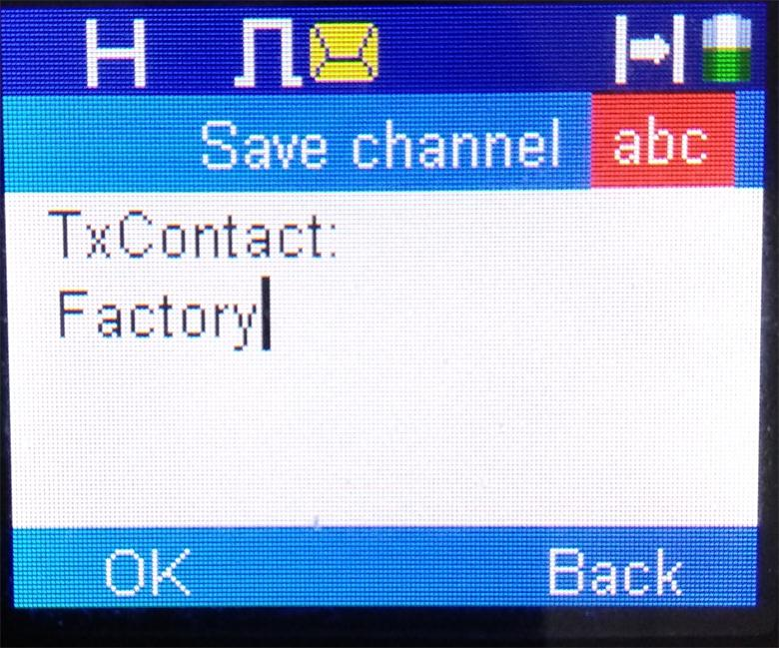
After that task is completed the radio gives you a message indicating it has been successfully saved.
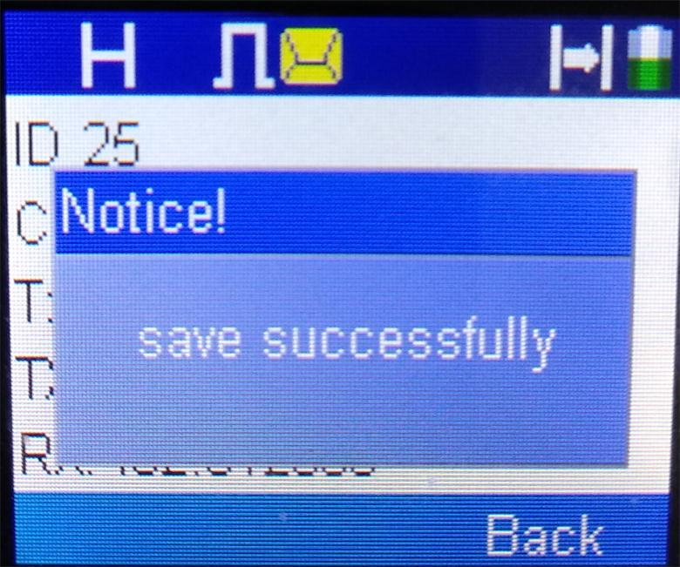

Enhanced Scanning
Pressing the Enhanced Scanning side button will get you to the screen below. If you start from a digital channel you scan digital channels and if you start on an analog channel you scan analog channels.

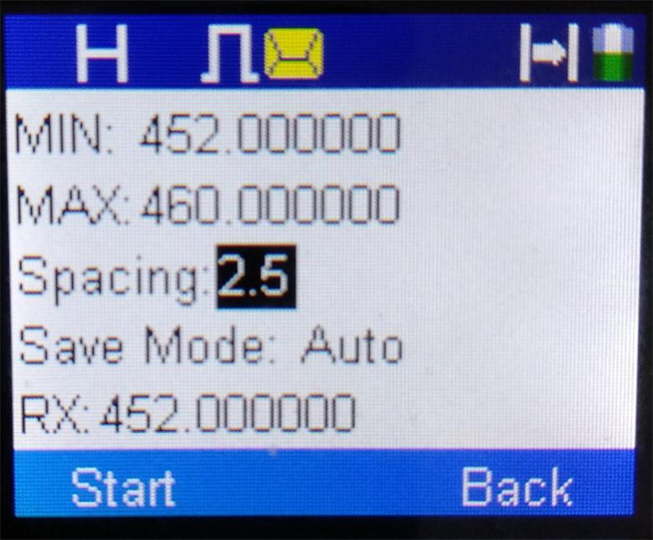

Like the Enhanced Parameter mode, all parameters could be entered from this screen. The frequency could be any valid frequency that is obtainable from the CPS. The Spacing is the same choices as available from the CPS
The Save mode has two choices: Auto and Manual. In auto mode, any valid channel is automatically stored in permanent memory in the current zone in unused channels and then it continues to scan. Before storage, a check is made to see if the channel is already in the existing zone before being stored. In operating in manual mode, the following screen is shown on the next page.
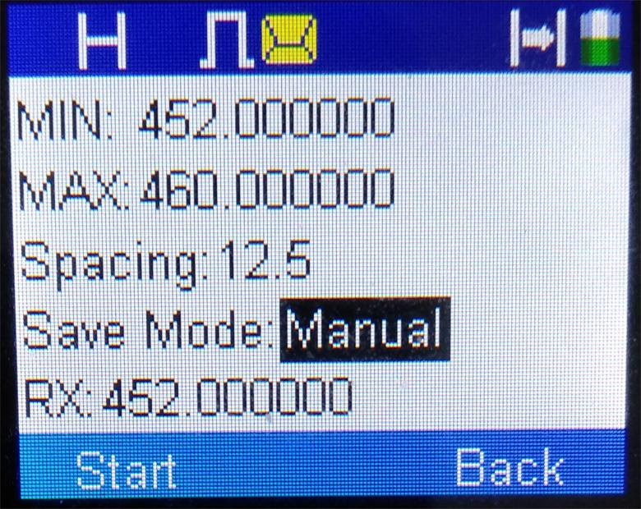
Pressing the start key will now start the scanning. If an active channel is found, the following screen will be shown. The Tx Frequency is a function of the CPS programming. It can be changed later if it is wrong by the Enhanced Parameter mode. If you want to save the channel, press the save key and if you want to search for the next channel press the continue key.

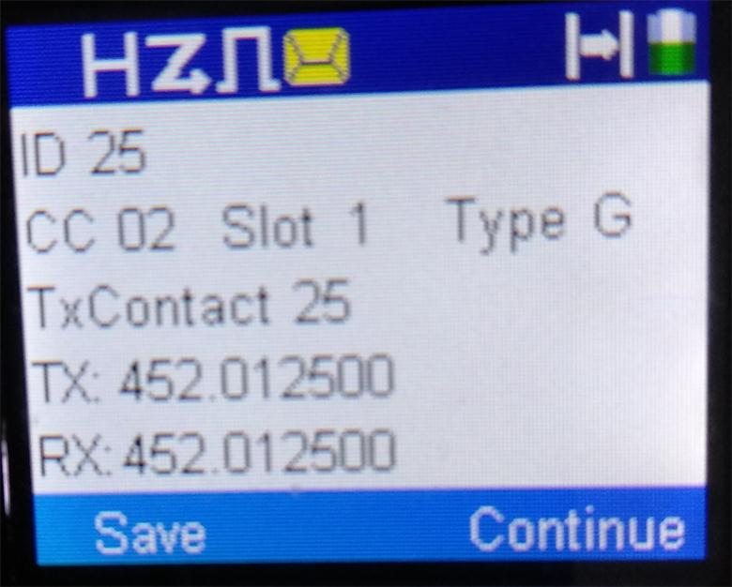

To save it in the first free channel in the current zone, press the free key. If you want to save it in the current channel press the Current key.
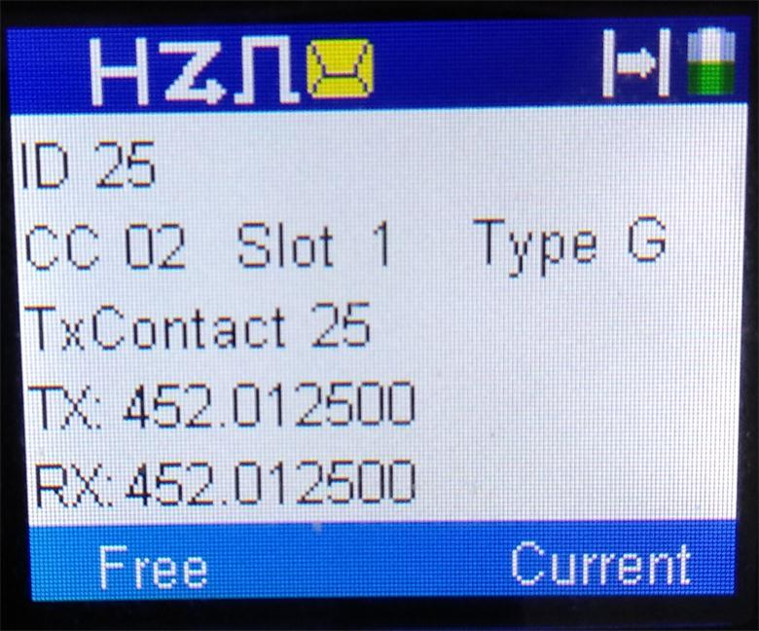
If there are no free channel, you will get an error message.
After the key is pressed the radio will continue scanning.

Menu

The menu now allows you to change the name of the Zones and the Channels from the keypad as shown in the next few screen shots. This is necessary because you are dynamically forming new channels and it would be desirable to allow the use of alias names that makes sense for the user.
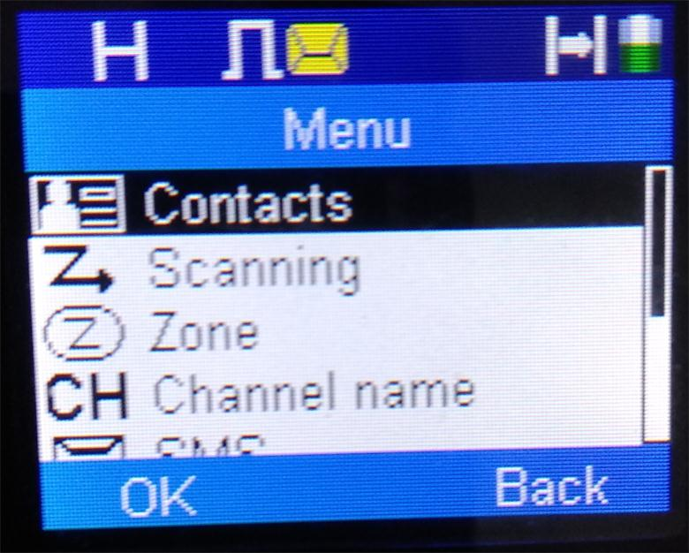
Menu-Channel name
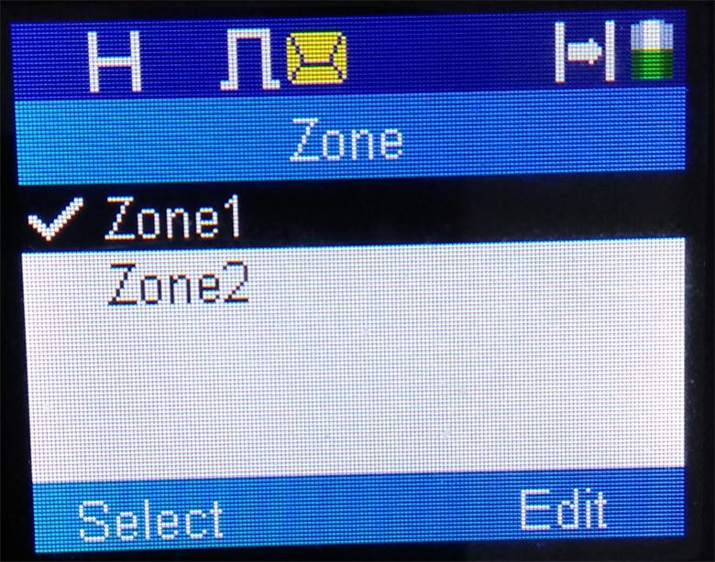
Zone-Edit
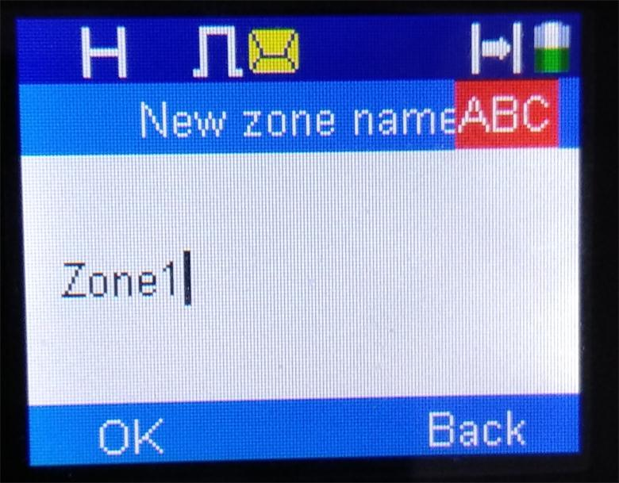
New zone name
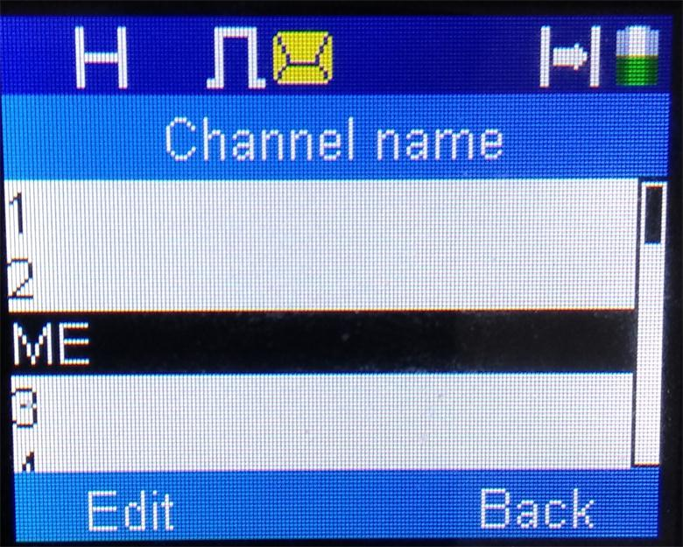
Channel name-Edit

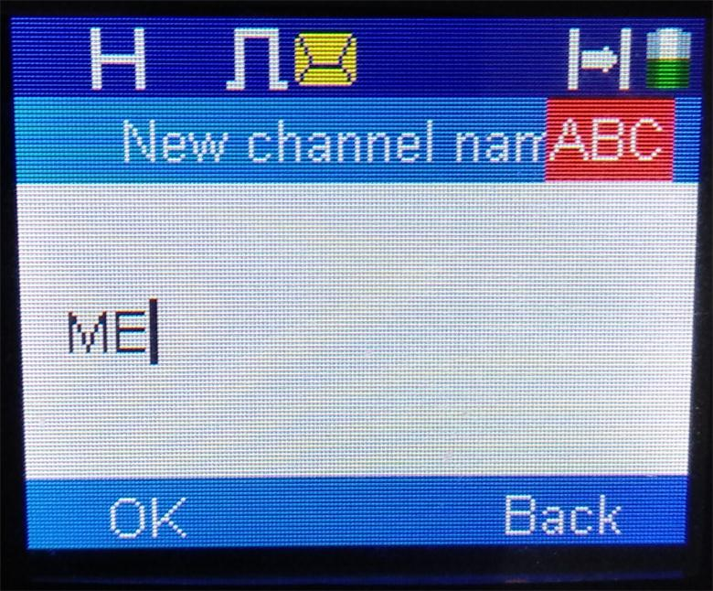
New channel name
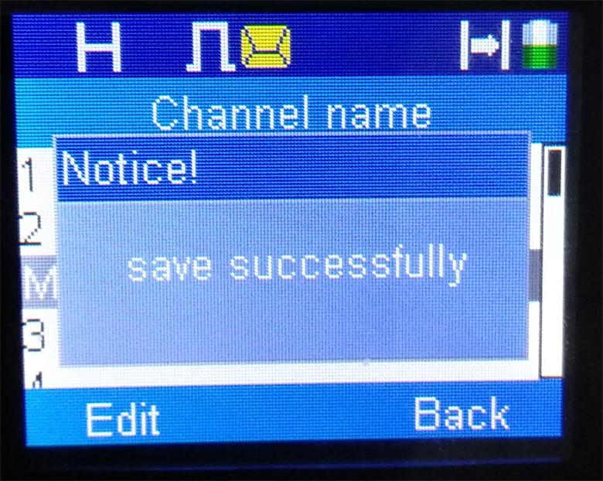
New channel name-Saved

