This procedure is used to recover a radio that has become unresponsive to the normal firmware update procedure, P1 + Power On. Please read through all of the instructions first to ensure that you have all of the tools and equipment needed.

Begin by installing the ‘DfuSe_Demo’ program on your PC. Run ‘DfuSe_Demo_V3.0.6_Setup.exe’ and follow the instructions to install the program.

Open the cover of your radio for access to the circuit board. You will need an instrument to produce a short across two points on the PCB. A pair of tweezers will work. You can solder in a jumper wire, but you will need to able to disconnect it once the bootloader has been reinstalled. Use extreme caution if working with tweezers as a jumper, since accidentally contacting the wrong points will kill the radio.

Run the DfuSe_Demo program and you will see the following window:
Connect the radio to your computer with the DB15 to USB cable, and the radio to a good power supply.
Refer to the next picture for the location of the points that need to be shorted.

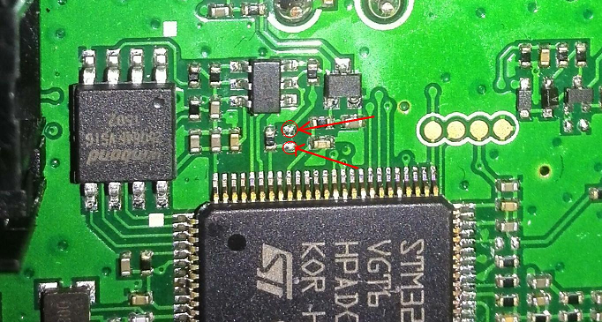
The next group of steps will require that the power button on the radio be held down while interacting with the computer. The MCU in the radio will not be able to properly control the radio power during the rewrite of the bootloader firmware to the STM chip. Make sure to press and hold the power button with the hand not normally used to control your computer mouse.

Short the two points on the PCB, then press and hold the power button. The computer may report that a driver is being installed. Wait for this to complete, after which you will see this screen:
You can remove the tweezers if using a temporary jumper, but keep holding the power button, and double click ‘Target Id 01 Option Bytes’ to erase the flash memory. You will see the following inquiry box, click ‘Yes’ to remove the read protection and erase.
Hold the power button and wait for the following screen to appear (the computer may make a disconnect sound before the screen appears – hold the power button). Click the OK button.
Now you can release the power button of the radio.
Short the two points again if using tweezers, then press and hold the power button until the following steps are completed:
This time, single click on ‘Target Id 00 Internal Flash’, the click the ‘Choose…’ button just below ‘Verify after download’ and ‘Optimize Upgrade duration…’ NOTE: do not check either of these boxes
Navigate to and select ‘****_Bootloader_R####.dfu’. You will need to determine the current ‘.dfu’ version of bootloader for the radio model and firmware series you are trying to load / recover. DfuSe will confirm that the file is correctly loaded. Continue to hold the power button.

Click the ‘Upgrade’ button. The following message will appear. Click ‘Yes’.
When the upload completes, the successful message will appear.
Click the ‘Leave DFU Mode’ button. The program will report successful departure. You can release the power button. Close the DfuSe program. If you soldered in a jumper, remove it now.
Keep your radio connected to your computer with the DB15 cable, open FlashBurn, then navigate to and select the desired version of firmware for the radio. It is usually best to load the RCDB version of firmware that is closest to the firmware you want to load to insure that the radio is cleared and reset, but this is not always necessary. Press and hold the P1 button and the Power button to bring the radio into Program Mode. When FlashBurn indicates that ‘The device has been connected’, click the Flash button and load the firmware into the radio. Wait for the progress bar to complete and success message to be displayed. Turn the radio off.

We still need to load the bootloader once more. In FlashBurn, navigate to and select the ‘.bin’ version of the bootloader you installed with the DfuSe program. Press and hold the P1 button and the Power button to bring the radio into Program Mode. When FlashBurn indicates that ‘The device has been connected’, click the Flash button and load the bootloader into the radio. Wait for the progress bar to complete and success message to be displayed. Turn the radio off.

You should now be able to turn the radio on and off both normally and in ‘Program Mode’. You can continue normally with further updates to the firmware if necessary.

