Using Factory Tool_M17_PLUS_DMR&OPNRTX_V1.0

This application note shows how to load the bootloader, M17 program and DMR program into the radio. It is assumed at this time that the radio is not bricked.

**Summary of Loading the Bootloader**

Transfer the M17PLUS_Bootloader_B7.06_20241214.boot or later version using the Factory Tool_M17_PLUS_DMR&OPNRTX_V1.0 program.

**Summary of Loading the M17 Program**

Transfer the openrtx_cs7000p_20241211.bin or later version using the Factory Tool_M17_PLUS_DMR&OPNRTX_V1.0 program.

**Summary of Loading the DMR Program**

Transfer the M17PLUS_HOST_V9.00.05_20241029.bin or later version using the Factory Tool_M17_PLUS_DMR&OPNRTX_V1.0 program.

You need the following programs and hardware:

CS7000 M17 PLUS radio  
Programming cable  
Factory Tool_M17_PLUS_DMR&OPNRTX_V1.0 program.  
Latest Version of the program you want to load into the radio

1. If you have not already done it, install the Factory Tool_M17_PLUS_DMR&OPNRTX_V1.0 Program on your PC. If done properly you should have the following shortcut on your PC.

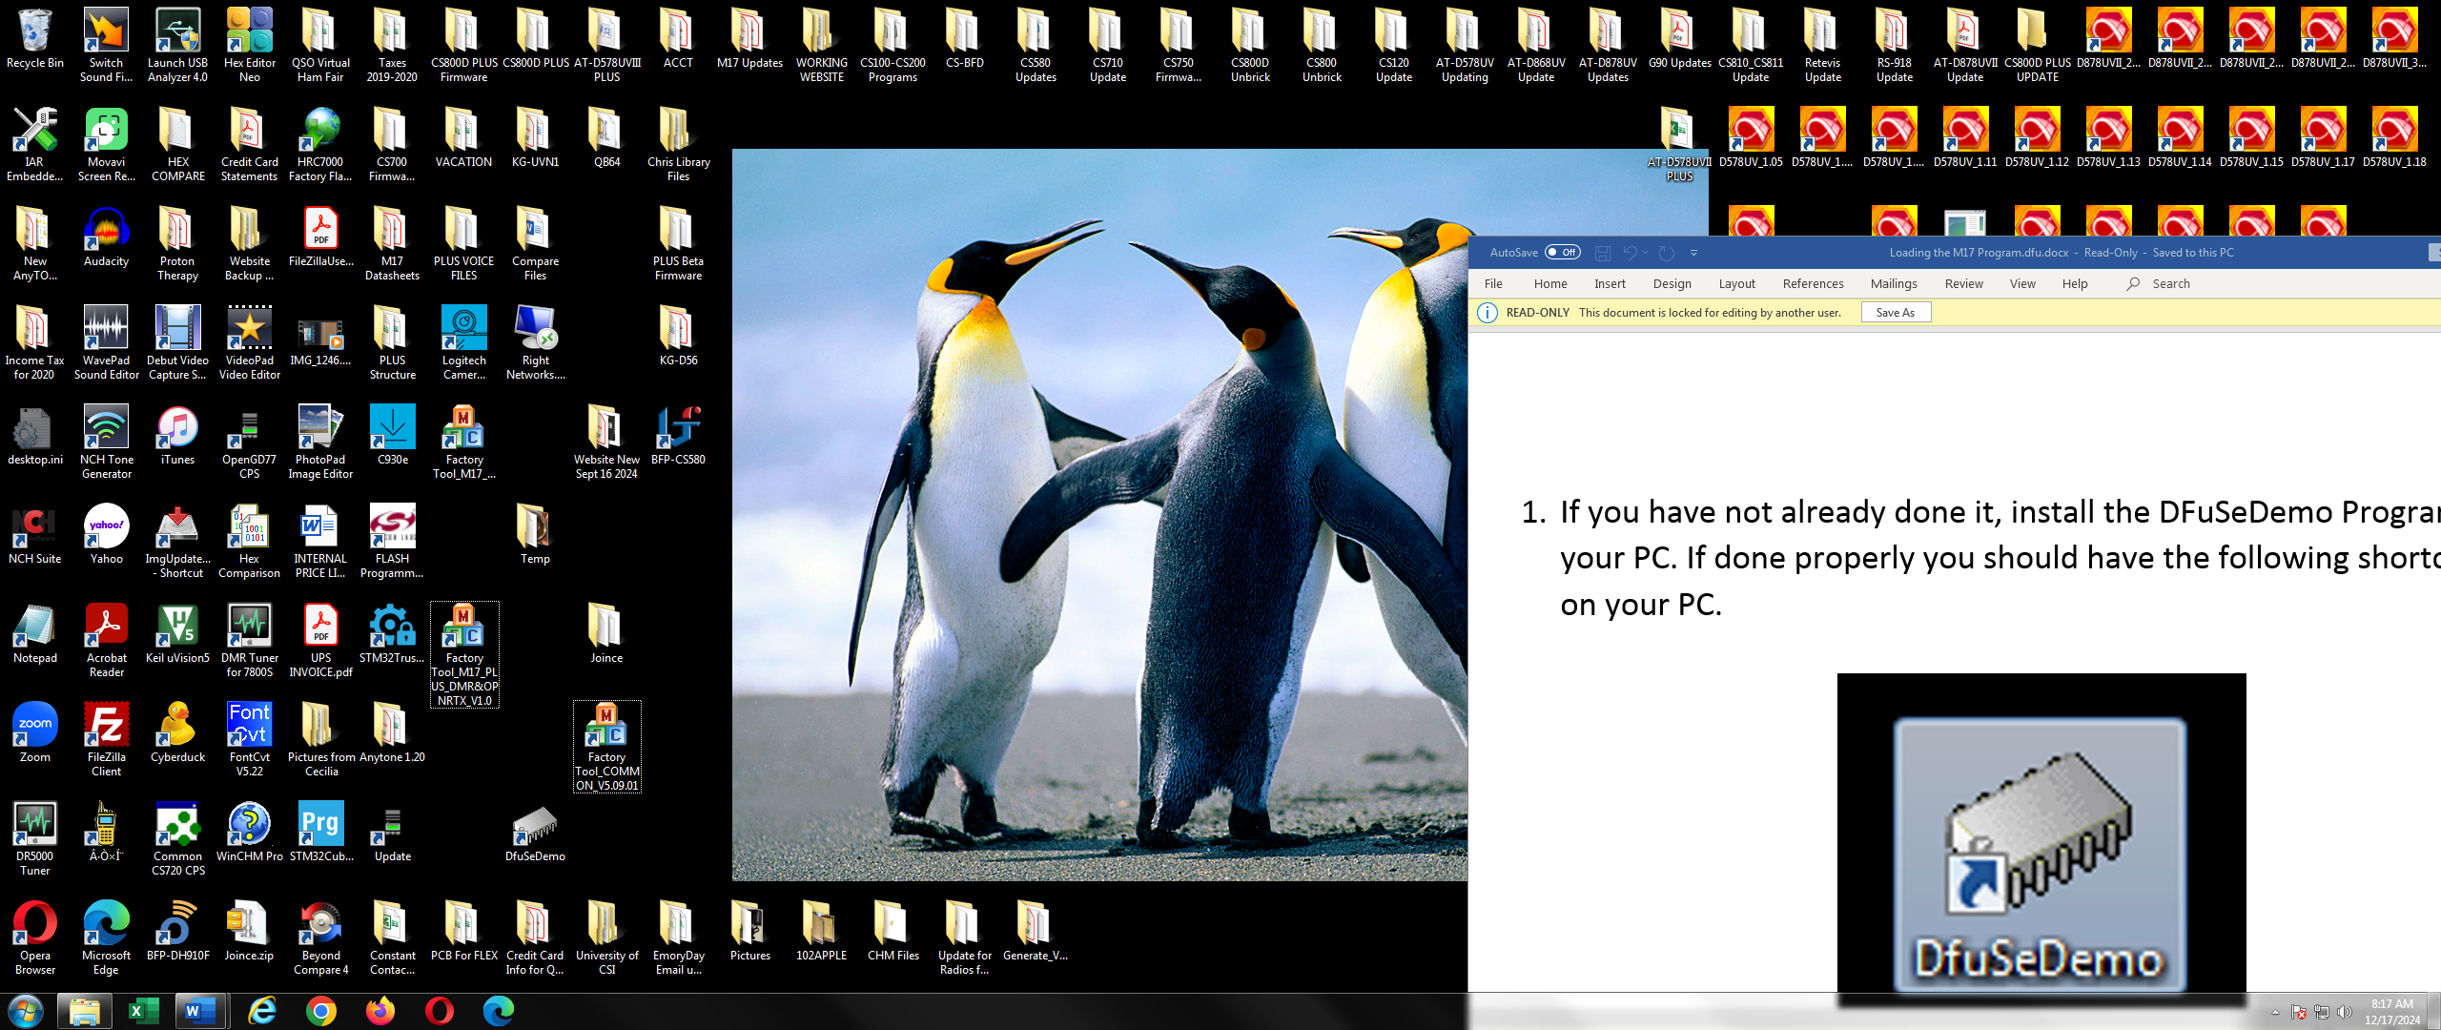

1. Attach one end of the programming cable to the radio and the other end to the USB port of the computer.
2. Run the Factory Tool_M17_PLUS_DMR&OPNRTX_V1.0 Program and you should get the following screen:

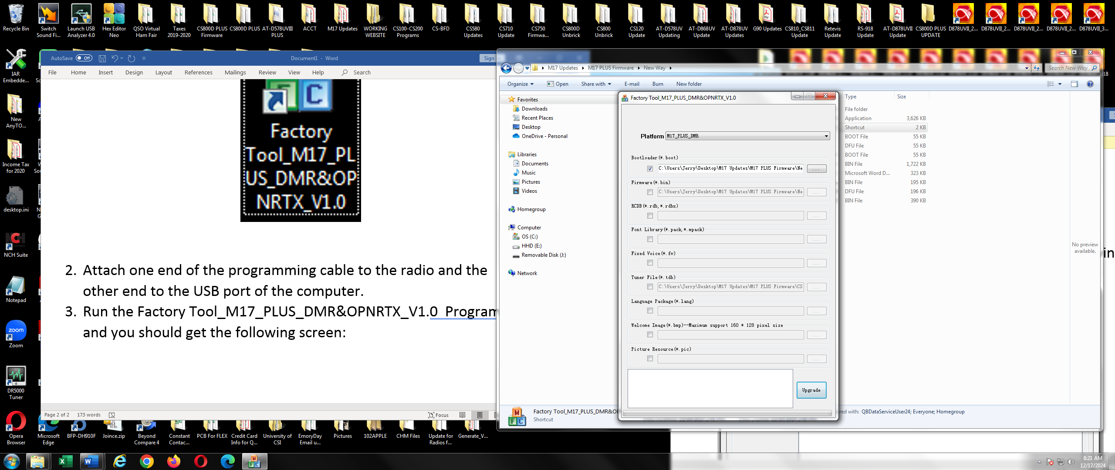

1. Below is a picture of the radio buttons:

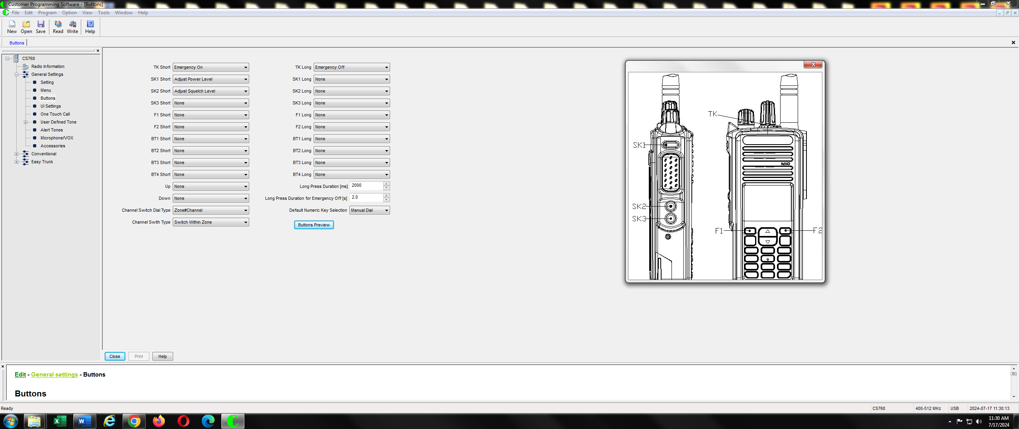

PTT

Press the top orange button and the PTT at the same time and while pressed, turn on the radio. The LED should display green, orange and red continuously.

1. Loading the Bootloader

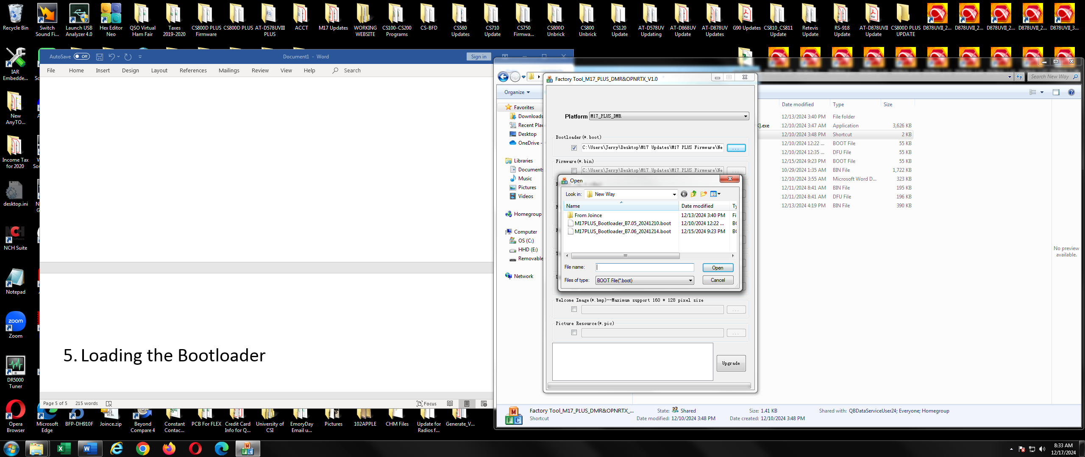

Latest bootloader file

Bootloader Box

Find File

Check the Bootloader Box, find the file, and double click on the latest bootloader file.

1. Loading the file into the radio

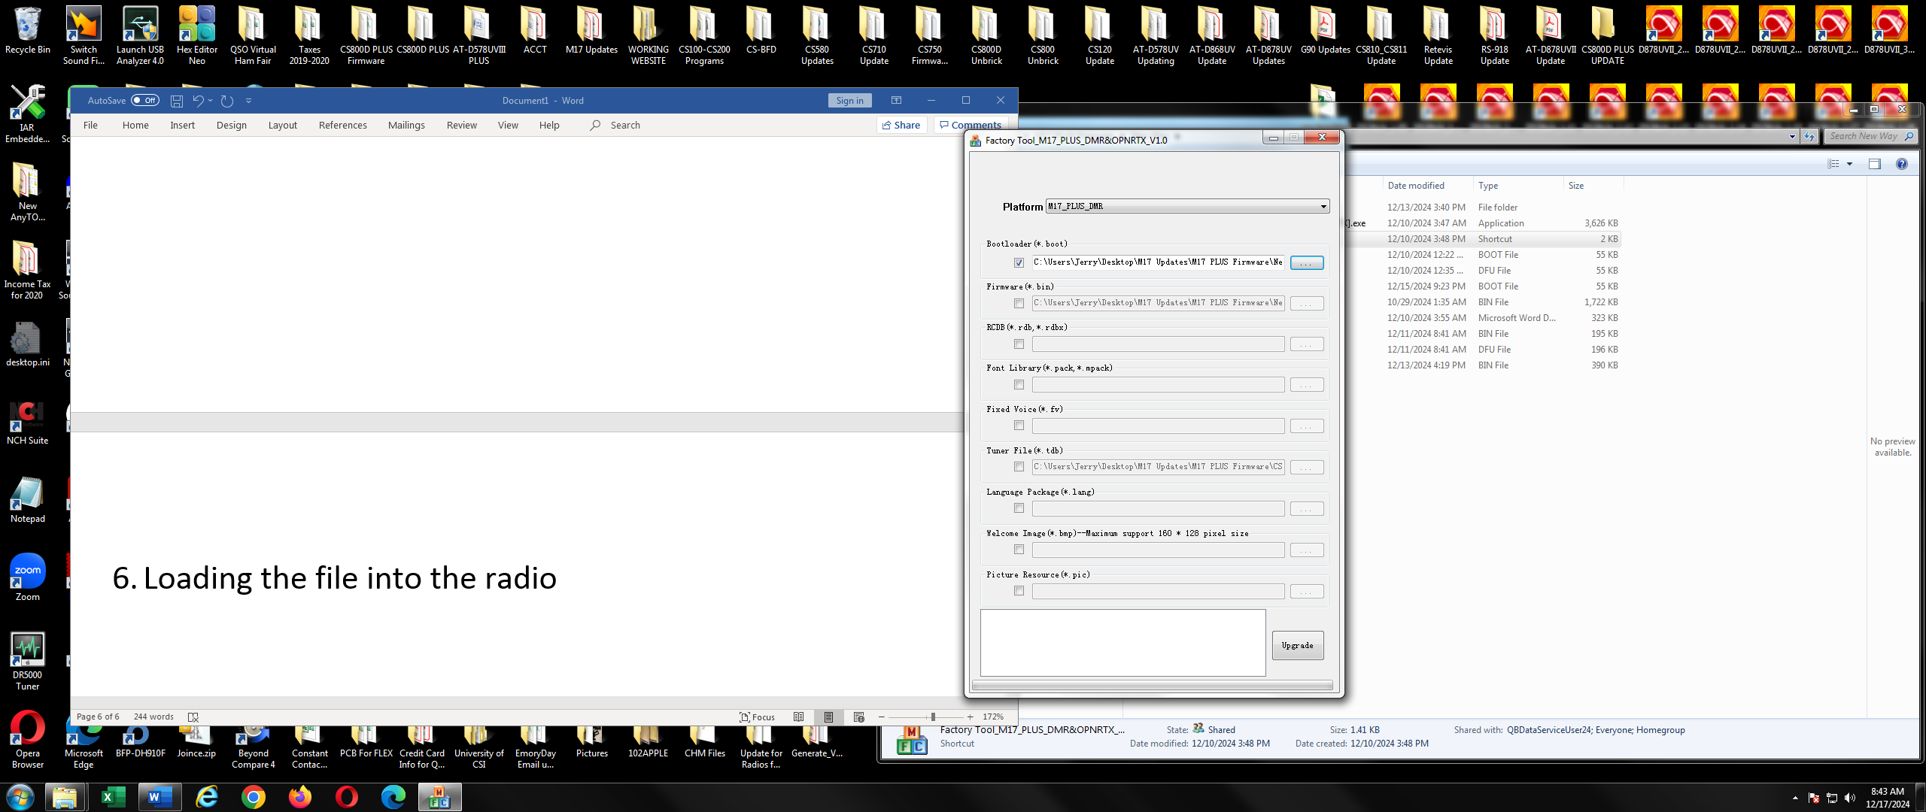

Press the Upgrade button and very shortly you will see:

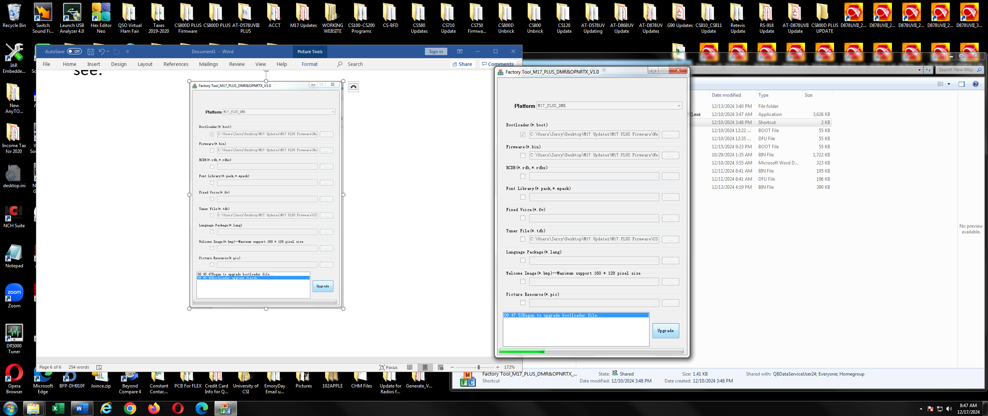

Followed by:

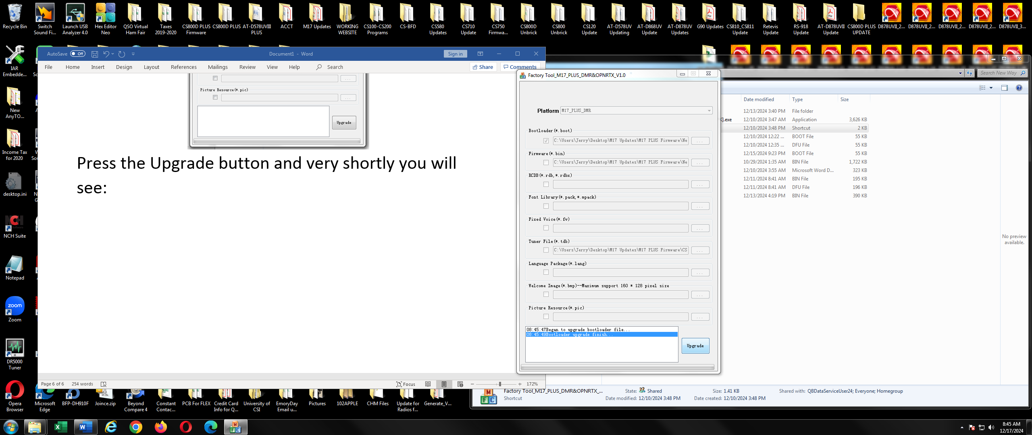

Followed by:

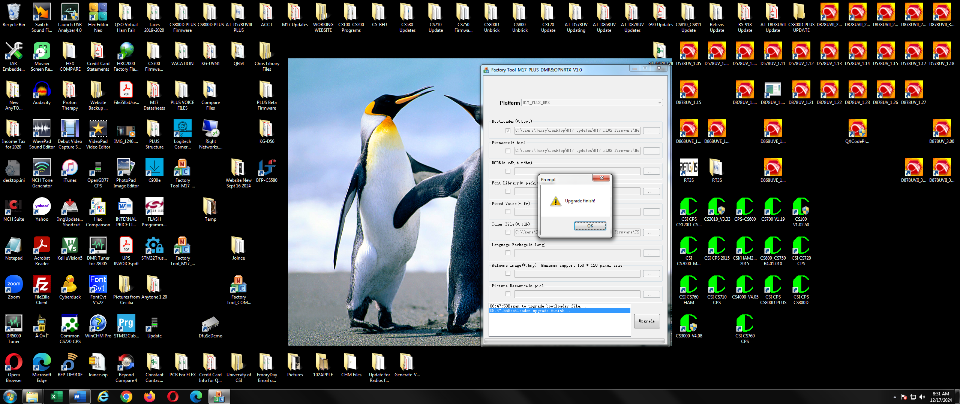

Press the OK button and you are done.

1. **Loading the DMR Program**

This works the same way as the bootloader except have to check the firmware check box as shown below.

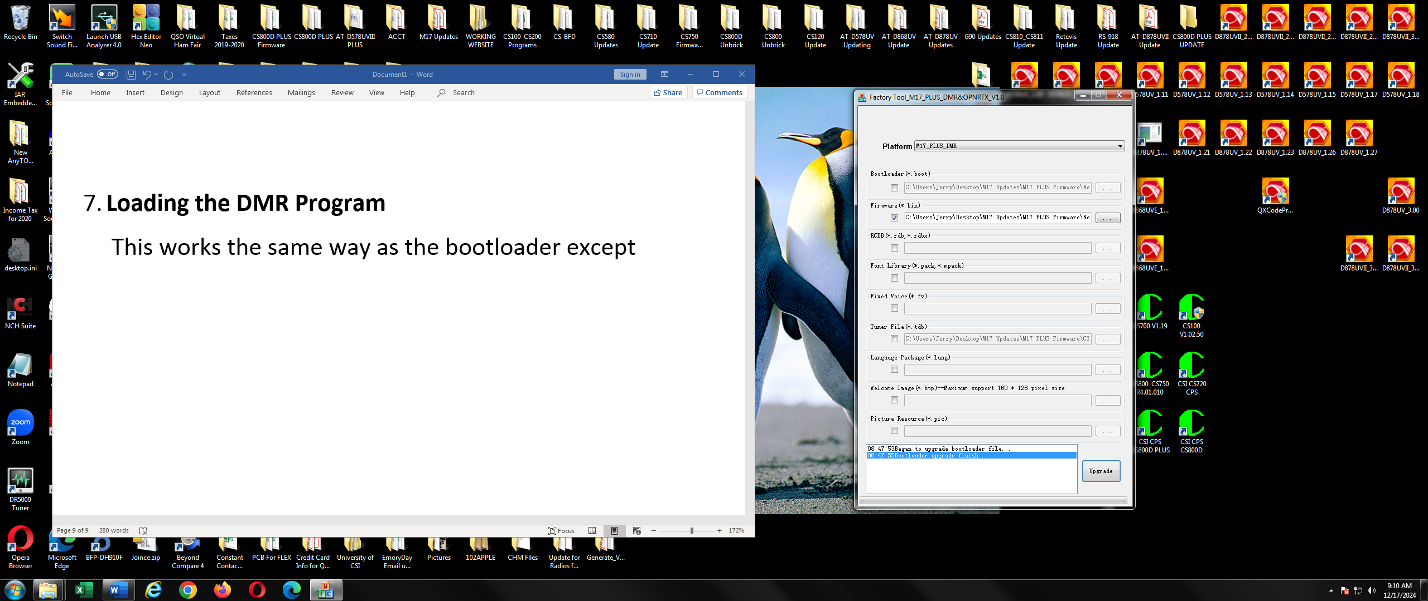

Firmware Check Box

1. **Loading the M17 Program**

This works the same way as the bootloader except have to check the firmware check box as shown below and set the Platform as shown below.

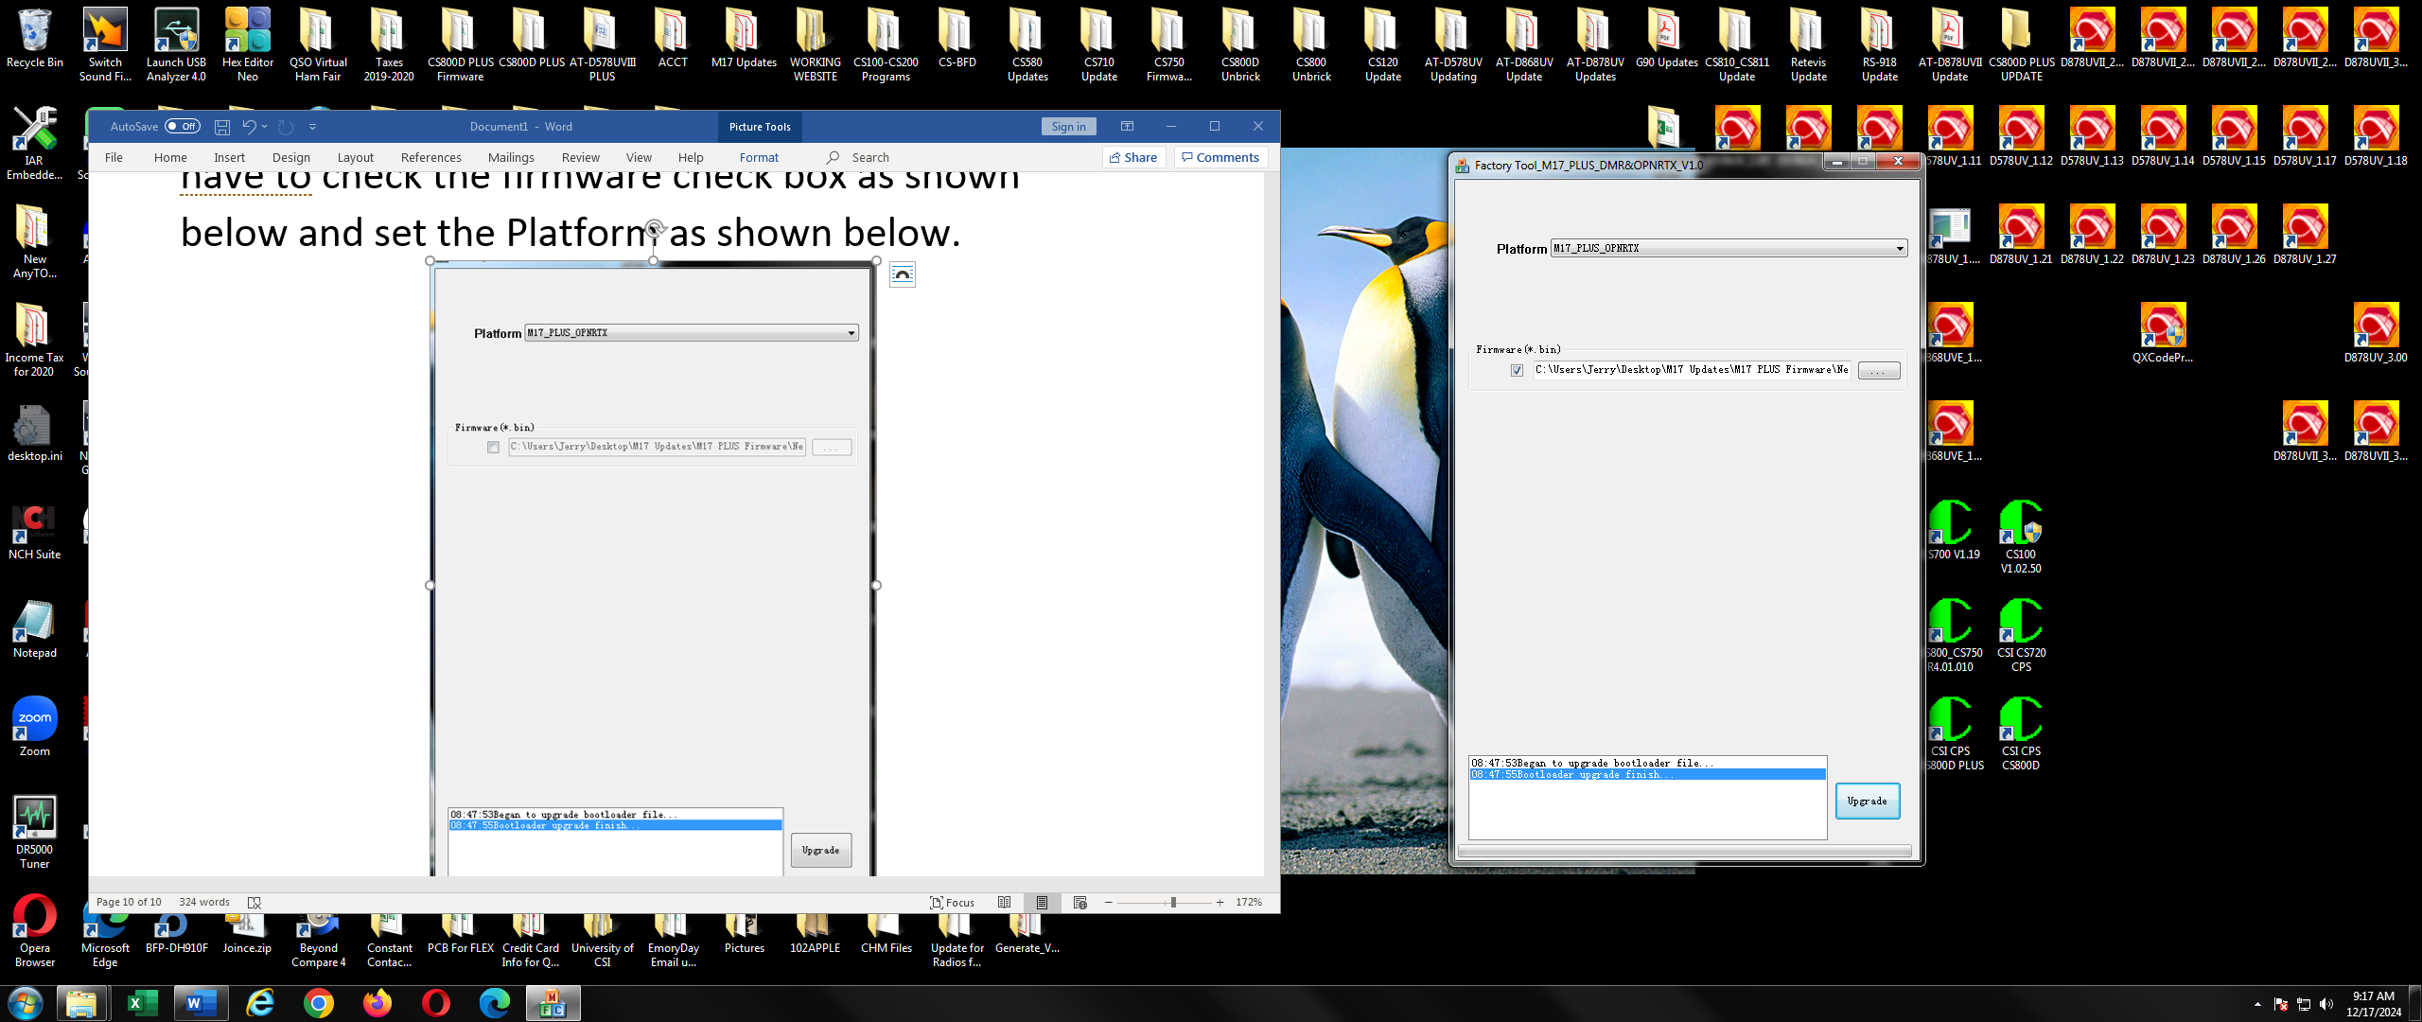

Platform

Firmware Check Box