DETAILED USERS MANUAL
Version 1.4
January 2, 2025
When turning on the CS7000 M17 PLUS radio, pressing the Top Orange button and the SK3 button at the same time will put it into the M17 mode. Pressing the Top Orange button and the SK2 button at the same time will put in into the DMR mode. The radio will remember the last button push when you next turn on the radio. For bootloader vesion B7.06 released on 12/16/2024, you only need to press the side key to get into the desired mode. For all other items, the CS7000 M17 and CS7000 M17 PLUS works the same in the M17 mode.
The M17 protocol was designed by Wojciech Kaczmarski (SP5WWP). The M17 name was part of the address from Wojciech’s ham club. The original firmware was programmed by Niccolo Izzo (IU2KIN), Silvano Seva (IU2KWO), Federico Amedeo Izzo (IU2NUO), and Federik Saraci (IU2NRO) Silvano Seva made the firmware compatible with our radios. The Codec 2, which is the Vocoder used in the Voice mode of the M17 was designed by David Rowe (VK5DGR).
There are three basic sections to what you see on the display as follows:
Screen with Frequency
Macro Menu
Menu
The Screen with frequency allows you to transmit and receive. You can change the frequency of the radio from that screen.
The Macro Menu allows you to change the following parameters:
CTCSS Transmit Tone (FM mode only)
When the Tones will be used (FM mode only)
Bandwidth (FM mode Only)
Mode (FM or M17)
Power output (1 Watt or 5 Watts)
Brightness of the display
Lock or Unlock

The Menu allows you to change various parameters. A summary of the screens is as follows:
Banks
Channels
Contact
Settings
Display
Brightness
Timer
GPS
GPS Enabled
GPS Set Time
UTC Timezone
Radio
Offset
Direction
Step
M17
Callsign
CAN
CAN Rx Check
Accessibility
Macro Latch
Voice
Phonetic
Default Settings
Info
About

STARTUP SCREENS
On the assumption the open RTX is installed, the first screen that will be displayed is as follows:
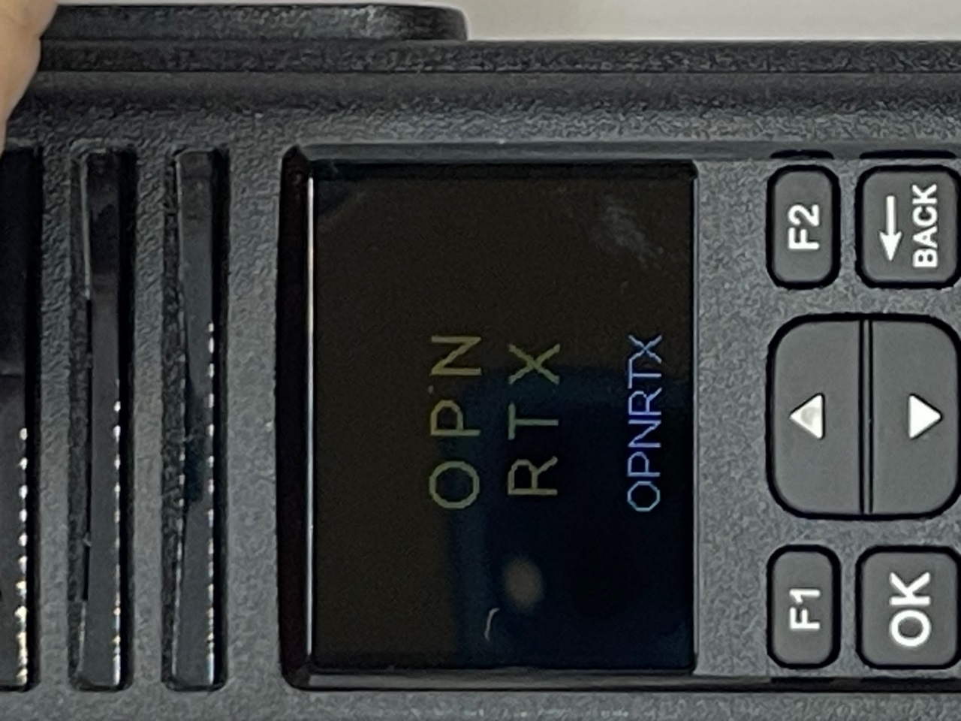

If you enter your call sign in M17 Settings menu, then the screen will be displayed as follows:
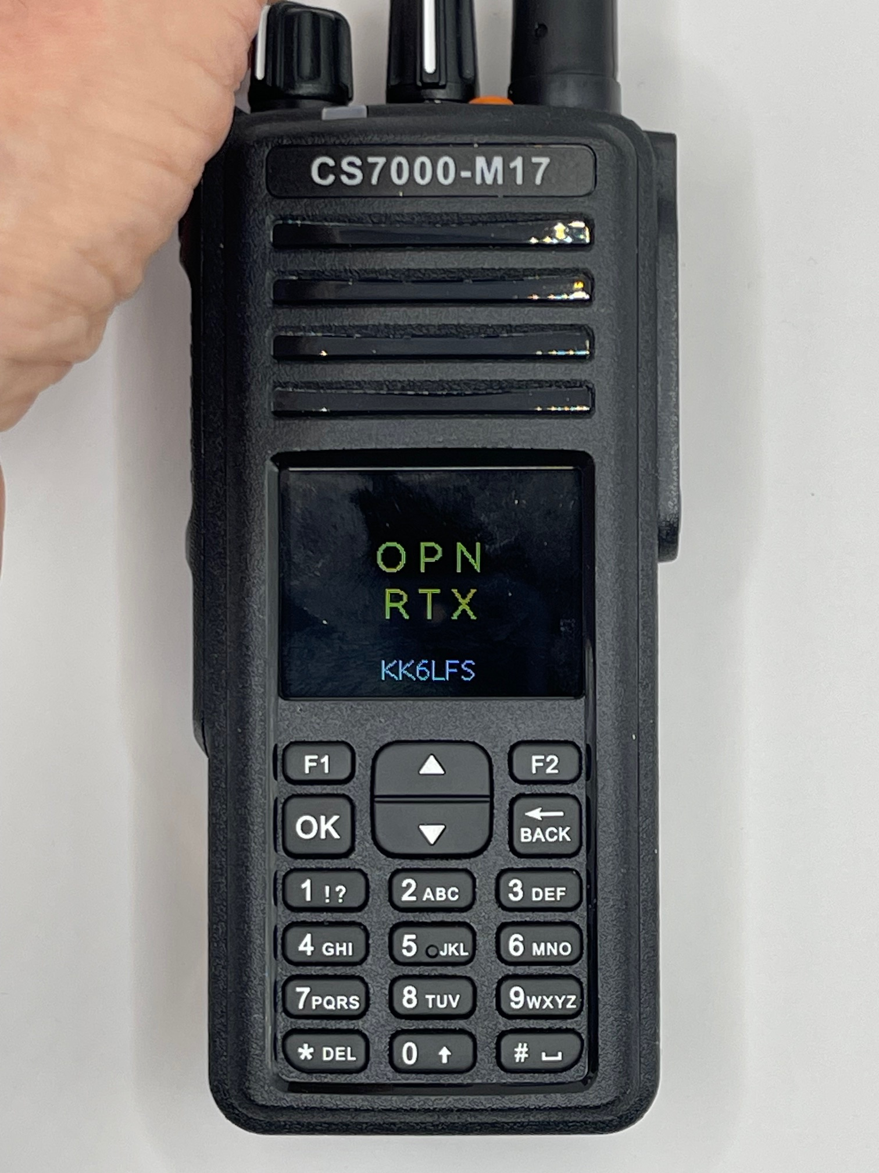

Followed by the screen that shows the mode and the frequency of the receiver.
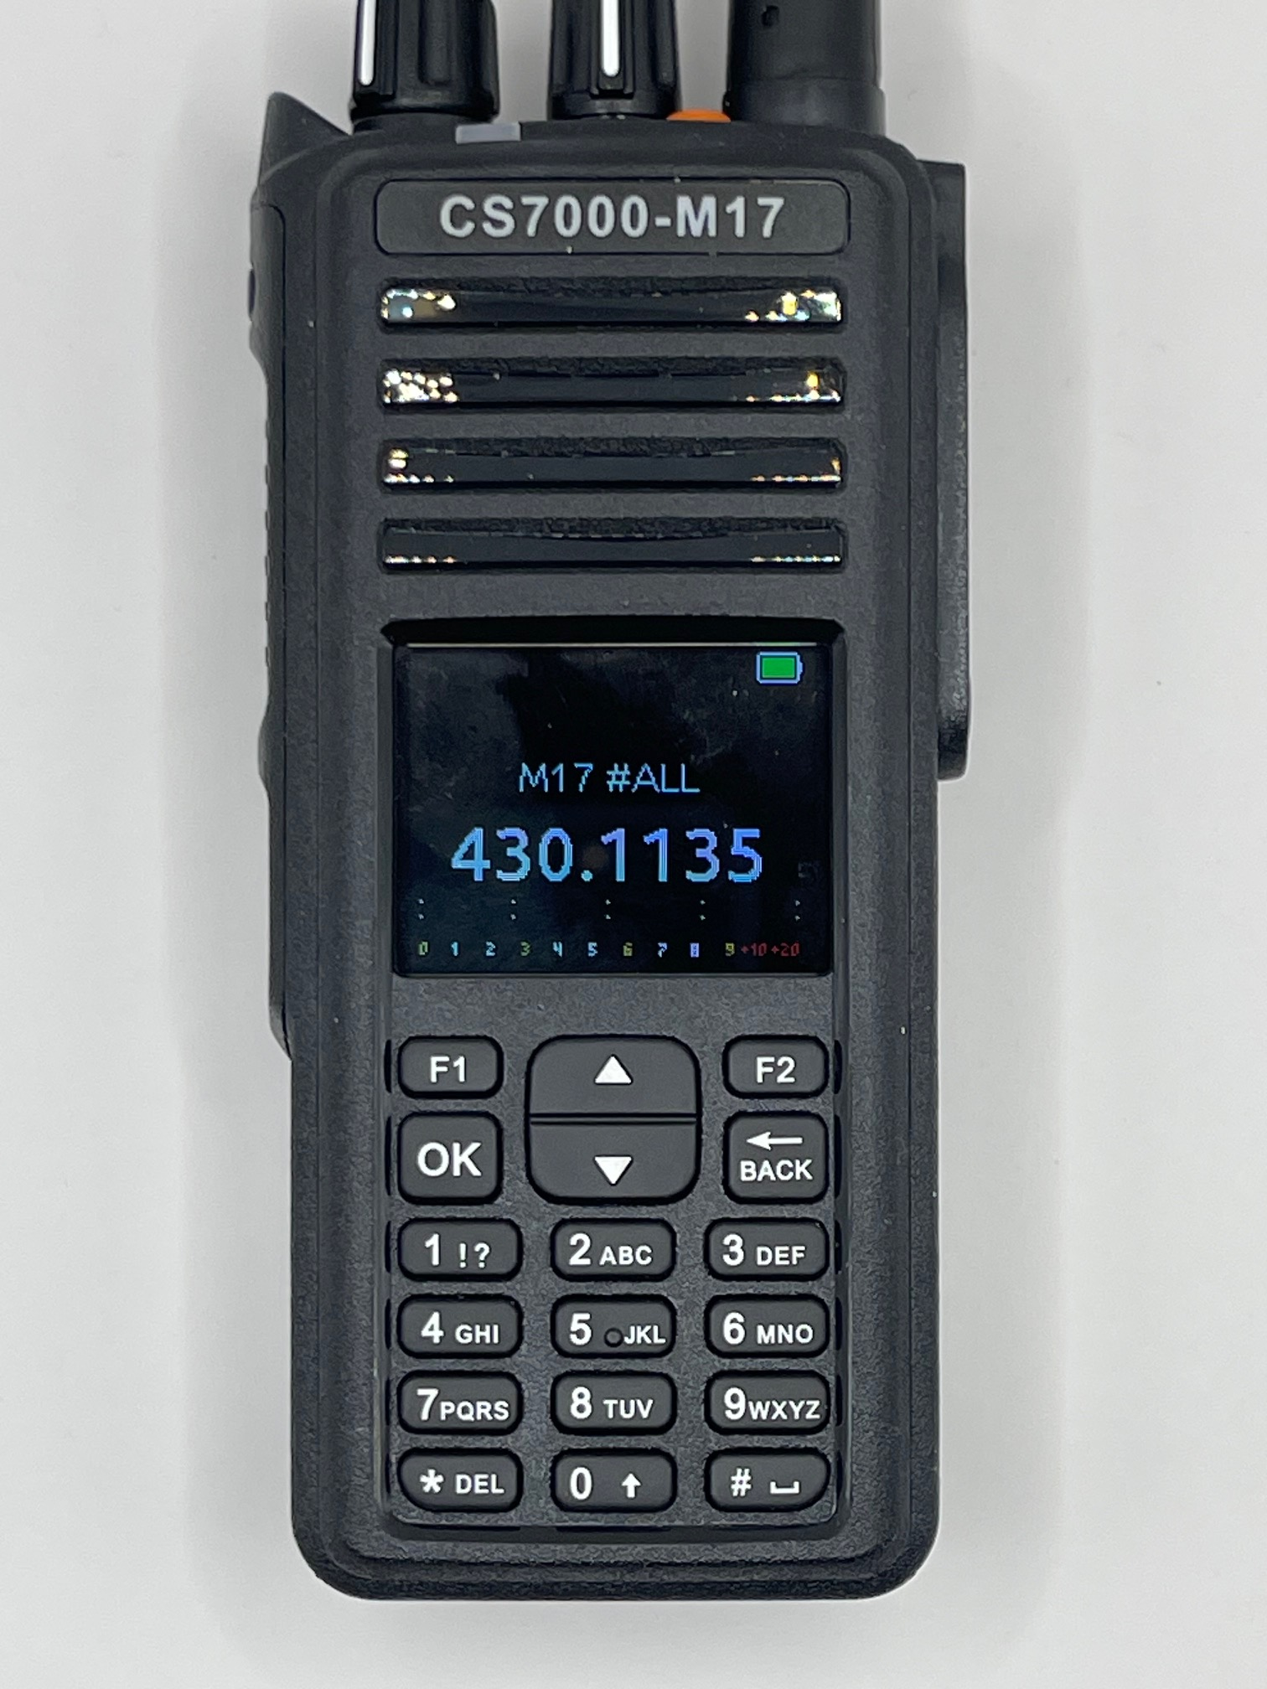

If the mode was FM then the following screen will be displayed
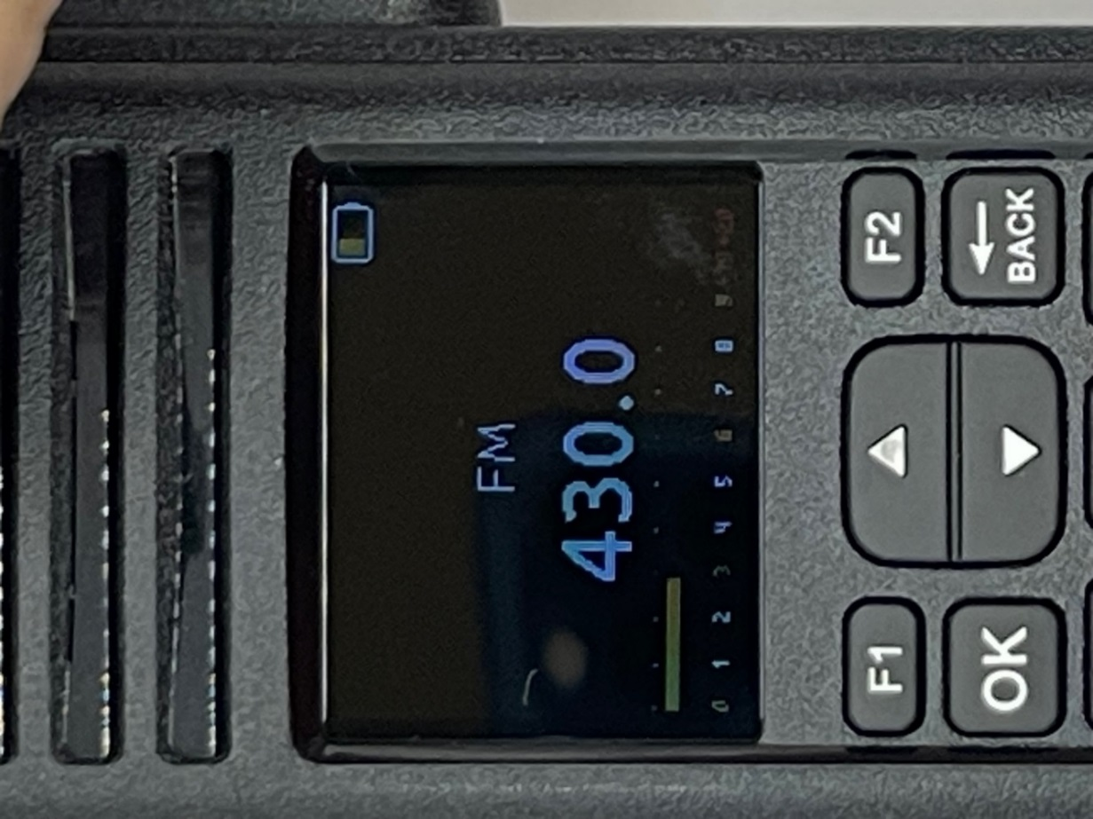

SETTING THE FREQUENCY
Pressing the up arrow will increase the frequency by an amount shown in the Step parameter of Radio Settings.
Pressing the down arrow will decrease the frequency by an amount shown in the Step parameter of Radio Settings.
The possible step settings are:
1.0 KHz 12.5 KHz 50 KHz
5.0 KHz 15.0 KHz 100 KHz
6.25 KHz 20.0 KHz
10.0 KHz 25.0 KHz
When the PTT is pressed, the display will show the frequency of the transmitter.
The transmitters frequency is determined by one of two methods:
- Set the offset and direction in the Radio Settings menu.
- Manually setting in the transmitter frequency.
If you manually set the frequency in the radio, then the offset and direction parameters in the Radio Settings menu is automatically changed.

Start by putting in four or five as the frequency of this radio is 400-527 MHz. If you put in a frequency out of range, the radio will put 400 MHz as a default. The top line is for the Rx Frequency and the bottom line is for the Tx Frequency. Pressing a number will now get the following screen:
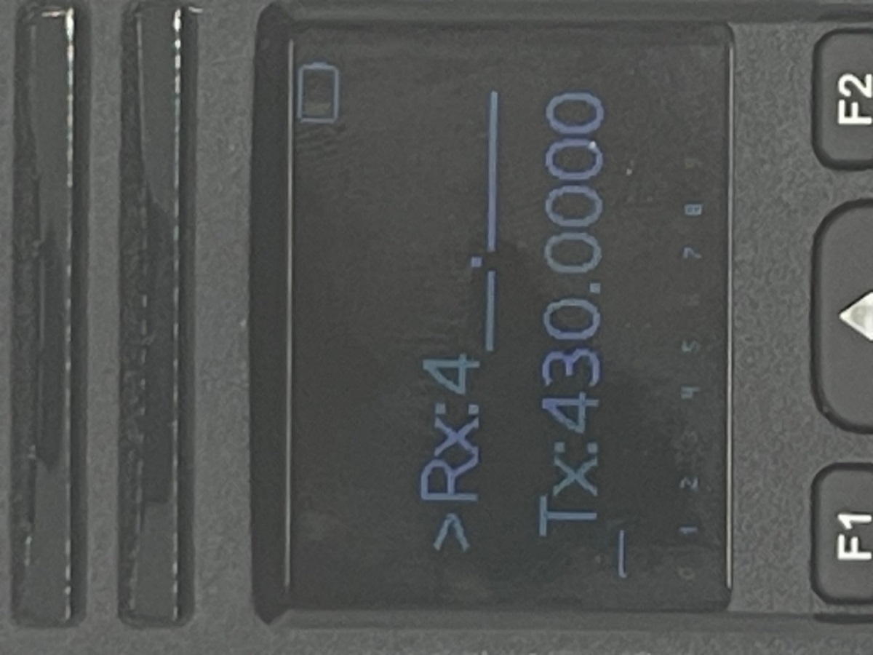
If you press the OK key before putting in all the digits, the radio will pad the rest of the digits with zeros. As an example, if you put in 4 like the screen above and press the OK key, the radio will give you a frequency of 400.0000.

This screen requires you to put in a total of 7 digits for both the Rx and Tx frequencies. After you put in the 7 digits for the Rx frequencies, a copy of the Rx frequency will be copied to the Tx frequency as shown below.
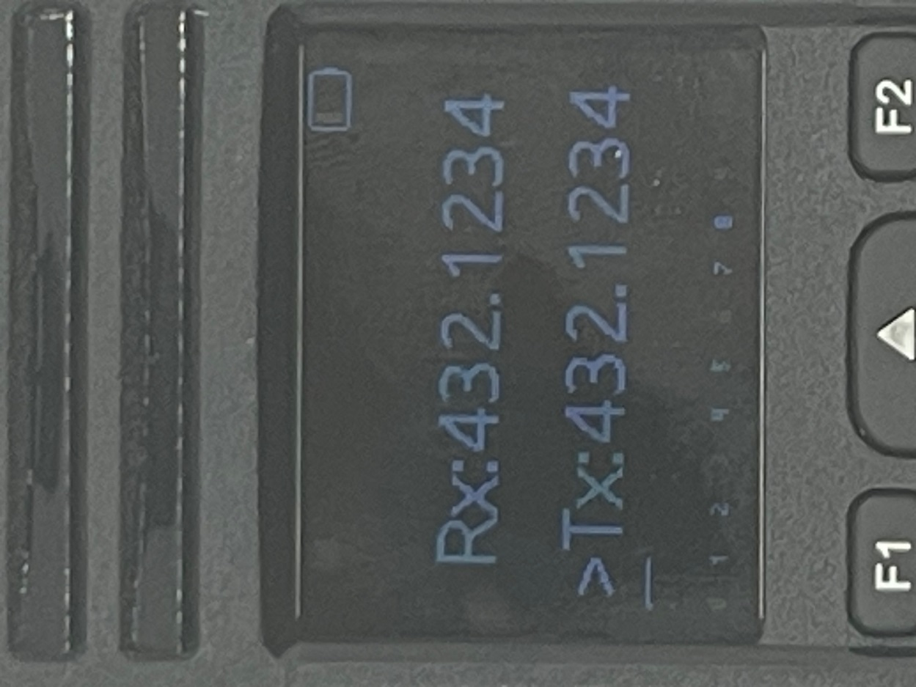

If you put in more numbers, then you will change the Tx frequency as shown in the screen below.
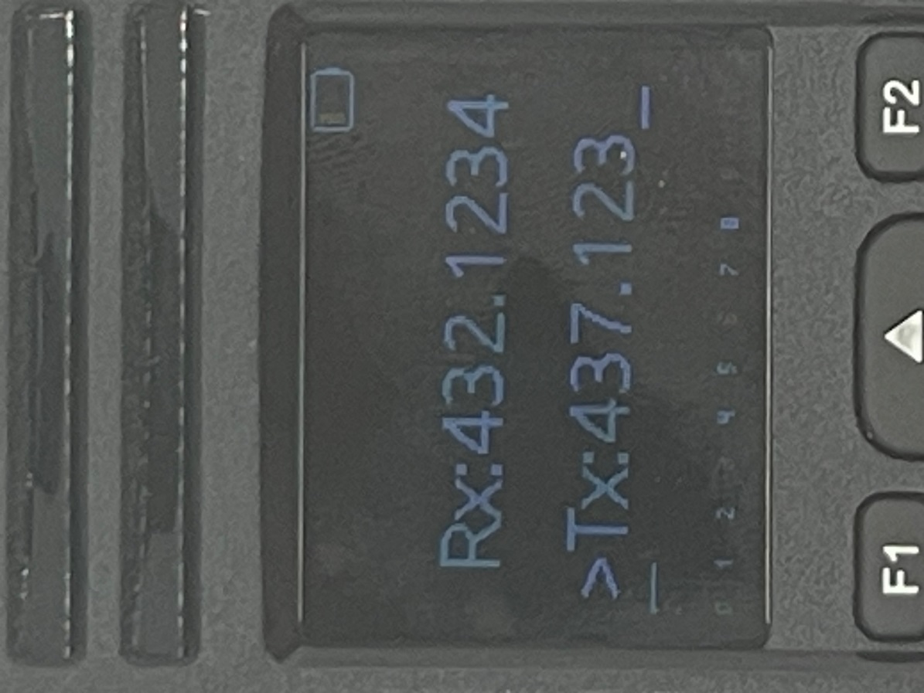

When you put in the last number for the Tx frequency, the screen will look as follows:
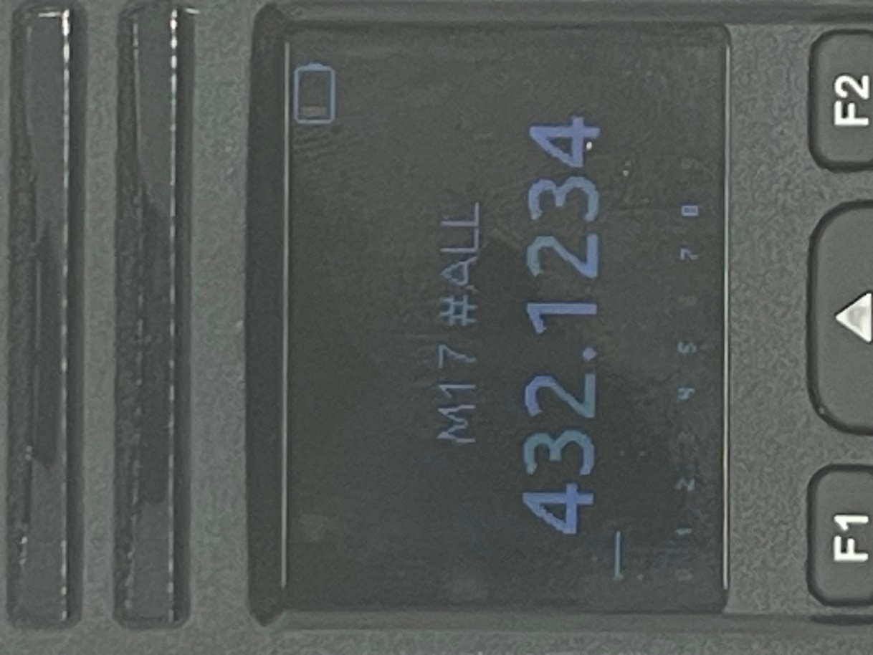
If you want to leave the Tx frequency and the Rx Frequency to be the same, press the OK button.
The radio is now ready to transmit!

MEANING OF THE SCREEN
A typical screen for the FM mode is shown below.
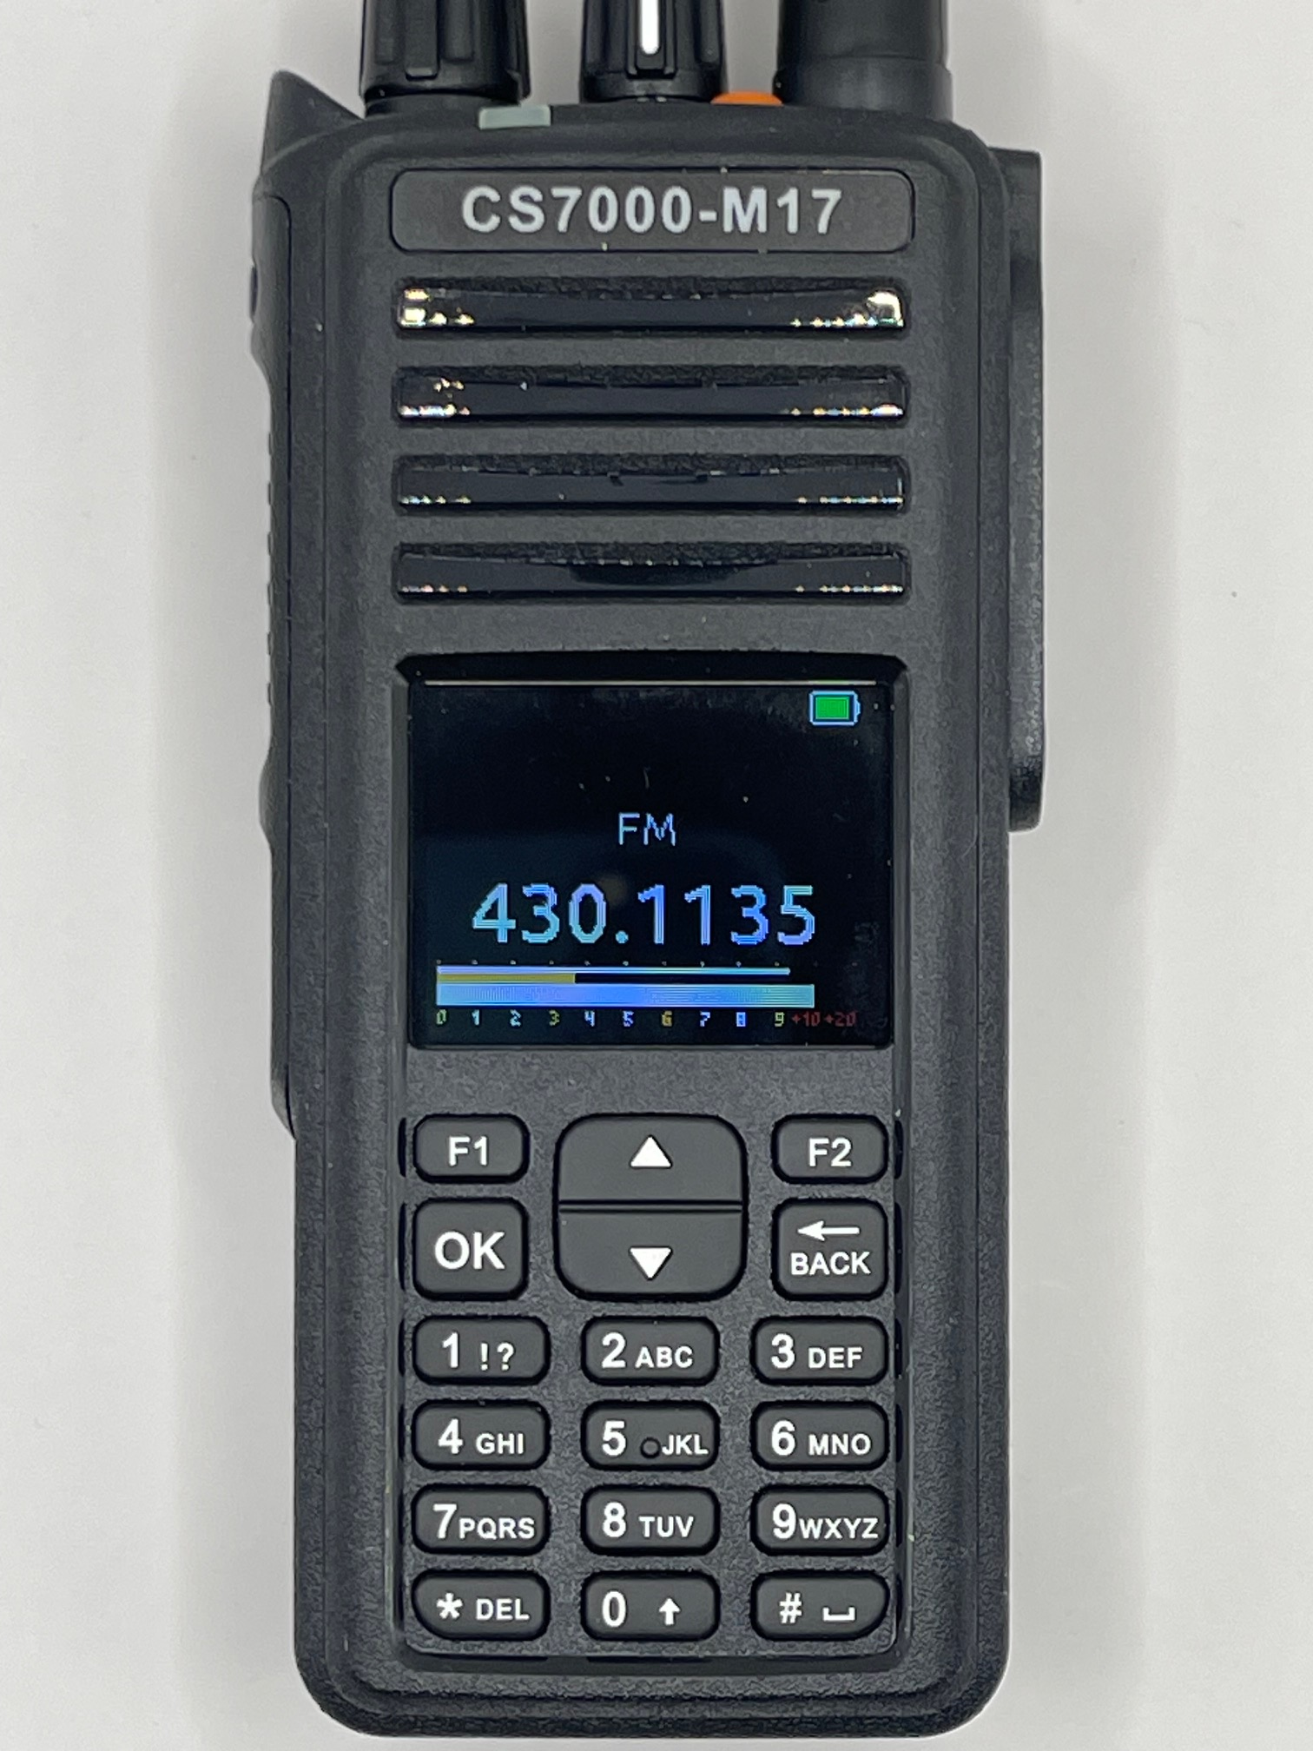
The frequency shown above is the receive frequency. When you press the PTT, the receive frequency is replaced by the transmit frequency.
The battery on the top right of the screen shows the charge of the battery. If it is all green, then the battery is fully charged.
If another radio is transmitting on the frequency shown above, then the bottom rectangle just above the numbers indicates receive strength.
The orange line above the signal strength indicates the current squelch level above which the speaker is active.
The line below the frequency is the volume control setting.
If the CTCSS is enabled, to the right of the FM will be the CTCSS frequency. To the right of the frequency will be E,D or ED standing for Encode, Decode, Encode and Decode respectively.
In the M17 Mode, the Receive Screen and the transmitting screen is different. The Screen below is the receive screen.
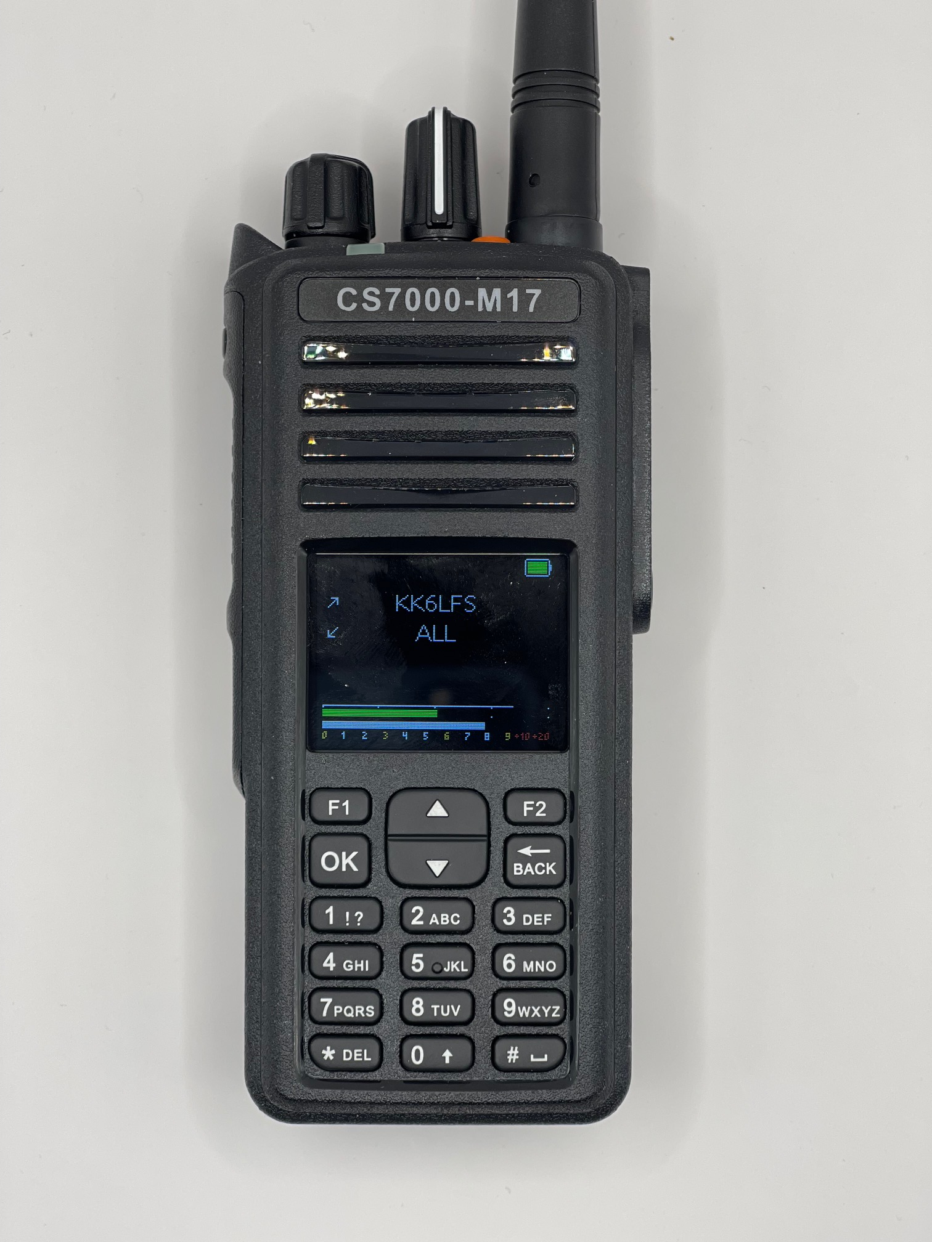
The battery on the top right of the screen shows the charge of the battery. If it is all green, then the battery is fully charged.
If another radio is transmitting on the frequency shown above, then the bottom rectangle just above the numbers indicates receive strength.
The Green line above the signal strength represents the strength of the incoming microphone signal and it only moves when transmitting.
The line below the frequency is the volume control setting.
The “ALL” prompt is what the transmitting radio is sending. If it is ALL it is meant for everyone on this frequency to receive it. If it matched your call sign stored in the radio you will receive the call. If it does not match your call sign, then you will see who is transmitting but you would not hear the audio.

The screen below is the transmit screen.
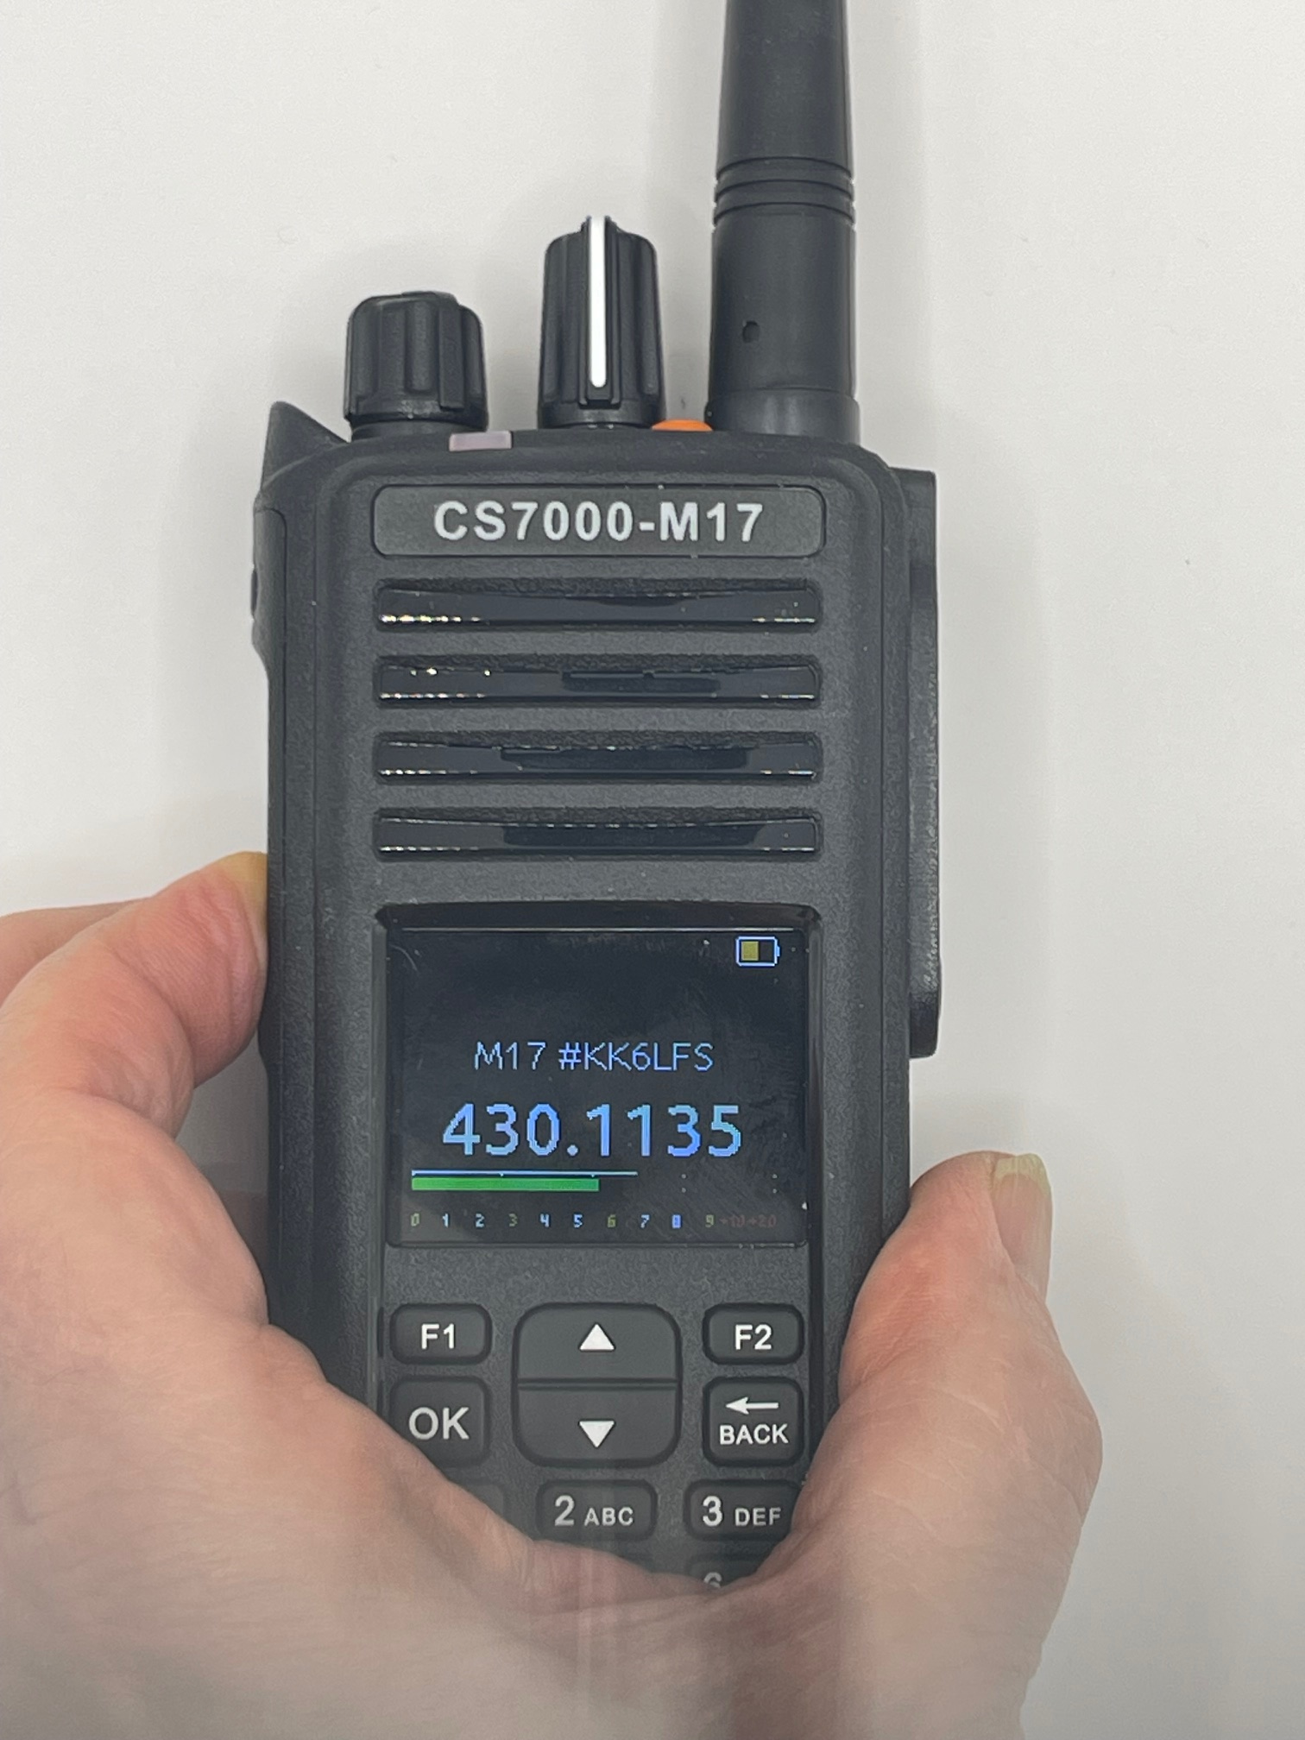
The battery on the top right of the screen shows the charge of the battery. If it is all green, then the battery is fully charged.
The Green line above the signal strength indicates the microphone level.
The line below the frequency is the volume control setting.
The KK6LFS indicates who the transmitted signal is for. In this case the only one who is going to receive this signal is a radio with their call sign of KK6LFS. If it said “ALL”, then it is a call for everyone who is in listening range.

SETTING THE DESTINATION ADDRESS
When in the M17 mode, pressing the “#” key will allow you to change the destination of the radio. If it is set for “ALL”, then the destination is all radios that can hear you. The Channel Access Numbers have to match unless you set it for promiscuous mode. If you change the destination address to something other than “ALL”, pressing the # key twice will set it back to “ALL”
The destination address can be any address between 1 and 9 characters. The possible characters that can be entered are defined below:
1: 1 5: J,K,L,5 9: W,X,Y,Z,9
2: A,B,C,2 6: M,M,O,6 0: 0,Space
3: D,E,F,3 7: P,Q,R,S,7 *: -,/
4: G,H,I,4 8: T,U,V,8 All other keys ignored.
Once you enter in your desired address from the keypad, lock it in by pressing the OK key.

MACRO MENU
Pressing the TK1 button on the top left will get the following screen:
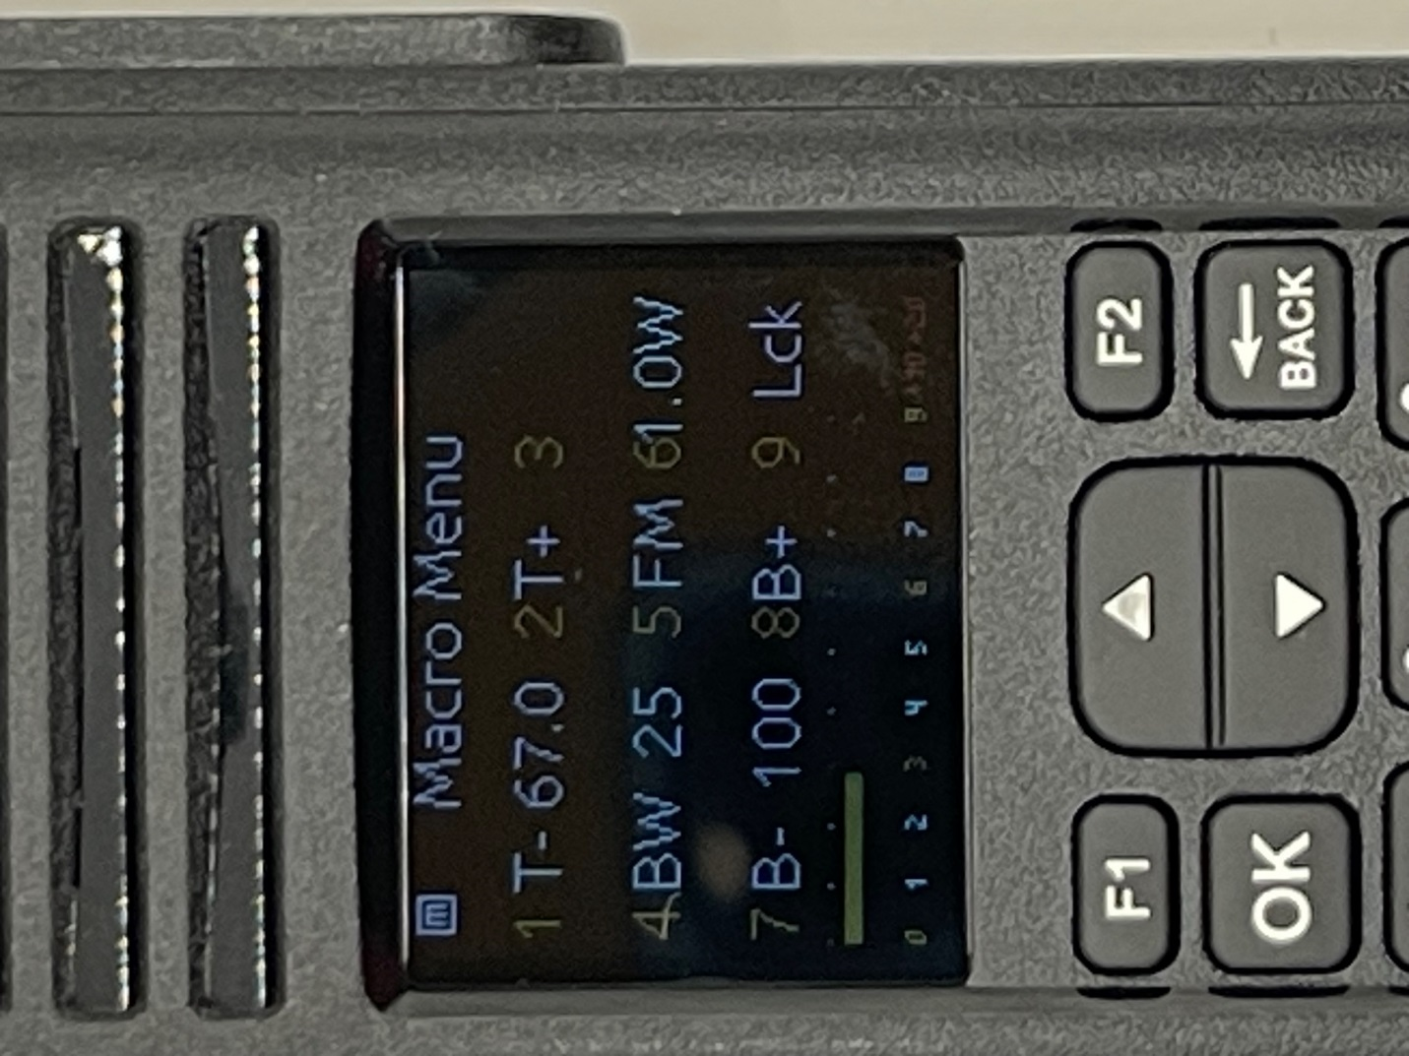
Take a look at the ICON to the left of the “Macro Menu”. Pressing the TK1 and letting go of TK1 while that ICON is there will lock in the Macro Menu. Letting go of the TK1 while the ICON is not there will not lock in the Macro Menu. If already in the Macro Menu, a quick press of the TK1 will get you back to the main screen.
If you notice, there are numbers 1 through 9 on this screen. The numbers are defined as follows:
- Set the CTCSS Encode down one position. The number to the right of the T- is the CTCSS Frequency. Decreasing the frequency when at 67.0 Hz wraps around to 254.1 Hz.
- Set the CTCSS Encode up one position. Increasing the frequency when at 254.1 wraps around to 67.0 Hz.
- Sets the CTCSS Mode. The interpretation is as follows:
- Blank: No CTCSS used
- D: CTCSS only use for decode (receiving)
- E: CTCSS on used for encode (transmitting)
- E+D CTCSS used for both decode and encode.
- Bandwidth of the channel. Choice is 25 KHz and 12.5 KHz
- Choice of FM mode or M17 mode
- Power output. Choice is 1 watt or 5 watts.
- Decrease the Screen Brightness. The number to the right of the B- is the screen brightness number. 100 indicates maximum brightness.
- Increase the Screen Brightness
- Choice of Lck or Unlk. When the radio is locked, you cannot use the keypad. When the radio is locked, the Maco Menu will show Unlck
If item #5 is set to M17 mode, item 1, 2, 3 and 4 are disabled.

In analog mode, pressing the Up Arrow Button and Down Arrow Button adjust the Analog squelch level.

The available CTCSS Codes are as follows:
67.0 103.4 159.8 199.5
69.3 107.2 162.2 203.5
71.9 110.9 165.5 206.5
74.4 114.8 167.9 210.7
77.0 118.8 171.3 218.1
79.7 123.0 173.8 225.7
82.5 127.3 177.3 229.1
85.4 131.8 179.9 233.6
88.5 136.5 183.5 241.8
91.5 141.3 186.2 250.3
94.8 146.2 189.9 254.1
97.4 151.4 192.8
100.0 156.7 196.6

Pressing the OK button from the main screen will get you to the menu screen as shown below.
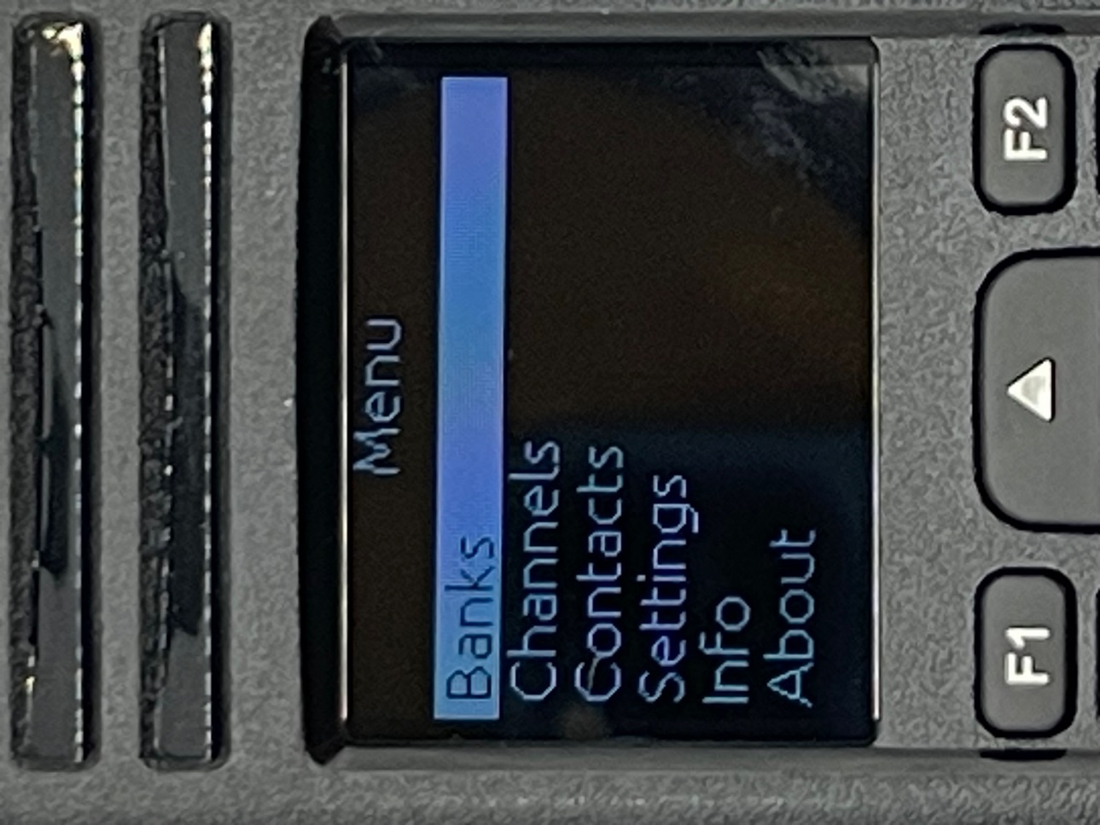

Pressing the OK button now get to the following screen:
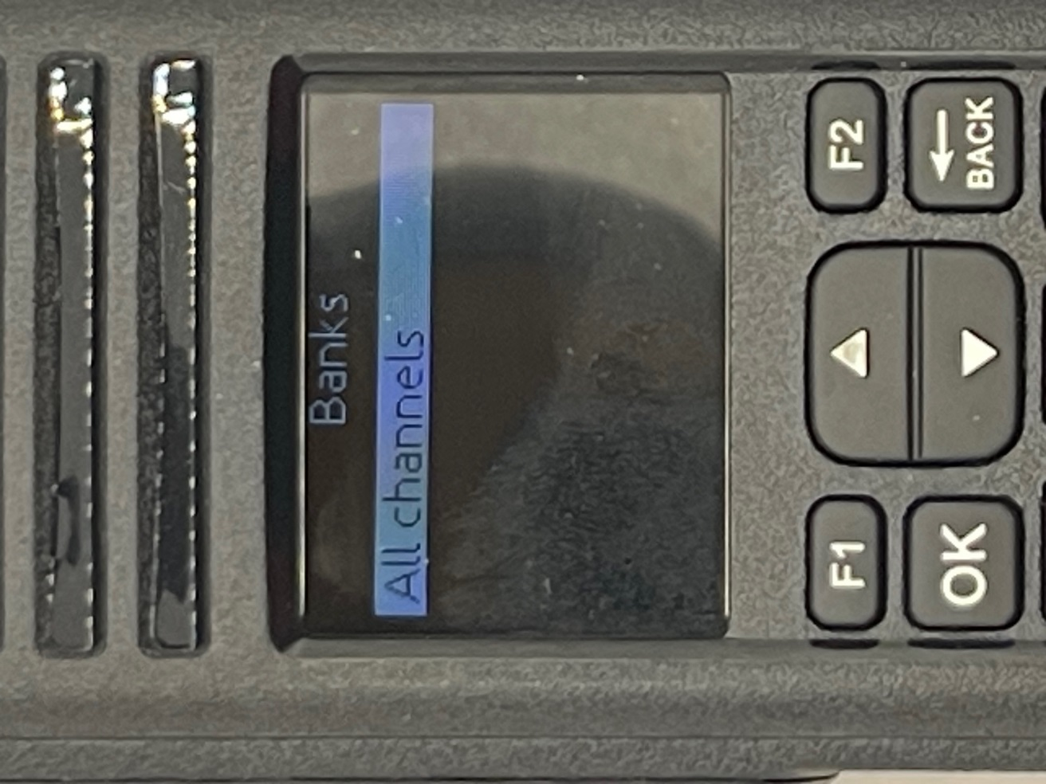
This feature is not supported at this time. This will be used once the CPS is available. Pressing the back key will get you back to where you came from.

Use the up and down arrow keys to select the feature you want. In this case we used the down arrow to get to the Channels.
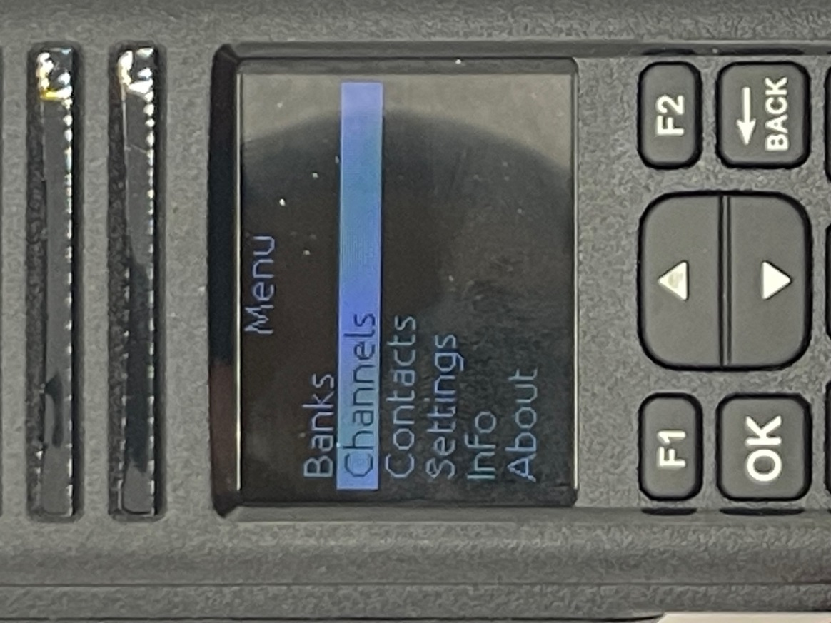

Pressing the OK button now get to the following screen:
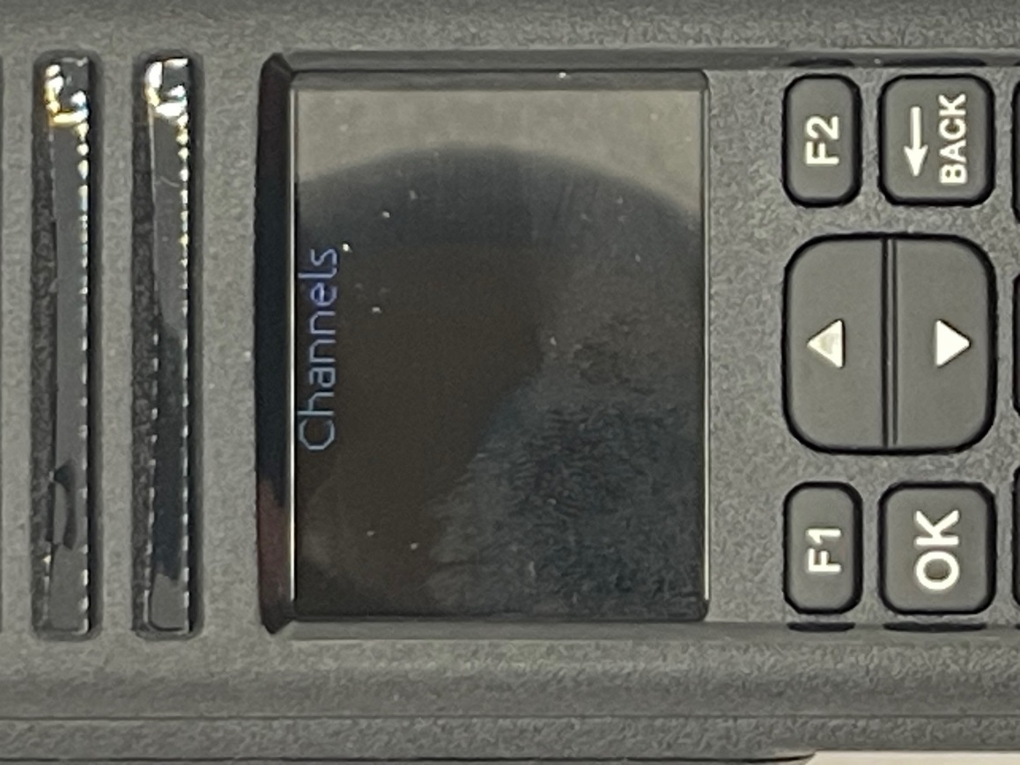
This feature is not supported at this time. This will be used once the CPS is available.. Pressing the back key will get you back to where you came from.

Use the up and down arrow keys to select the feature you want. In this case we used the down arrow to get to the Contacts.

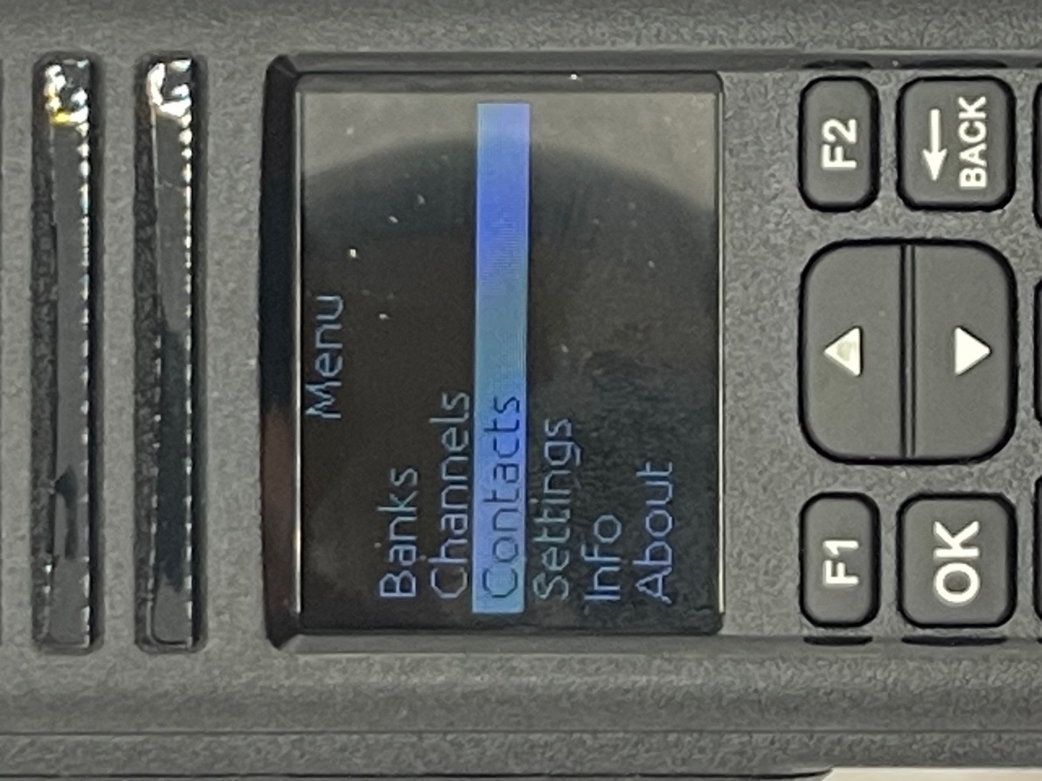

Pressing the OK button now get to the following screen:
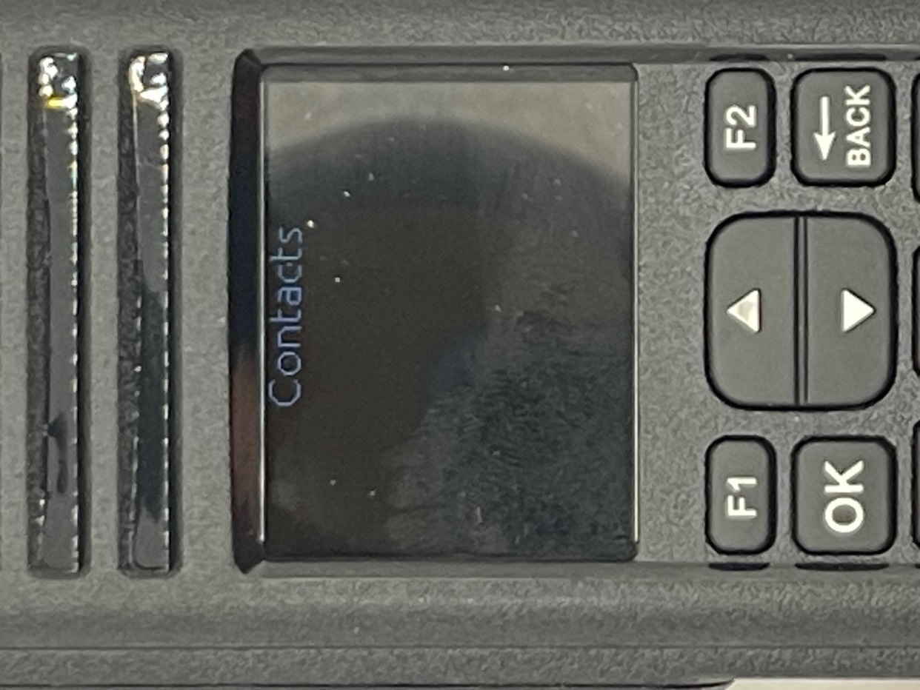
This feature is not supported at this time. This will be used once the CPS is available. Pressing the back key will get you back to where you came from.

Use the up and down arrow keys to select the feature you want. In this case we used the down arrow to get to the Contacts.
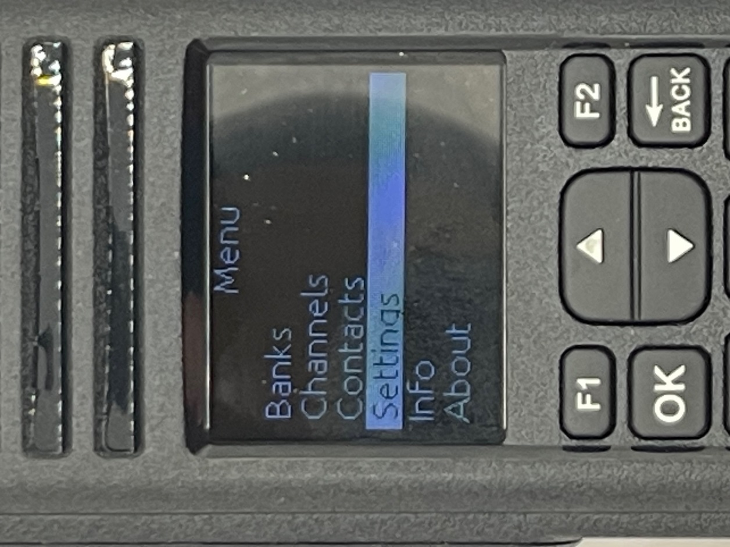

Pressing the OK button now get to the following screen:
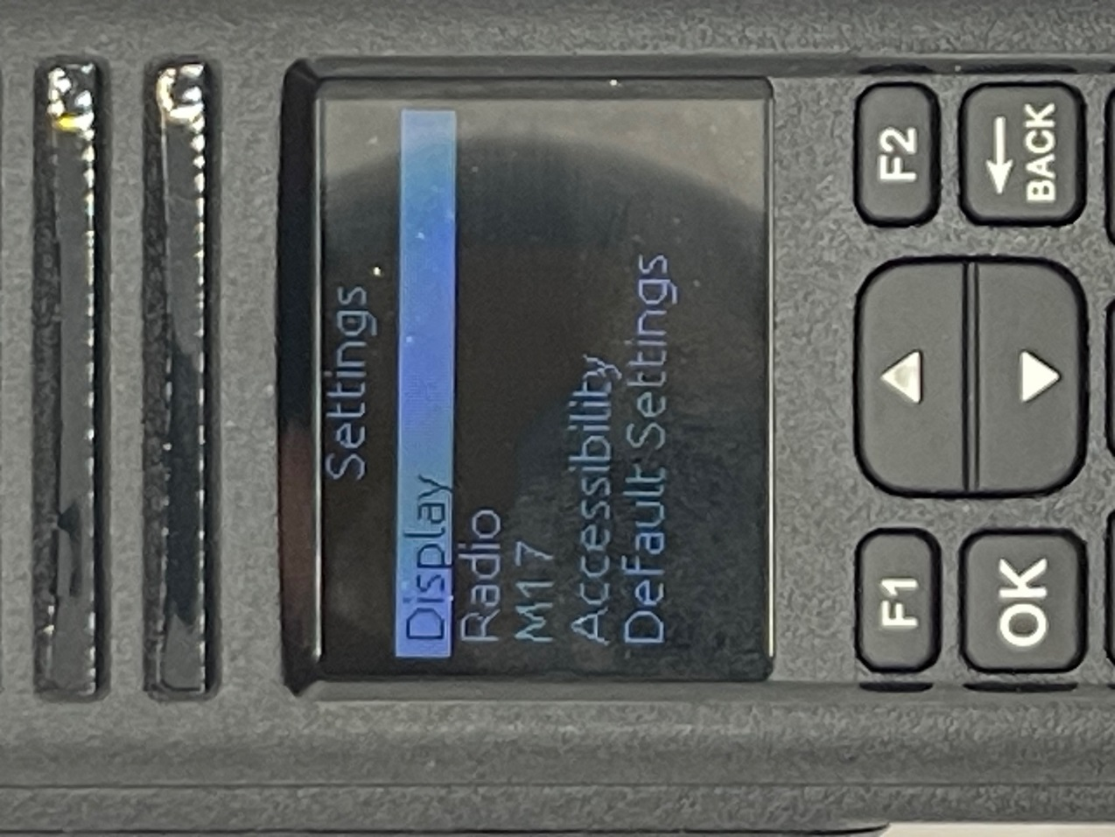
Use the up and down arrow keys to select the feature you want.

Pressing the OK button now get to the following screen:
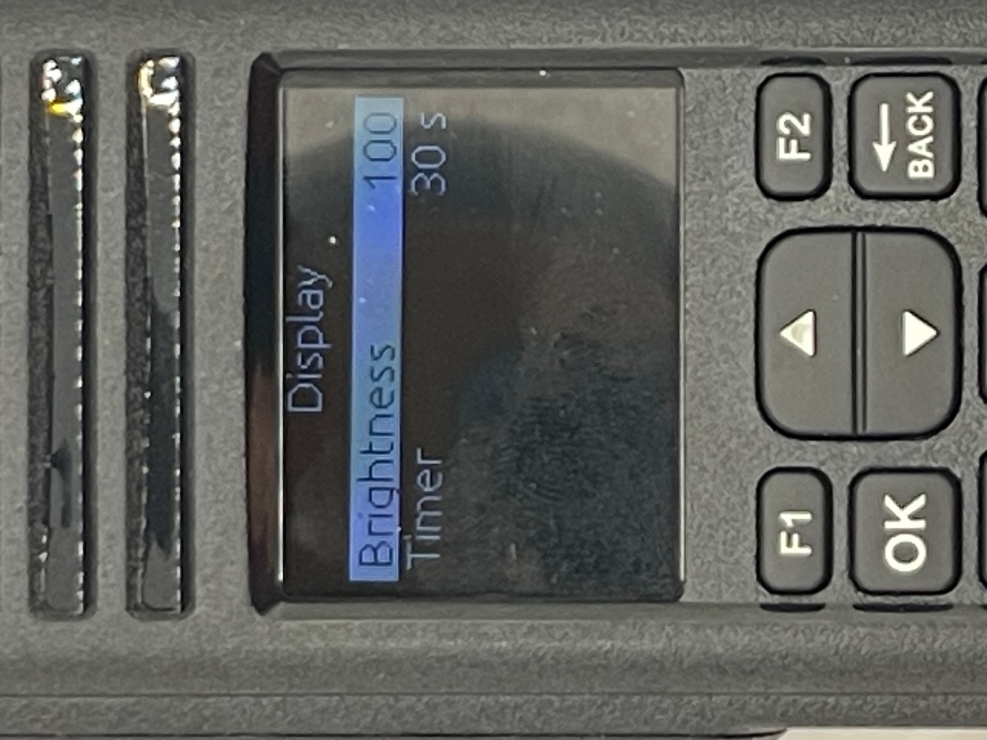
Use the up and down arrow keys to select the feature you want to modify.

If you want to modify the Brightness, Press the OK button again and you get the following screen.
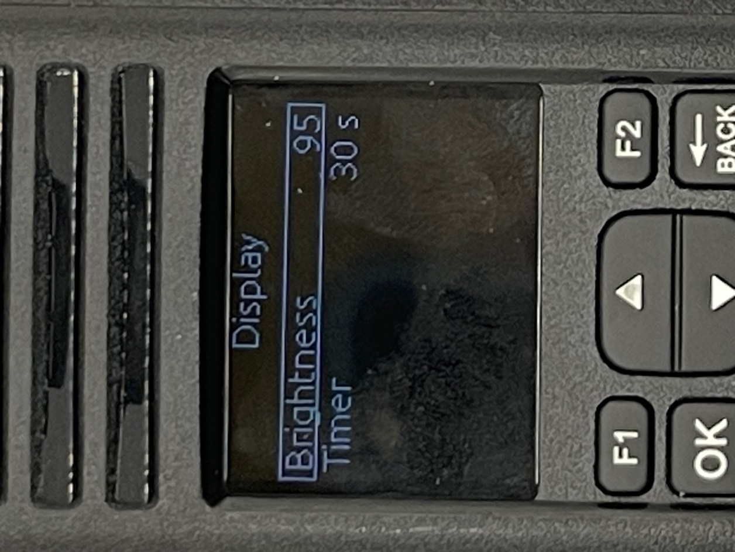
Use the up and down key to select the value you want. The values you can select is between 5 and 100 in increments of 5. The higher the number the brighter the display.

If you want to modify the Timer, highlight the timer as explained before and press the OK key and you will get the following screen:
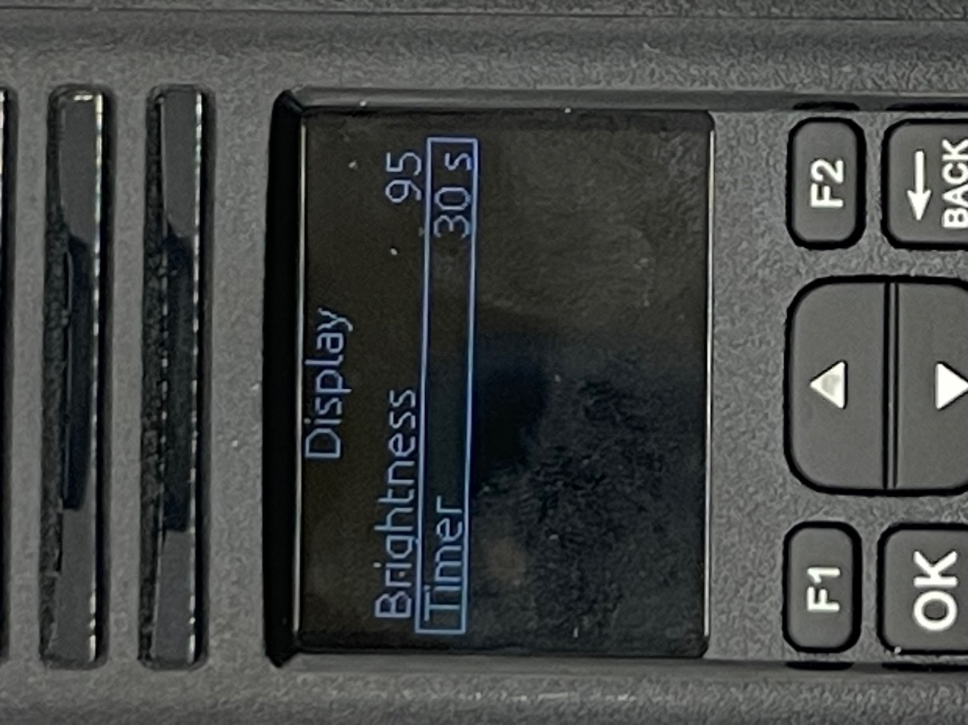

Use the up and down key to select the value you want. The possible values are shown below. Setting to off keeps the display always on.
Off 25 Sec 4 Min 1 Hour
5 Sec 30 Sec 5 Min
10 Sec 1 Min 15 Min
15 Sec 2 Min 30 Min
20 Sec 3 Min 45 Min
Using the Back key, you get to the following screen:
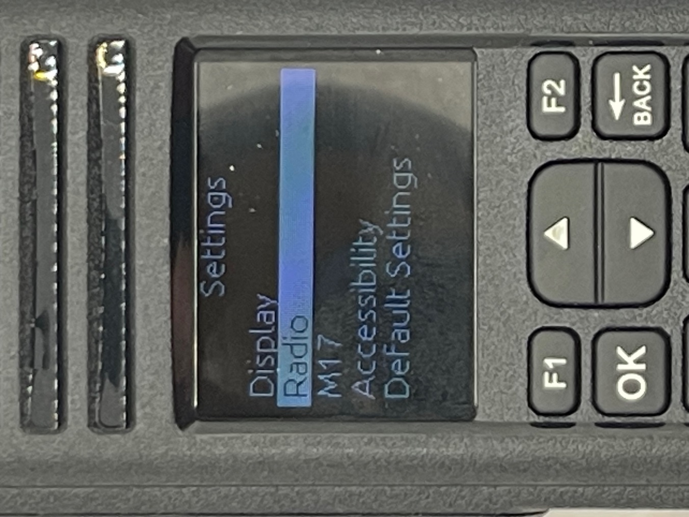
Use the up and down arrow keys to select the feature you want

Pressing the OK button with the Radio Highlighted gets to the following screen:
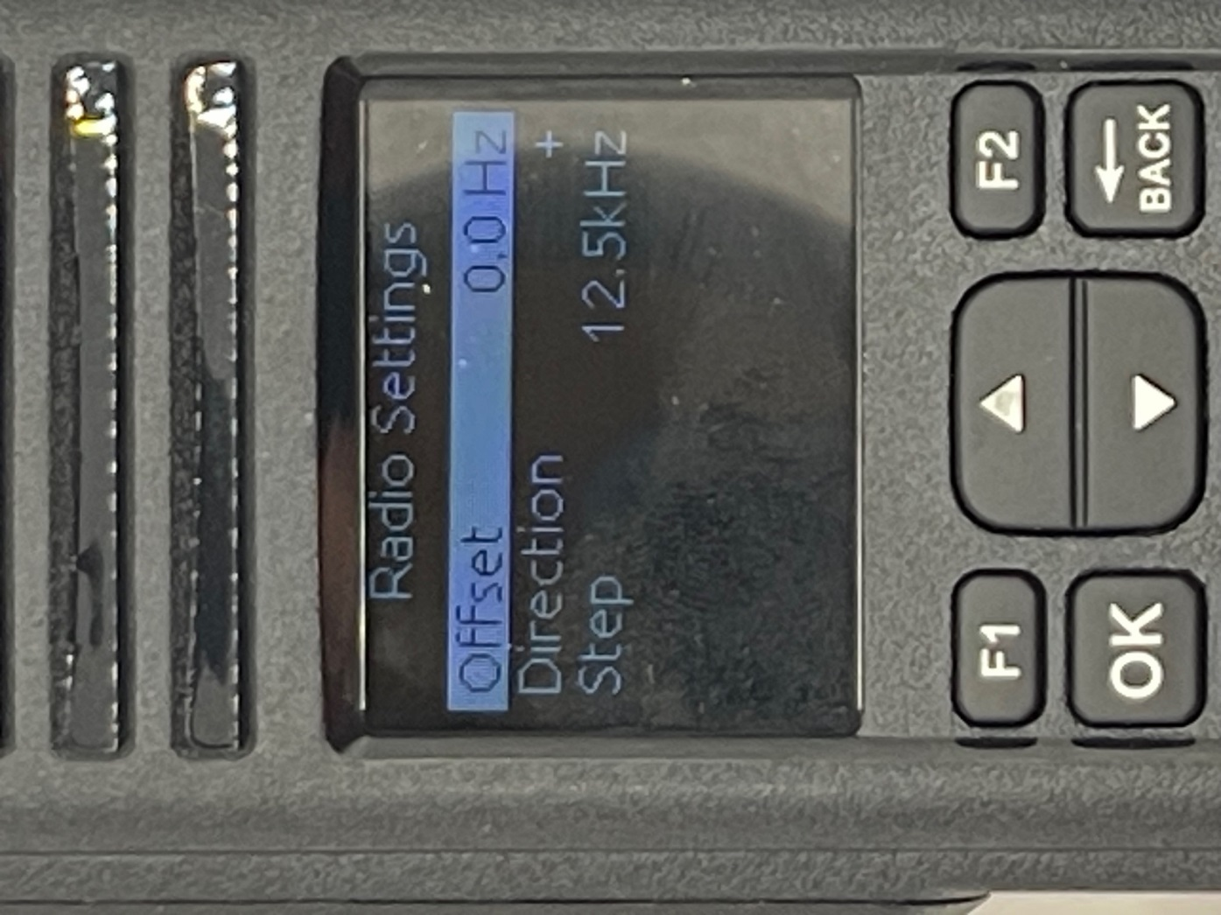
Use the up or down key to get to the feature you want to modify.

Pressing the OK button with the Offset highlighted gets the following screen:
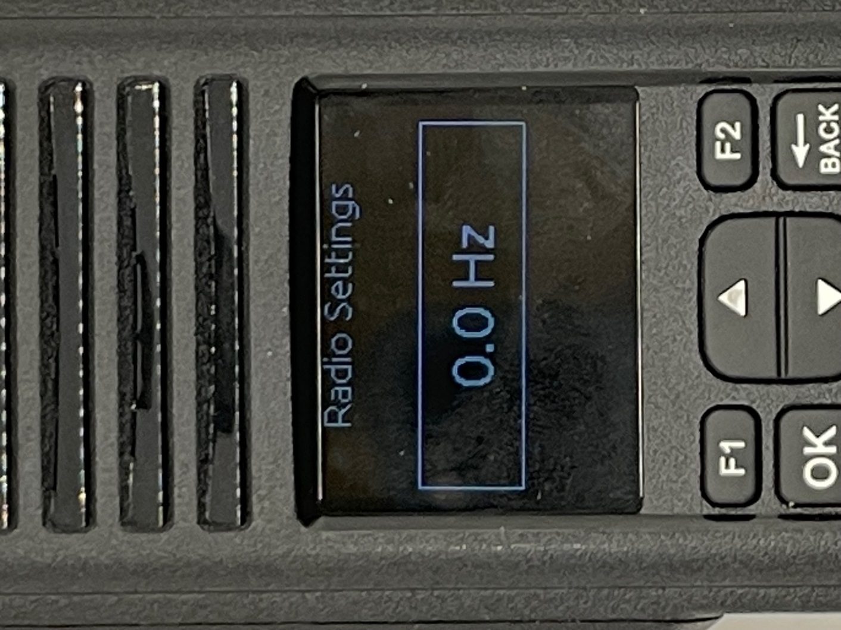
Use the numeric keys to enter your desired offset. Press the OK key to lock in your value. This feature is used to determine the frequency when you press the PTT. If the offset is zero, then the Rx and Tx frequency will be the same. If the offset is not zero, and the direction is “+” then the Tx frequency is going to be the Rx frequency plus the offset. If the offset is not zero, and the direction is “-” then the Tx frequency is going to be the Rx frequency minus the offset.
Pressing the OK button with the Direction highlighted gets the following screen:
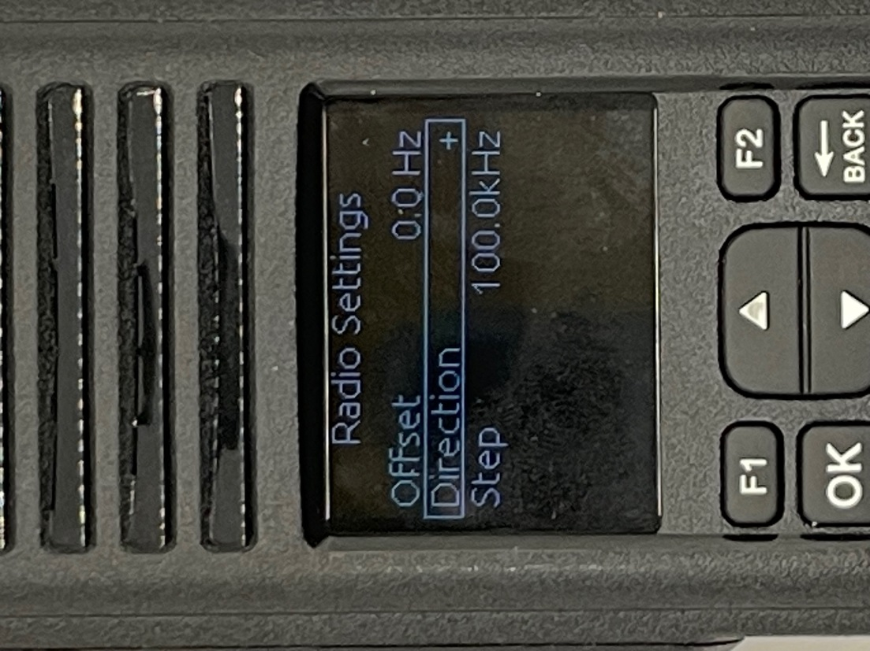
Use the up and down arrow to select either “+” or “-“. Use the OK key to lock in the value.

Pressing the OK button with the Step highlighted gets the following screen:
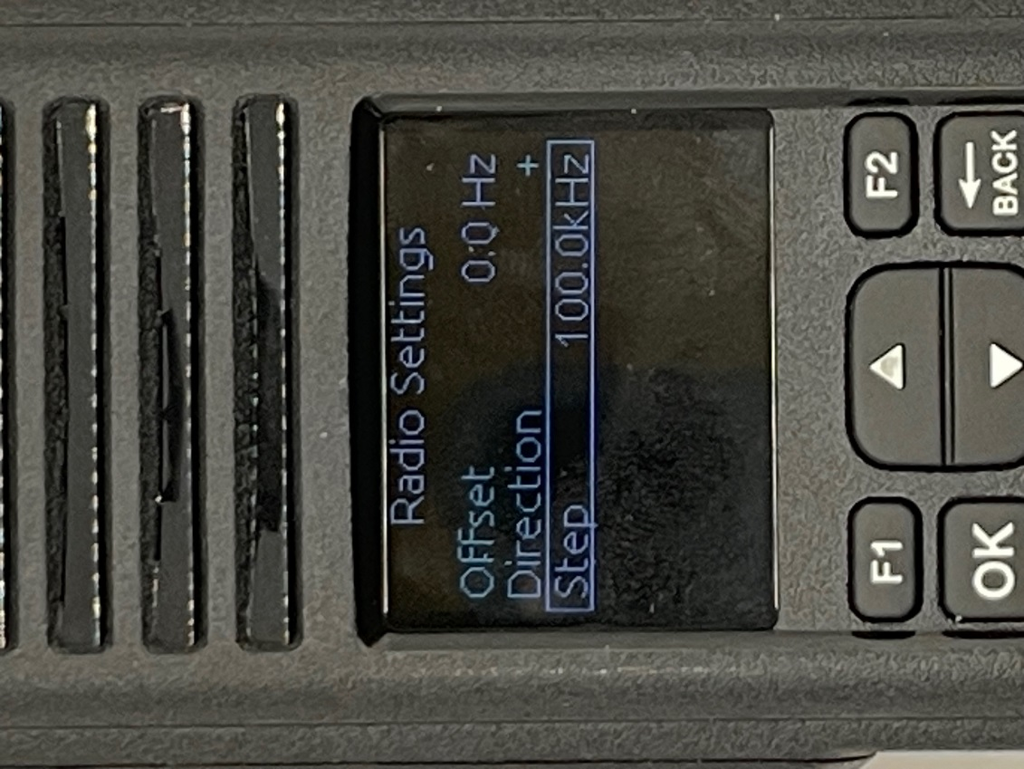
Use the up and down arrow keys to select the step value. Use the OK key to lock in the value. The possible values are:
1.0 kHz 15.0 kHz
5.0 kHz 20.0 kHz
6.25 kHz 25.0 kHz
10.0 kHz 50.0 kHz
12.5 kHz 100.0 kHz
When you use the up and down arrow for changing frequency, this number gives the amount to change with each press.

Using the Back key, you get to the following screen:
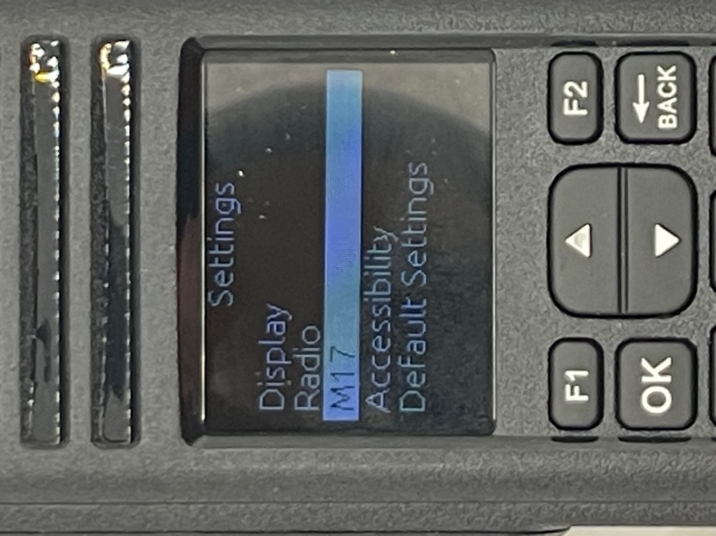

Pressing the OK button with the M17 highlighted gets the following screen:
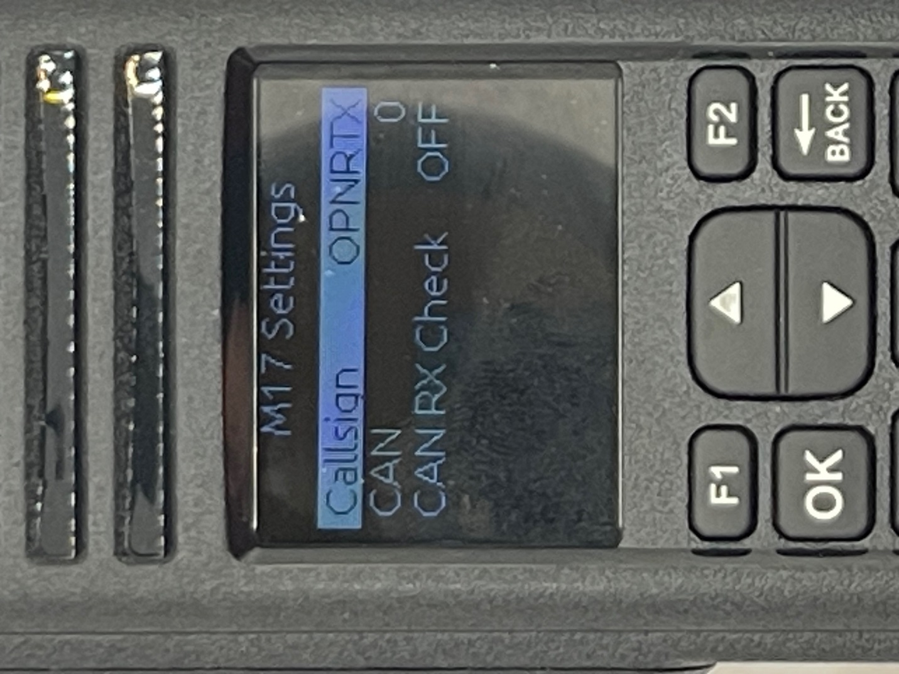
Us the up or down arrow to select the parameter you want to modify and then press the OK key to start the modification process.

Pressing the OK key with the Callsign highlighted gets the following Screen:
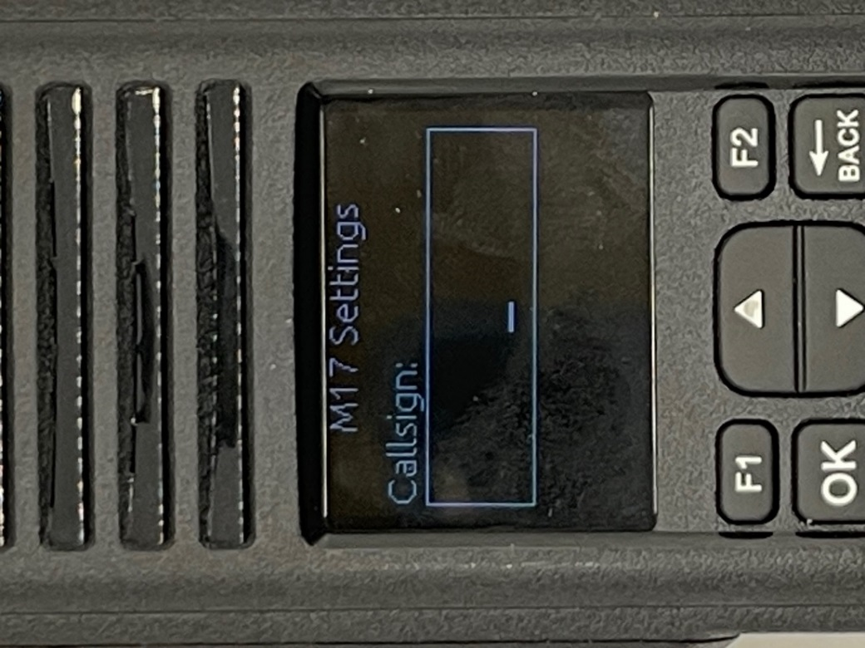
Use the numeric keys to enter your call sign.
Once you enter in characters and you made a mistake, you can use the up or down arrow keys to back up one character at a time. Once you enter in your entire call sign, press the OK key to lock it in. A complete summary of what characters can be displayed for each number is shown below.
1: 1 5: J,K,L,5 9: W,X,Y,Z,9
2: A,B,C,2 6: M,M,O,6 0: 0,Space
3: D,E,F,3 7: P,Q,R,S,7 *: -,/
4: G,H,I,4 8: T,U,V,8 All other keys ignored.
Pressing the OK key with the CAN highlighted gets the following Screen:
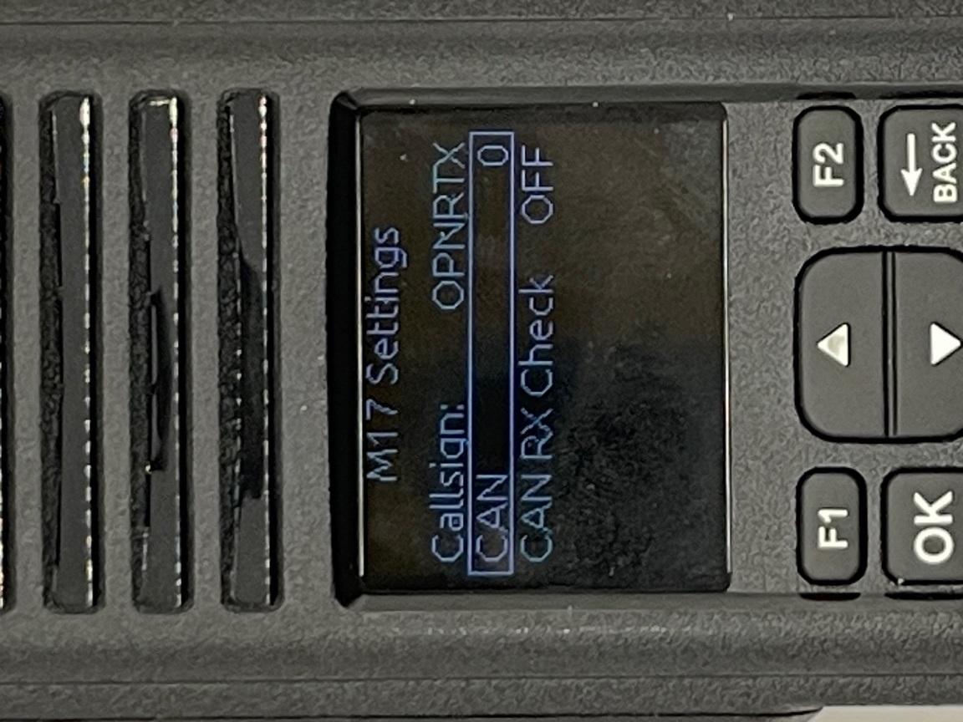
Use the up and down keys to select the value. The possible values are between 0 and 15. When finished, press the OK key to lock it in. The CAN is an abbreviation for Channel Access Number and is like a CTCSS number. If someone is transmitting to you and your CAN numbers do not match, then you will not hear them unless the CAN Rx Check is OFF.
Pressing the OK key with the CAN Rx Check highlighted gets the following Screen:
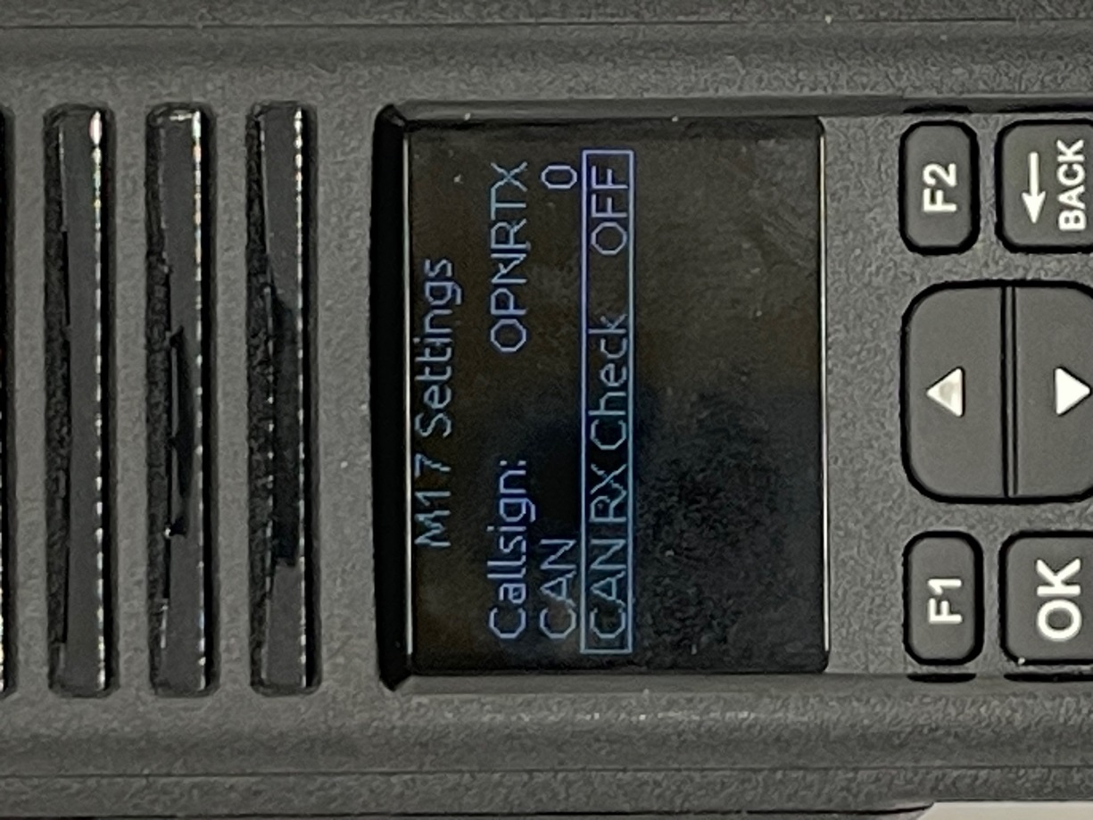
Use the up and down keys to select the value. The possible values are ON and OFF. When finished, press the OK key to lock it in. If set to OFF, then it acts like a promiscuous mode and will hear the other radio no matter what the CAN is set to.

Using the Back key, you get to the following screen:
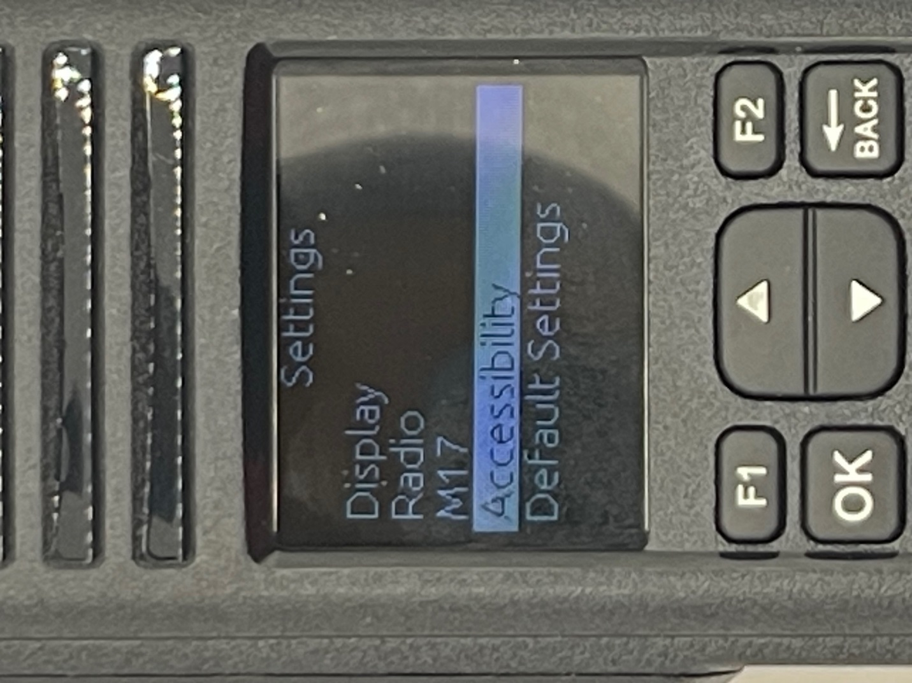
Use the up and down arrow keys to select the feature you want.

With the Accessibility highlighted, pressing the OK key get to the following screen:
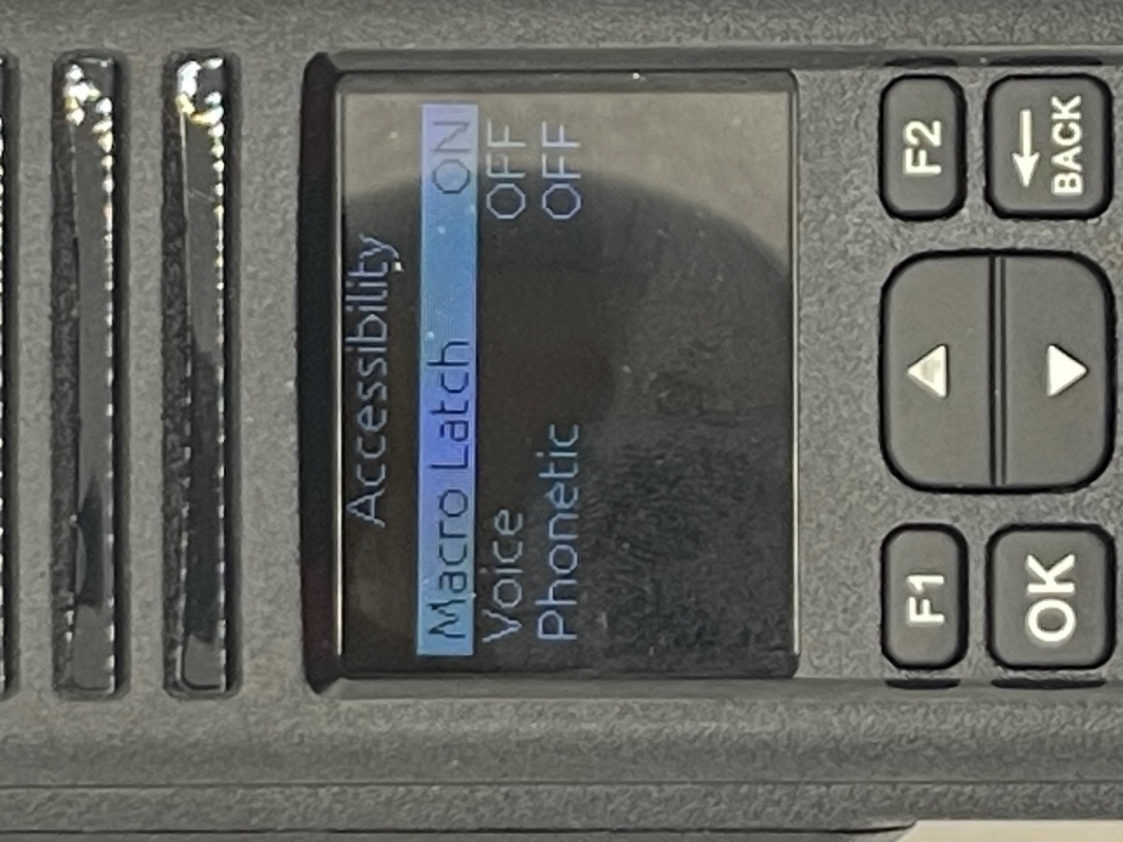
Us the up and down key to select the feature you want to modify.

Pressing the OK key with Macro Latch highlighted gets the following Screen:
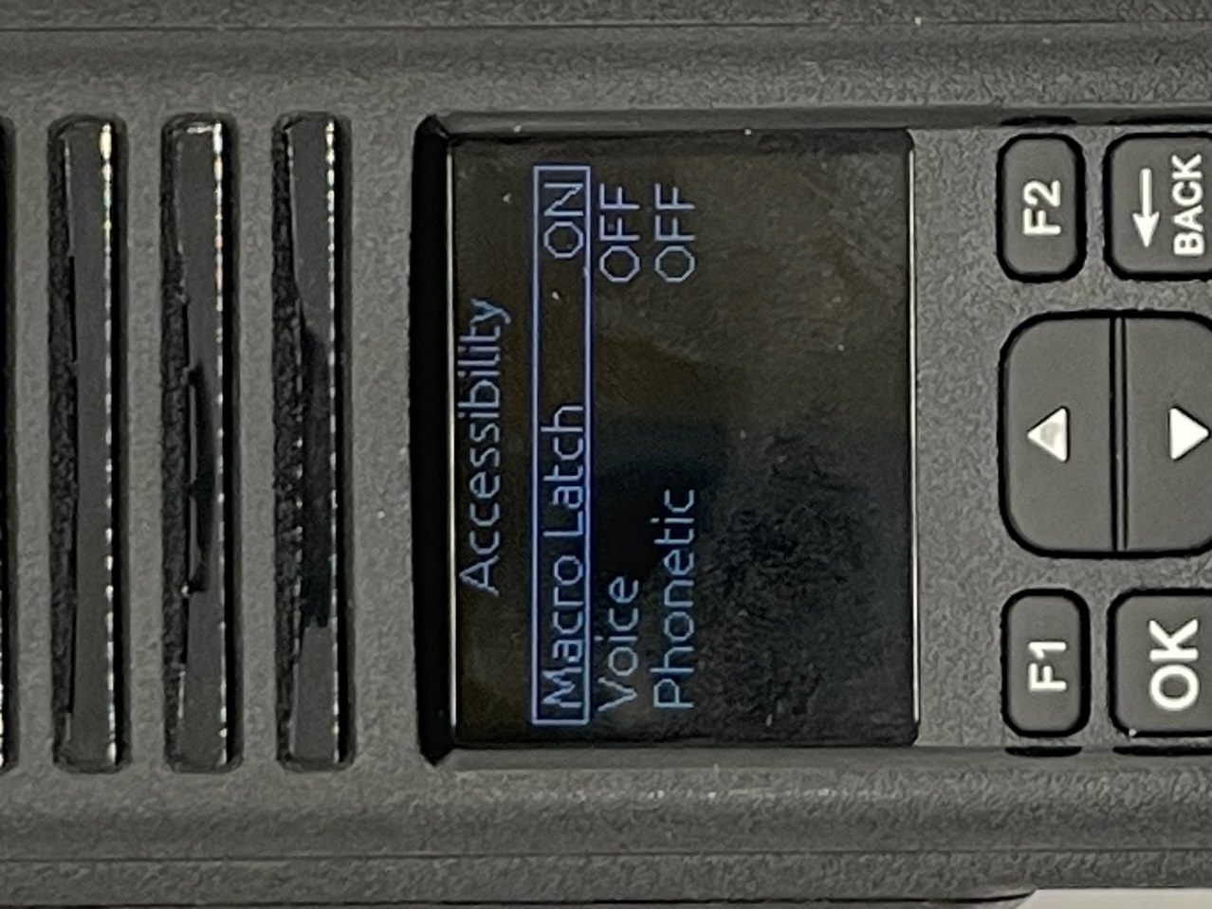
Use the up and down keys to select the value. The possible values are ON and OFF. When on, the macro menu latches after a 700ms press of the macro button (TK1). This allows the user to keep the macro menu active even when the side key is released, useful for the people having reduced mobility. When OFF, the user has to press the macro button at the same time as pressing the keys used in the macro menu.
When finished, press the OK key to lock it in.
Pressing the OK key with voice highlighted gets the following Screen:
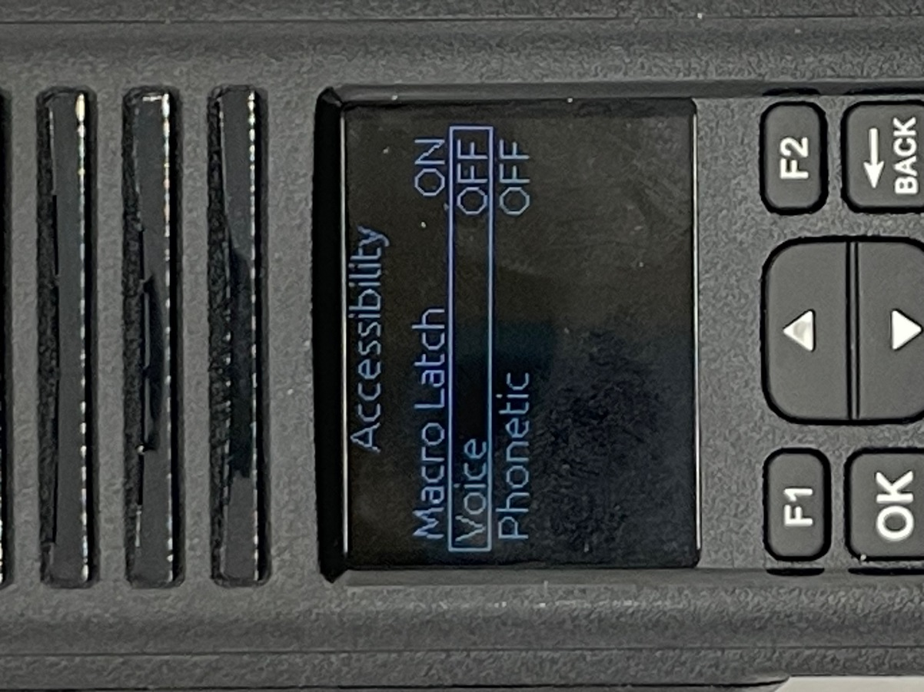
Use the up and down keys to select the value. The possible values are ON and OFF. This control the various levels of voice prompts for vision impaired operators. By default, voice prompts are off. The other steps are: keyboard beeps and then three different levels of spoken prompts with increasing verbosity.
When finished, press the OK key to lock it in.

Pressing the OK key with Phonetic highlighted gets the following Screen:
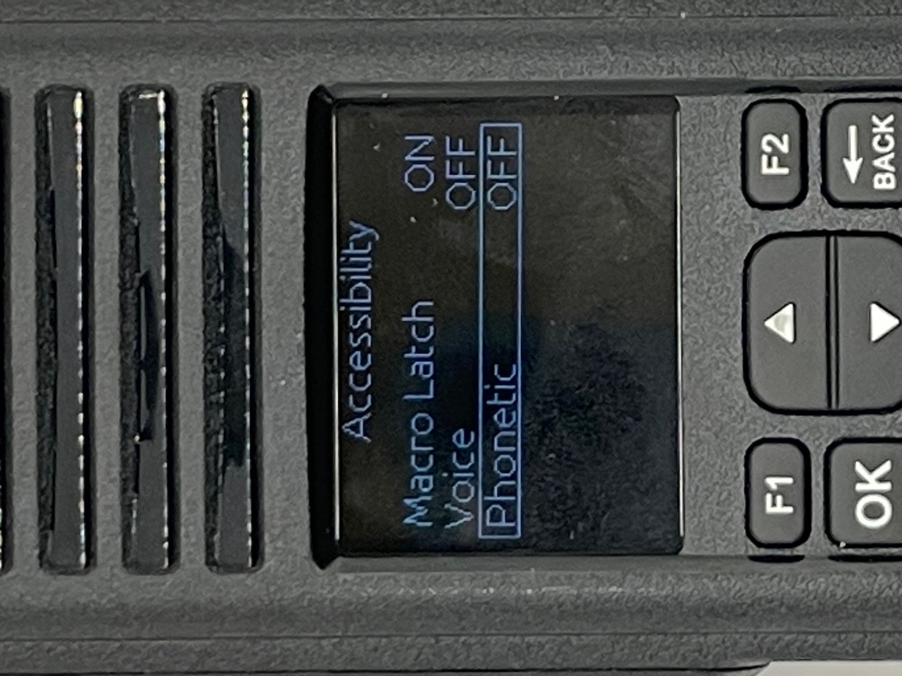
Use the up and down keys to select the value. The possible values are ON and OFF. This controls the spelling of the words which are not present in the voice prompts table. When active, the words are spoken using the ITU phonetic language, otherwise the spelling uses the standard language phonemes.
When finished, press the OK key to lock it in.

Using the Back key, you get to the following screen:
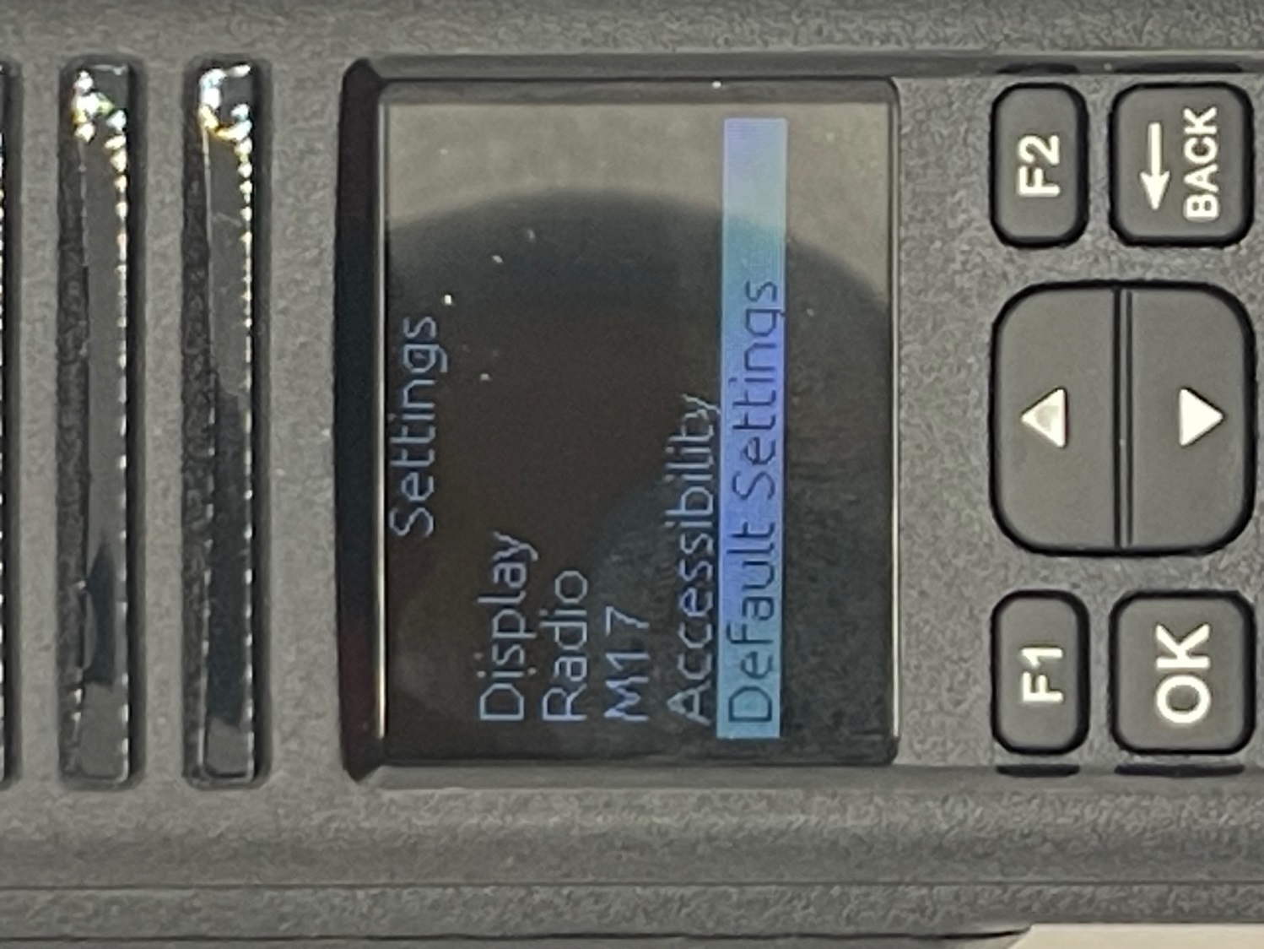
Use the up and down arrow keys to select the feature you want.

With the Default Settings highlighted, press the OK key to reset the parameters screen. Press OK twice to reset the parameters.
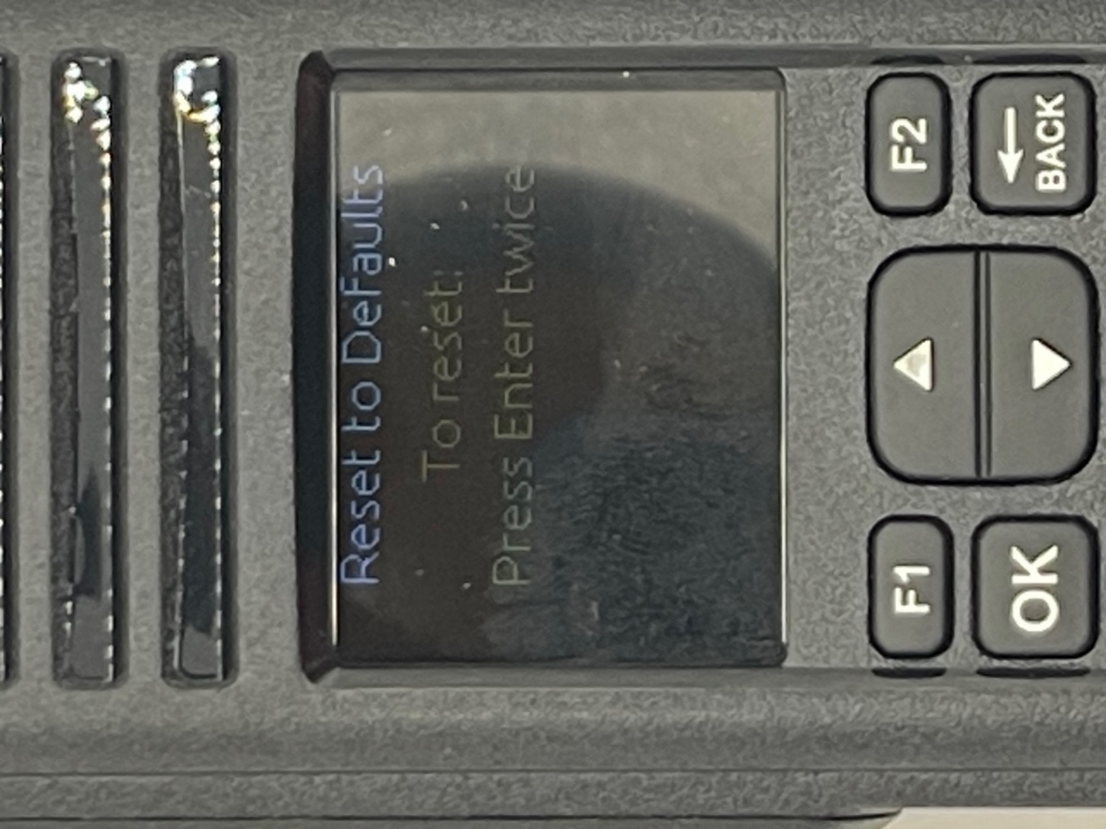

Press the back key to get to the screen below.
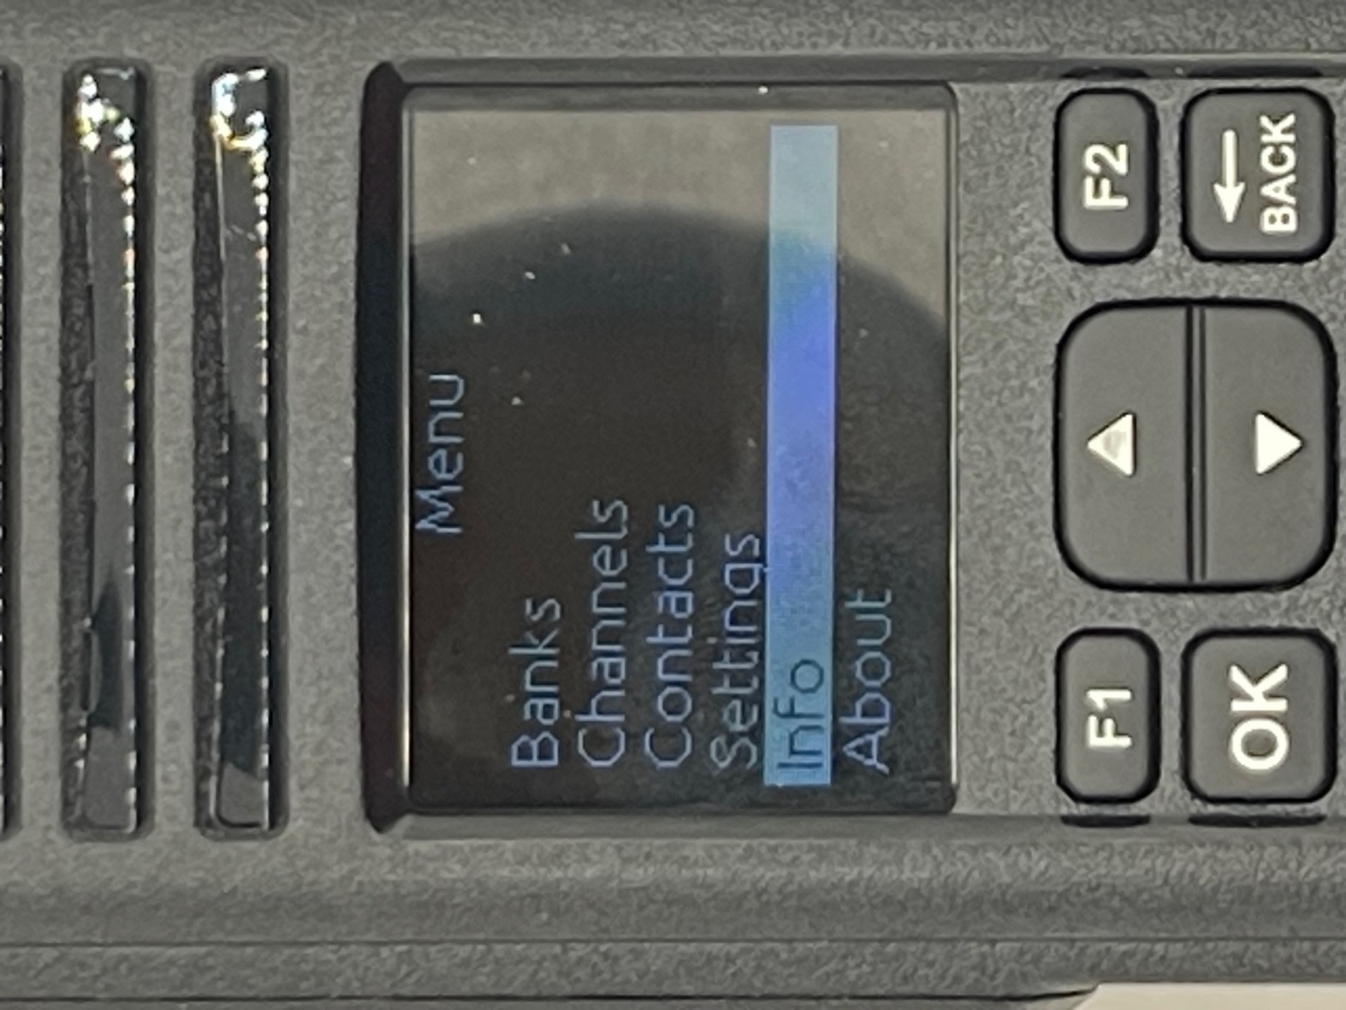
Use the up and down keys to select the feature you want. In a later firmware version, GPS was added. Then either the top of botton entry is not shown dependent on the scroll position.

With Info highlighted, press the OK key to see the various parameters available.
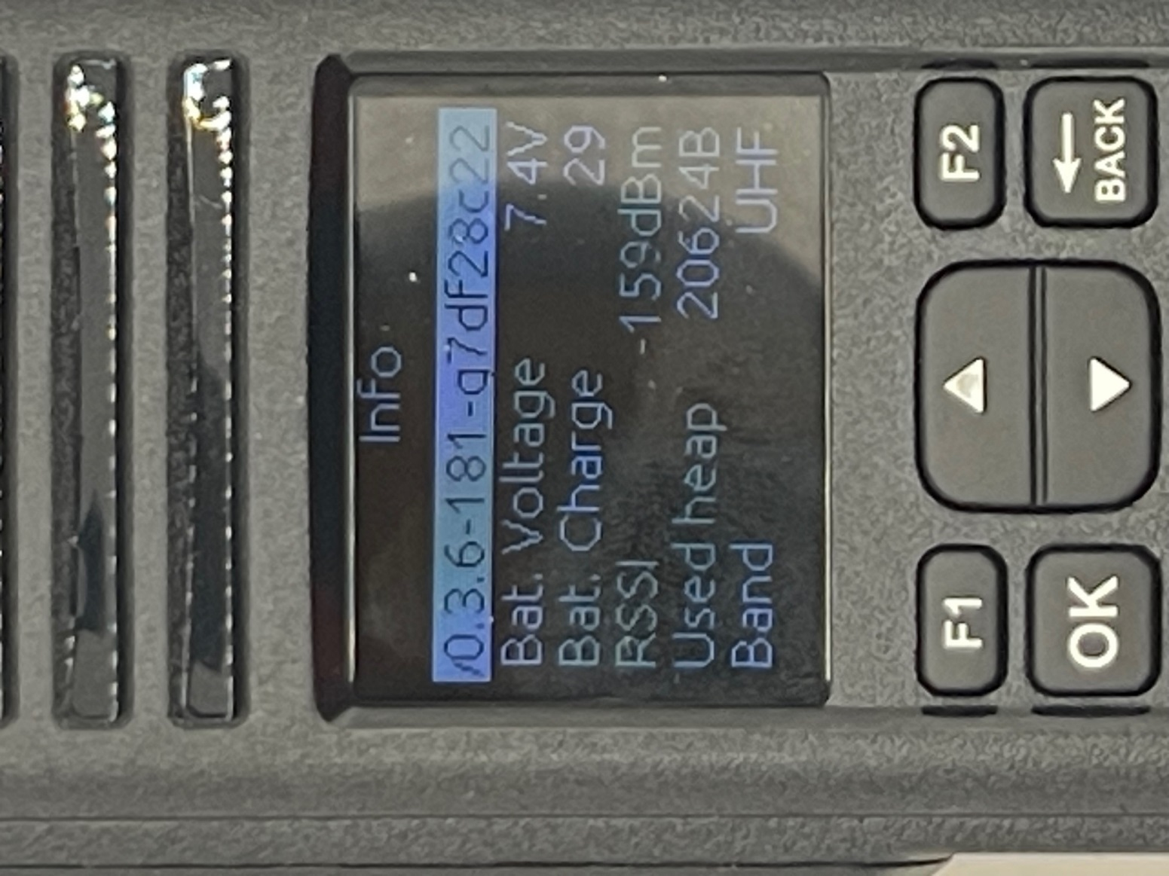
You cannot change any of the parameters from this screen.
The 0.3.6 represents the firmware version of the radio. It will change with each released version.

Press the back key to get to the screen below.
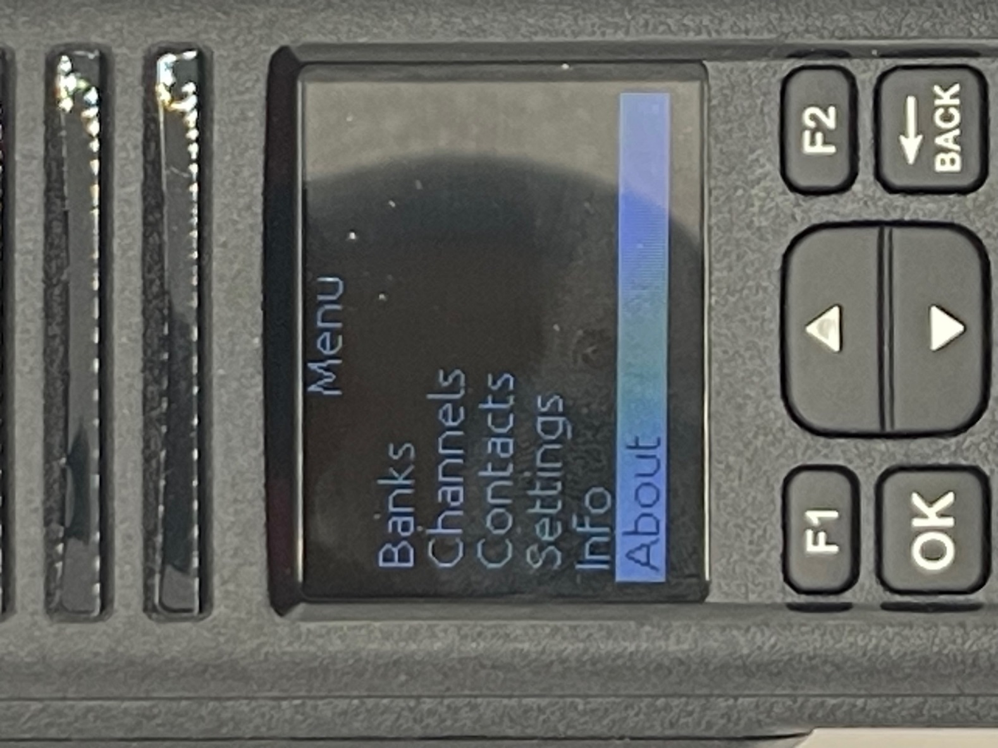
Use the up and down keys to select the feature you want.

With About highlighted, press the OK key to see the primary developers of the OPNRTX project.
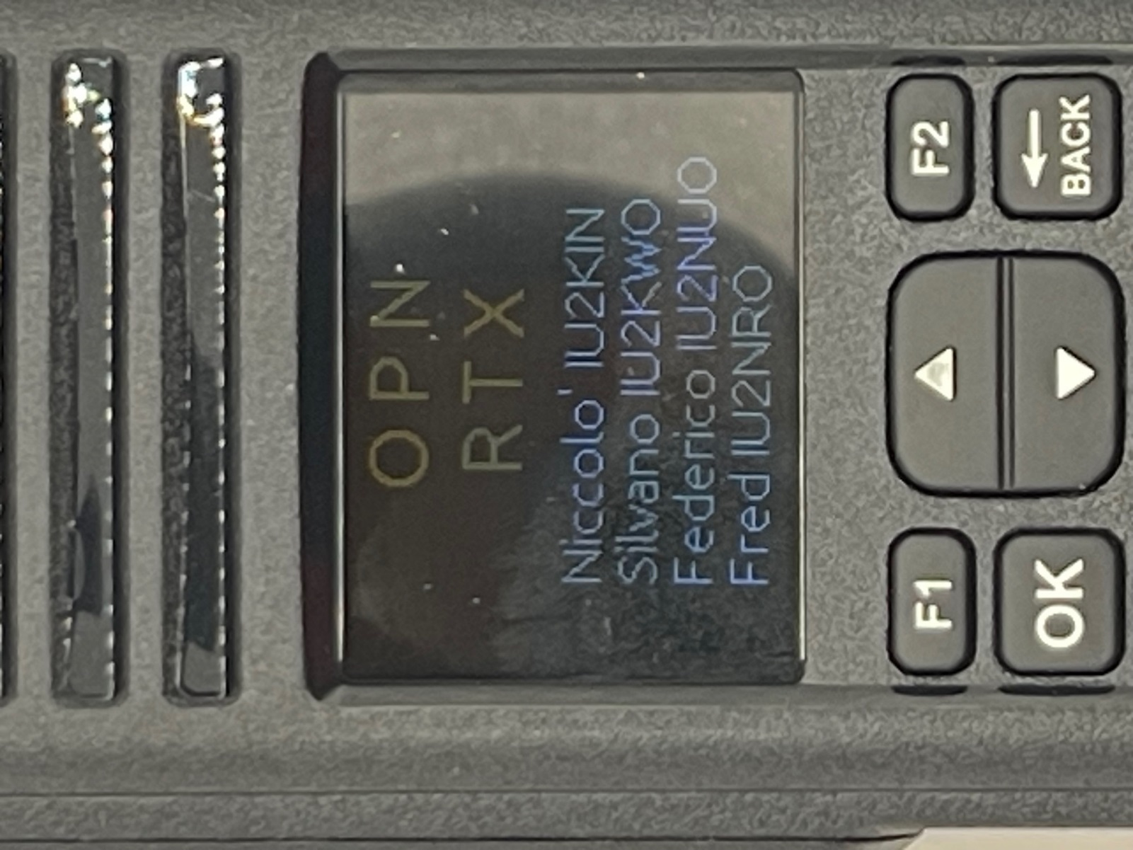
Use the back key to go back to the menu selection.

Changes
Version Changes
1.0 | Initial Release
1.1 | Added summary in front and short cuts and hints for some of the parameters. Added change log in back.
1.2 | First complete release.
1.3 | Added startup for the CS7000 M17 PLUS. Added definition of the green bar in M17 transmit mode.  Added information about the info screen. Added GPS parameters in summary. Valid only in Firmware version 0.3.7 and later.
1.4 | Added how to adjust the Analog Squelch in the Macro Menu.

