How to Upgrade CS100/CS101 Two Way Radio

- Run CFU_V1.01a.exe to install the upgrading tools.
- Then run the upgrading software, such as duouble clicking the shortcut icon.
- Choose Radio Type as CU600, set the right serial port and baud rate
- Open the *.bin file, and connect the programming cable to the wanted radio
- Power on the radio, and then click ”E.P” (Erase, Program).
! Pay attention to keeping the cable connected stably and the radio is power on all the upgrading period.
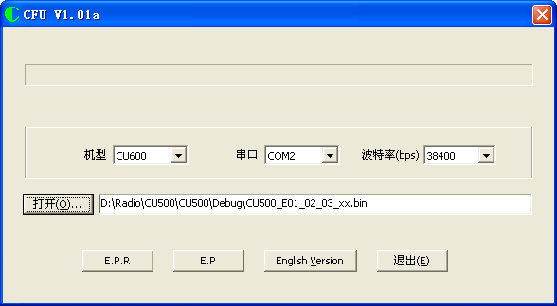

NOTE： CU500 firmware version
- After reading the radio,If the firmware version starts with ‘E’, you should choose CU500_Exxx.bin; if starts with ‘S’,you should choose CU500_Sxxx.bin
- After reading the radio, If the firmware is (E/S)1.1.xx or less, you should choose the bin file with xx, or none.

