1. Open the STM32CubeProgrammer tool, as shown in the following figure：

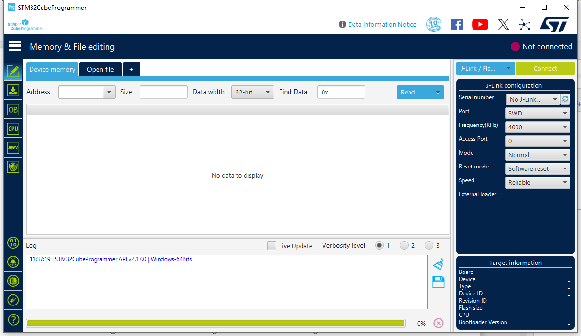

1. Connect the walkie talkie to the computer via USB. Press and hold the SK1 key to turn on the walkie talkie when it is turned off, and the screen will appear gray after turning it on.

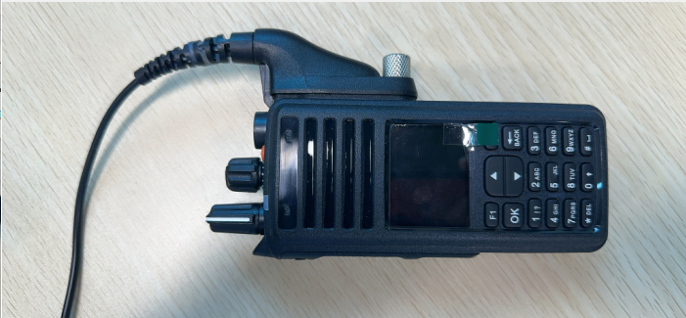

1. Set the Pulldown menu shown below to USB

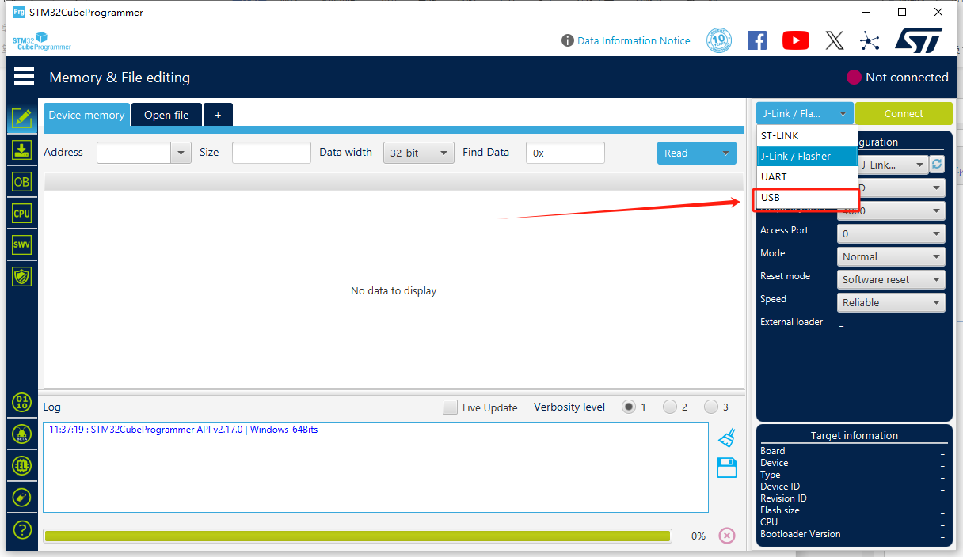

1. Click on the Box circled in red and it should look like the next screen

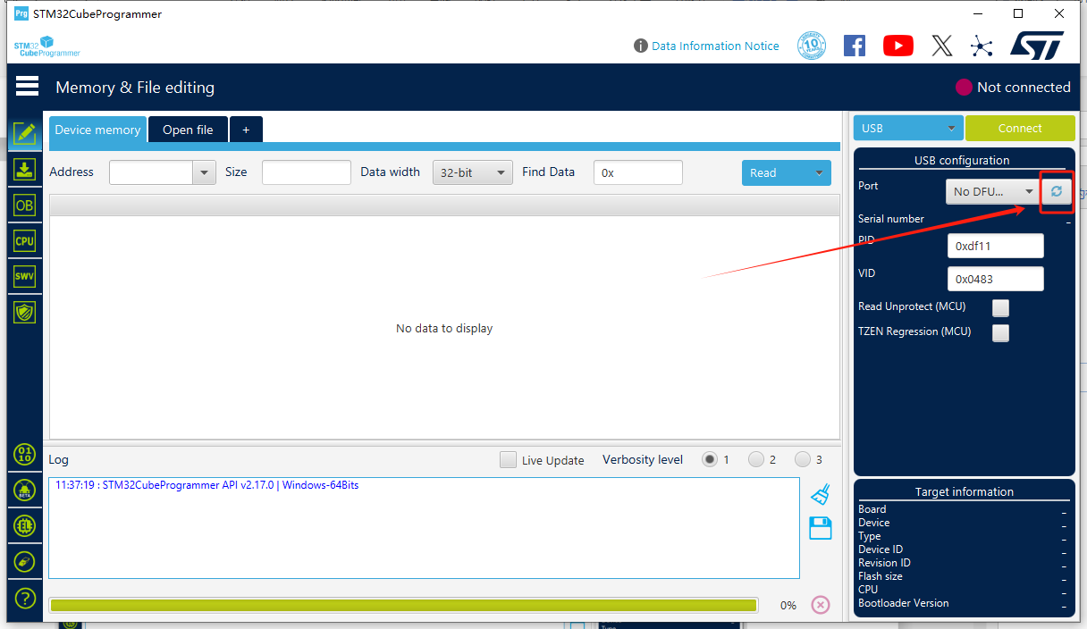

Notice the box turned from “No DFU” to “USB1”  
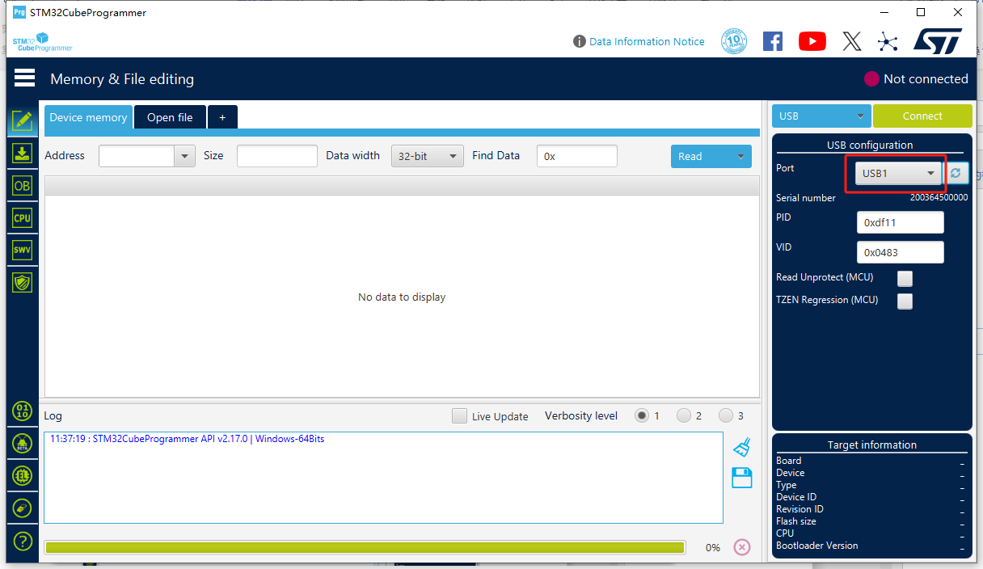

1. Check “Read Unprotect（MCU)” as shown below  
   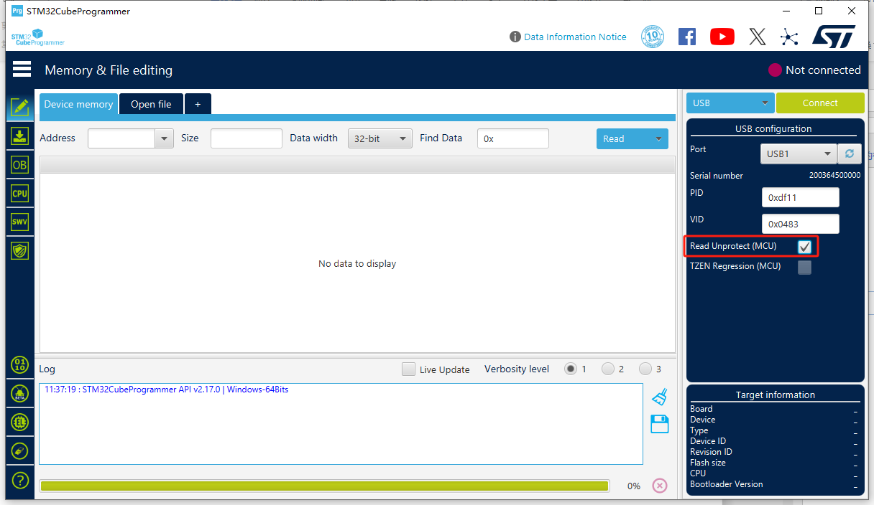
2. Click on the Blue “Read” button. Nothing will happen for about 60 seconds. No action is required, just wait.  
   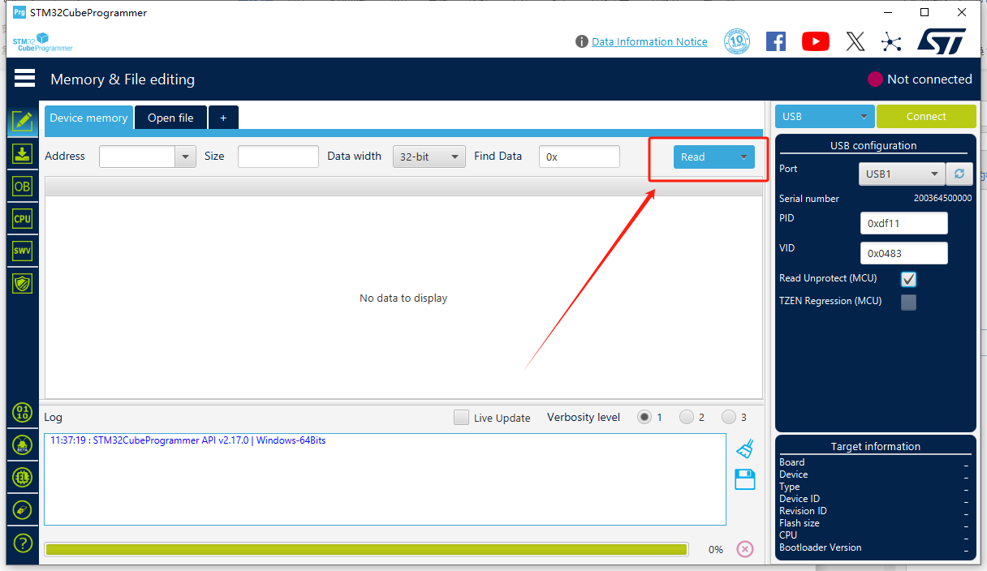
3. Wait for the pop-up window on the page “Please Power off Power on your device.”, which indicates successful erasure. 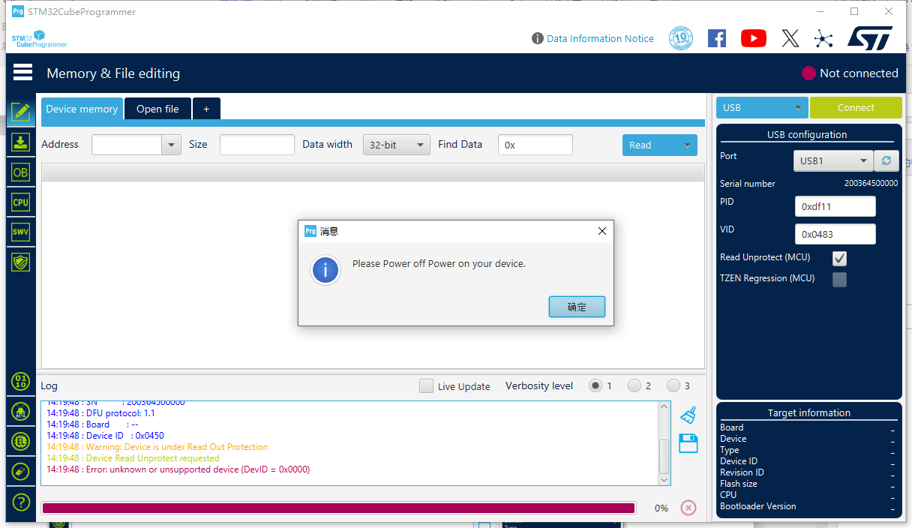

You are now finished clearing the radio so you can now install new programs.