**Summary of Loading the DMR Bootloader**

1. Transfer the M17PLUS_Bootloader_B6.06_20241029.boot to the radio using the Factory Tool_COMMON program.

Below is a picture of the radio buttons.

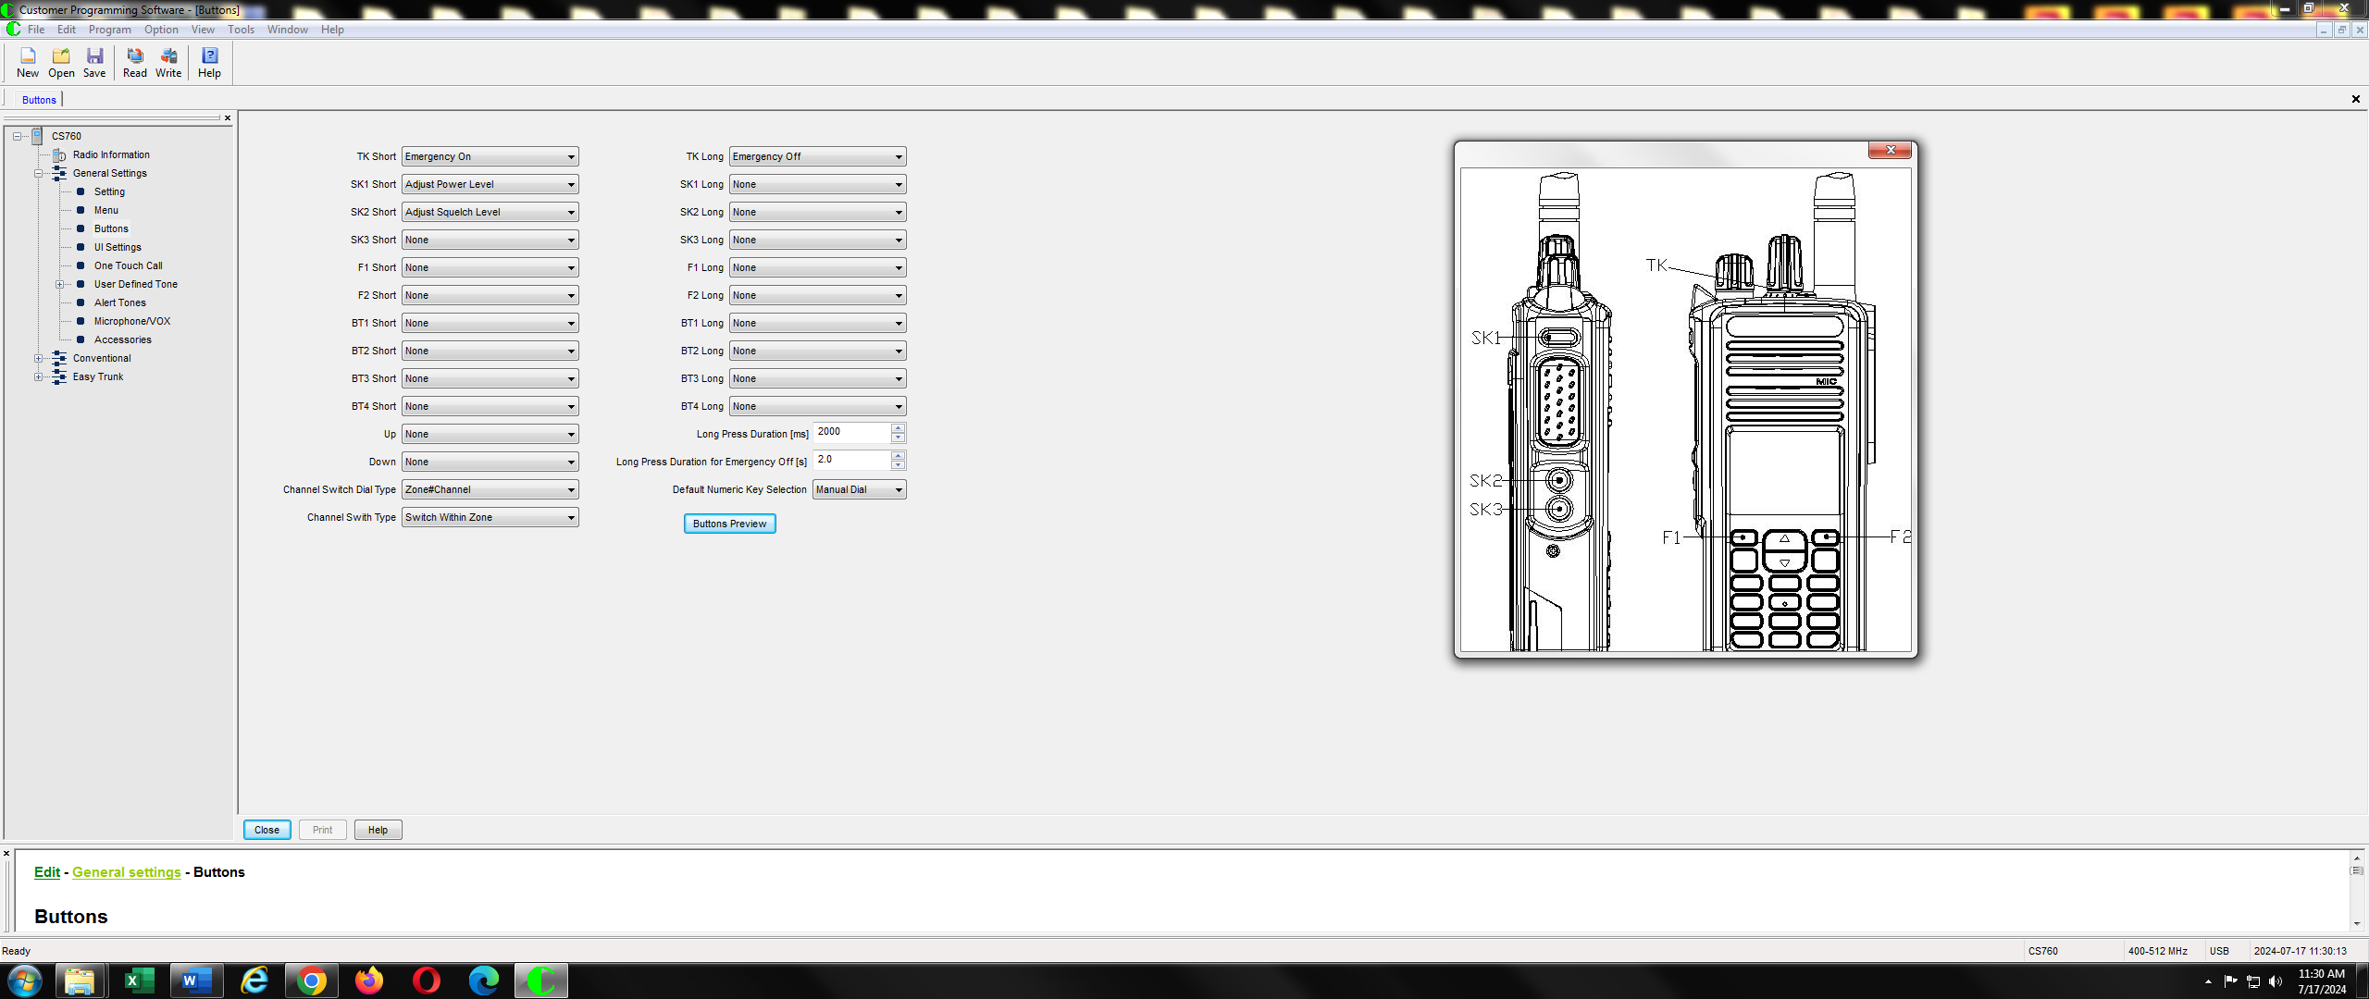

**Loading the DMR Bootloader**

You need the following programs and hardware:

CS7000 M17 radio

Programming cable

Factory Tool_COMMON_V5.09.01_setup.exe program

M17PLUS_Bootloader_B6.06_20241029.boot

Note: The above bootloader was for the initial build of the project. You might need to install a later version. The technique is identical except for the name of the bootloader.

1. If you have not already done it, install the Factory Tool_COMMON program on your PC. If done properly you should have the following shortcut on your PC.

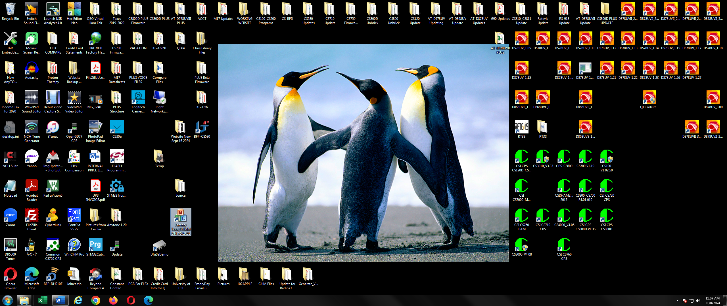

1. Press the PTT and Orange TK button at the same time and turn on the power. You should get the screen as shown below and the LED should blink Orange, Red, Green.

1. Start the Factory Tool_COMMON program and you should get the following:

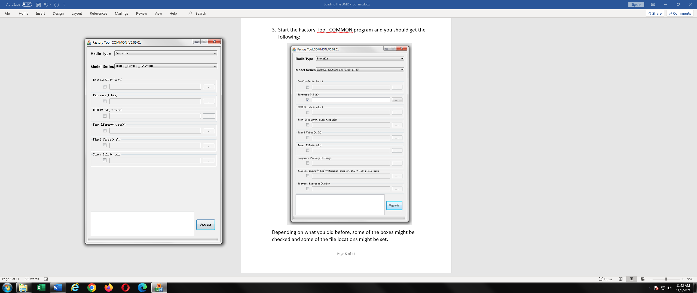

Depending on what you did before, some of the boxes might be checked and some of the file locations might be set.

1. Set the Radio Type to Portable,

Model Series to DR7800S_HRC6000_SKY72310_H7

Bootloader checkbox to checked

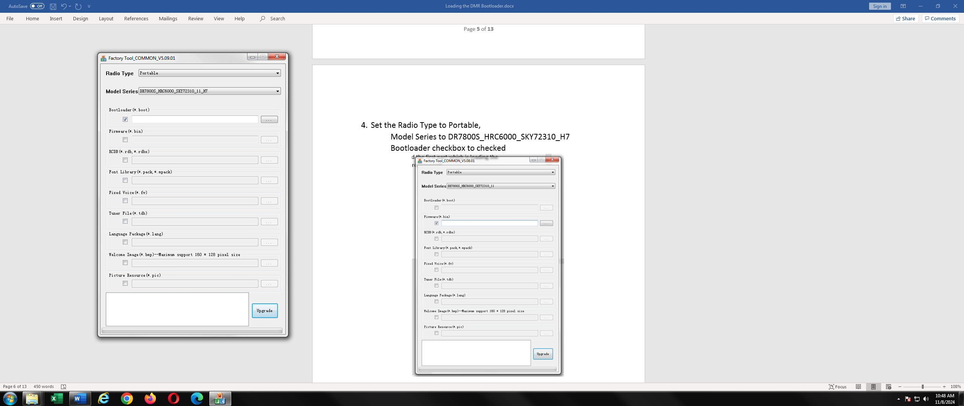

1. Press the file locator button the right of Bootloader(*.boot) and you get the following:

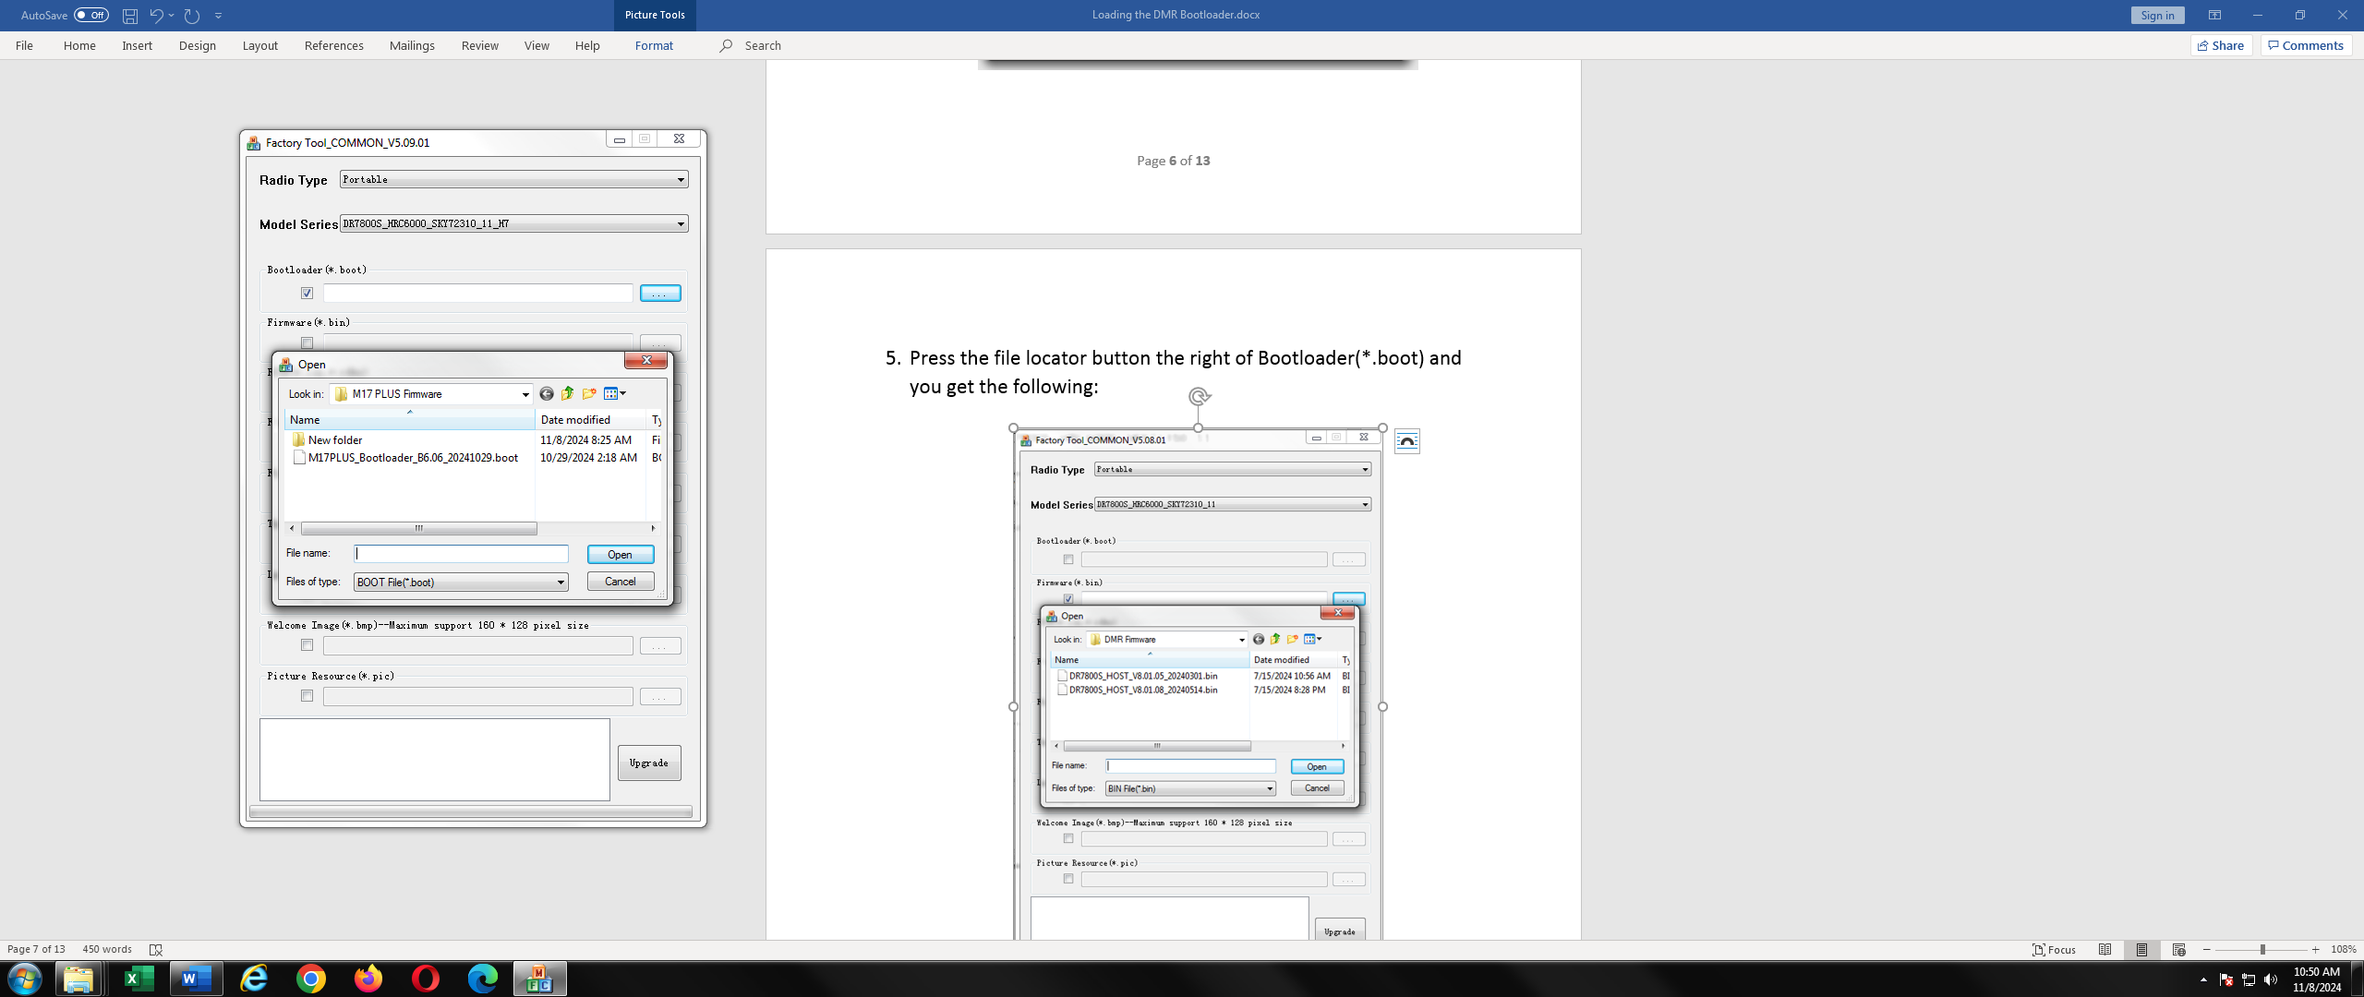

1. Highlight the latest firmware version and press the Open button and you get the following:

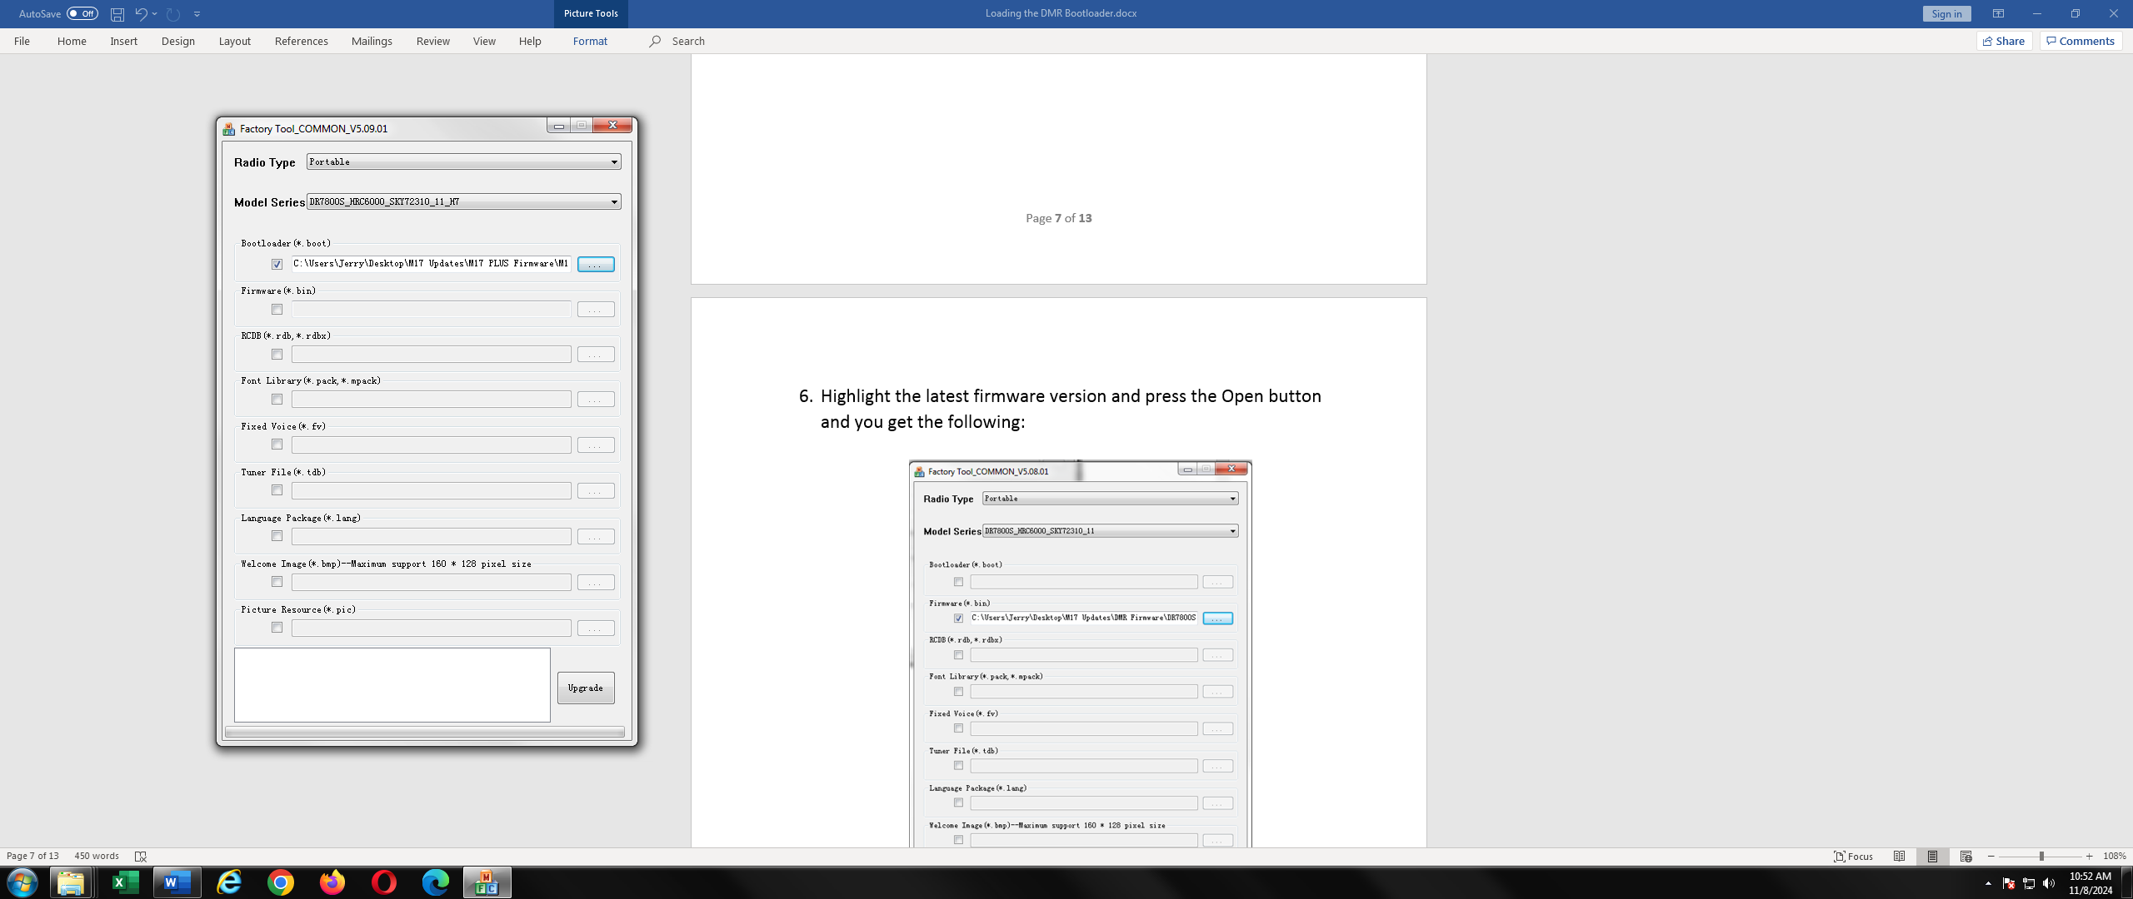

Notice the file location is now in the box adjacent to the Bootloader (*boot)

1. Press the Upgrade button and in a few seconds, you get the following screen.

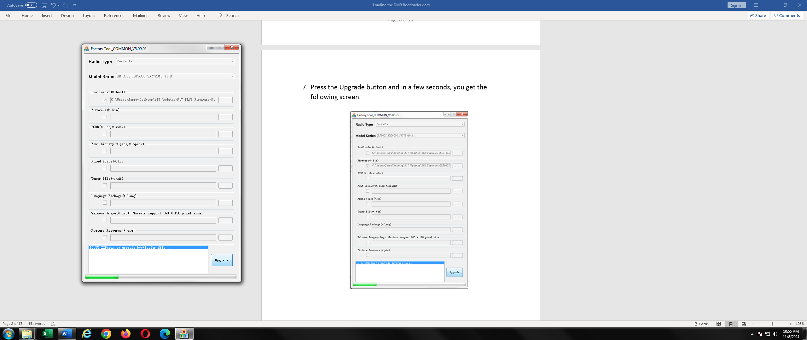

1. In a few more seconds it will be finished, and you get the following screen.

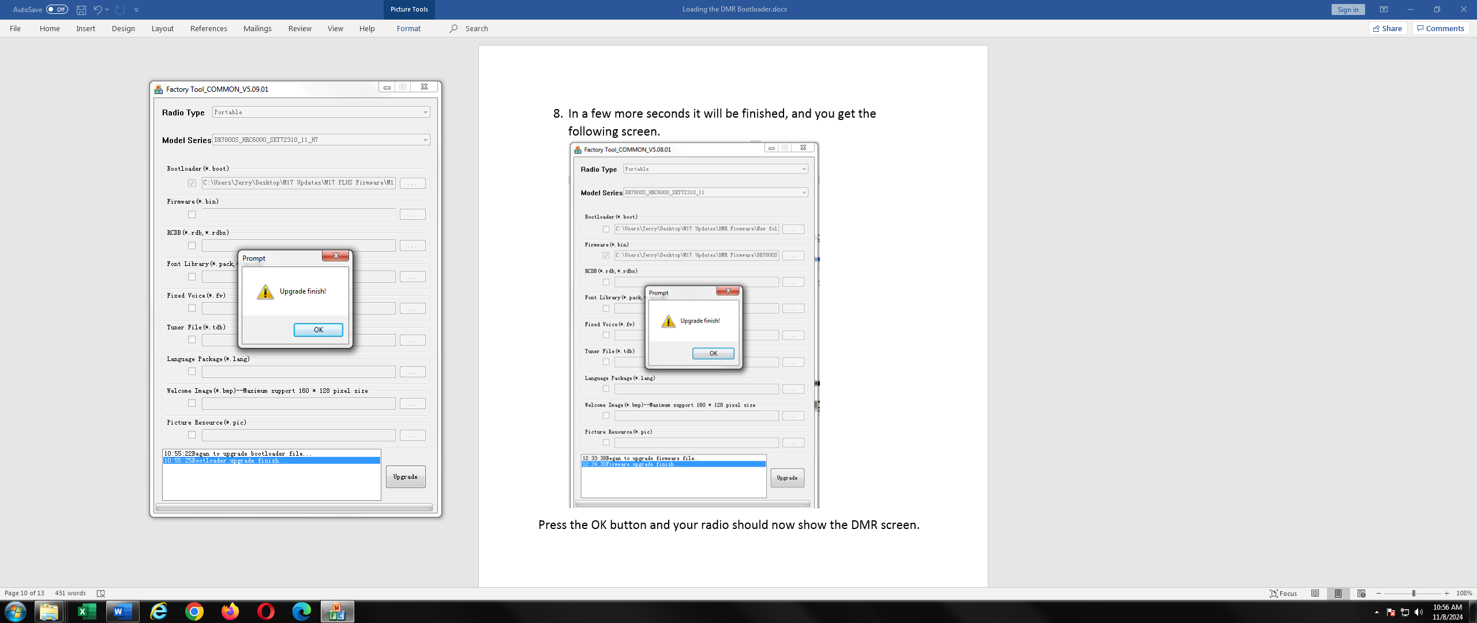

Press the OK button and your radio should now show the DMR screen.