Mobile GPIO Application (V1.0.3)
Preface
This document is for how to use the GPIO of the mobile.
If had any questions, please ask your delear for further help.

Table of contents

1 DB15 2
1.1 15-Pin Connector for Mobile Radio 2
1.2 Make a DB-15 UART cable 3
2 Input GPIO 4
3 Output GPIO 5
3.1 Output an active Level by DTMF signaling Received 6
4 UART GPIO 8
4.1 Enable UART Feature 8
4.2 Use UART to set a new channel 8
4.3 Use UART to request the current channel information 9
4.4 Use UART to report the current channel information automatically 9

DB15

15-Pin Connector for Mobile Radio
Male type (Refer to the number in the connector) Female type
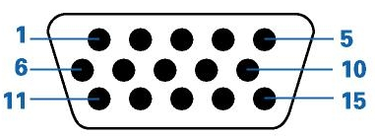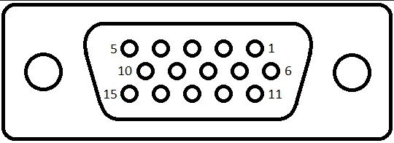
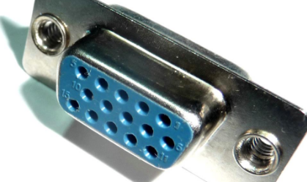
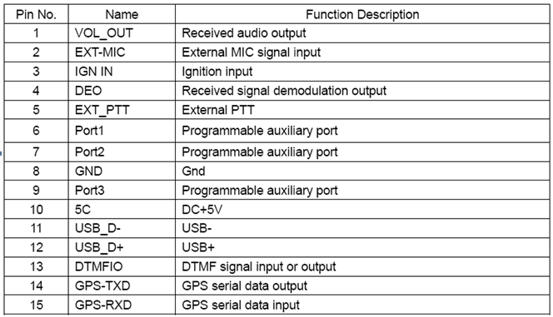

Make a DB-15 UART cable
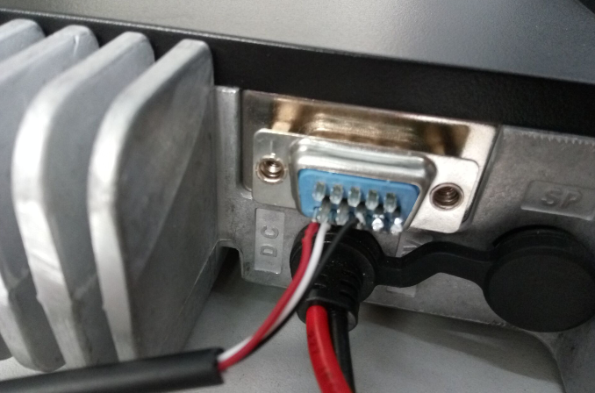

Some specifications
1. mV peak to peak for audio out 500mV
2. mV peak to peak for external MIC signal input 80mV
3. mV Received signal demodulation output 300mV
4. External PTT active high or low LOW

Input GPIO
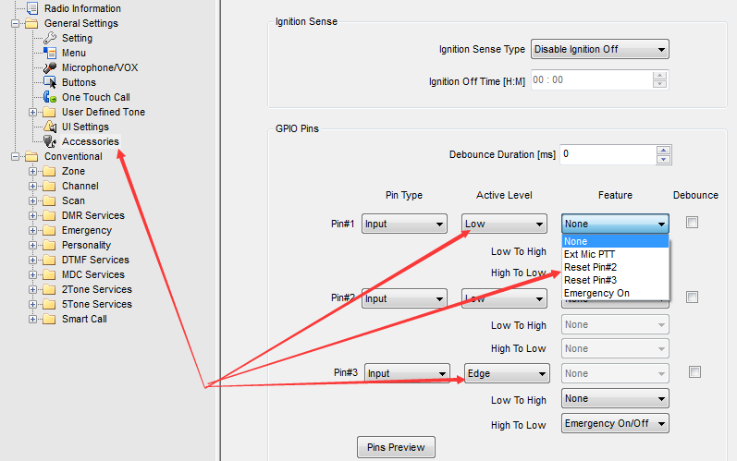
- None: No feature
- Ext Mic PTT: Exteranl PTT to start/stop the Transmission.
- Reset Pin#2: If the corresponding pin active, the radio will reset the Pin#2 to Inactive level
- Reset Pin#3: If the corresponding pin active, the radio will reset the Pin#3 to Inactive level
- Emergency On: If the corresponding pin active, the radio will start “Emergency mode”.
- Emergency On/off: If active, the radio will start/exit “Emergency mode”, i.e. in the above, the first edge trigger will start the emergency and the second trigger will exit the emergency.

Output GPIO
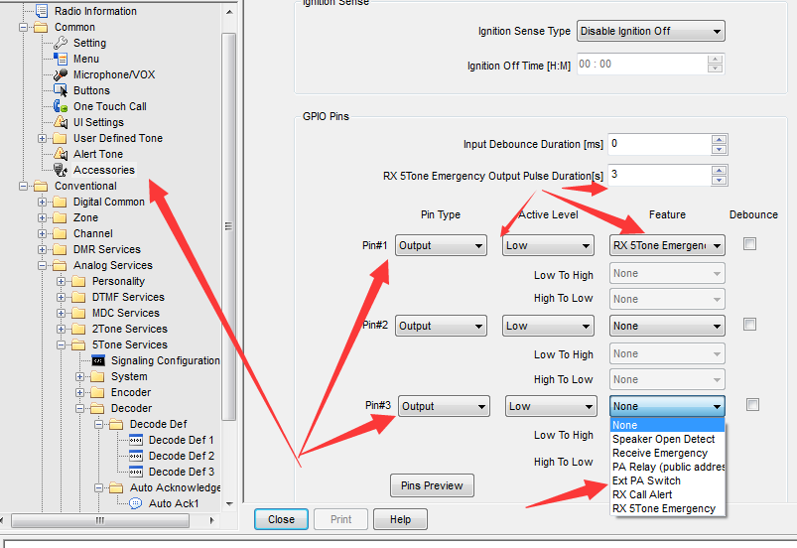
- None: No feature
- Speaker Open Detect: If the squelch open(speaker unmute), the GPIO will output the active level.
- Receive Emergency: If the radio receive a remote Emergency, Output the active level.
- PA relay(Public address): If the enabled the PA, Output the active level.
- RX Call Alert: If received a Call Alert, Output the active level.
- RX 5Tone Emergency: If received a 5-tone Incoming Emergency, Output an active pulse.

Output an active Level by DTMF signaling Received
1) set a GPIO pin
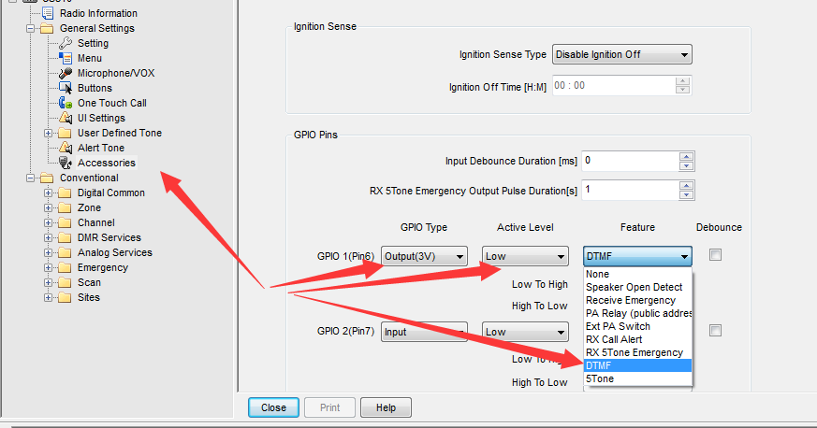

2) set a DTMF decode definition
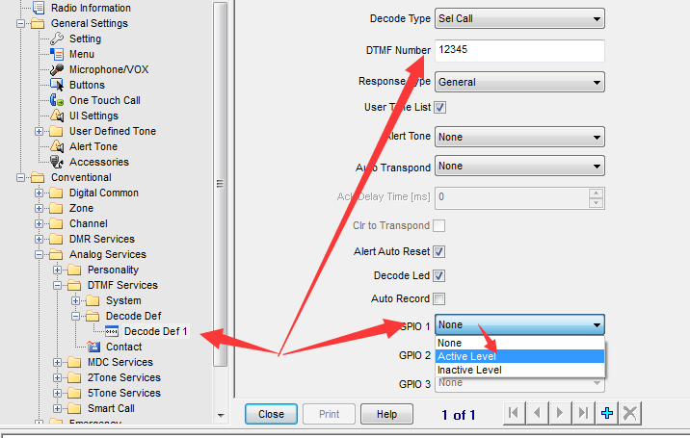

3)Set a Personality for an analog Channel to use
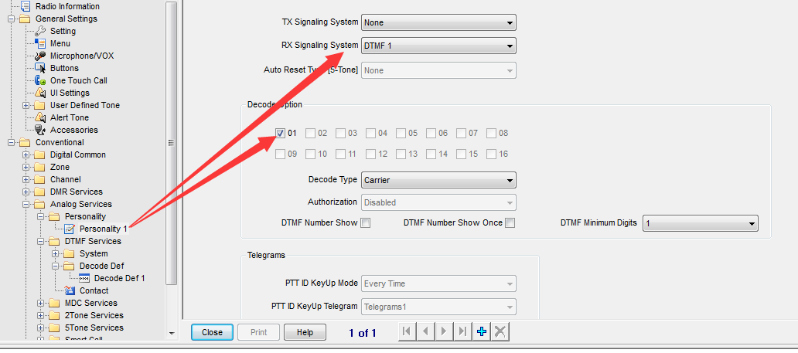

4)Set a certain chanel to use that Personality
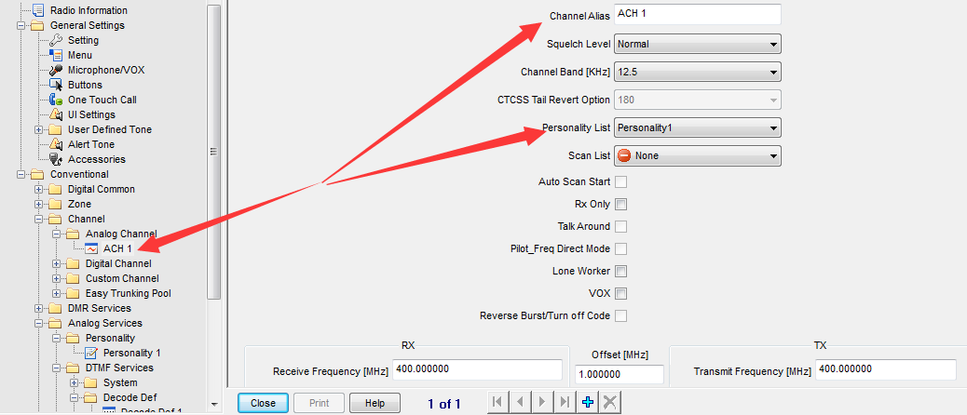

UART GPIO

Enable UART Feature
If you enabled this UART feature, the corresponding UART will not work as the default GPS UART, and change to work as a second development UART which could support the following features.
Note for UART
Baud Rage： 9600bps
Start Bit： 1bit
Data Bit： 8bits,
Stop Bit： 1bit
Odd/Even Check： None
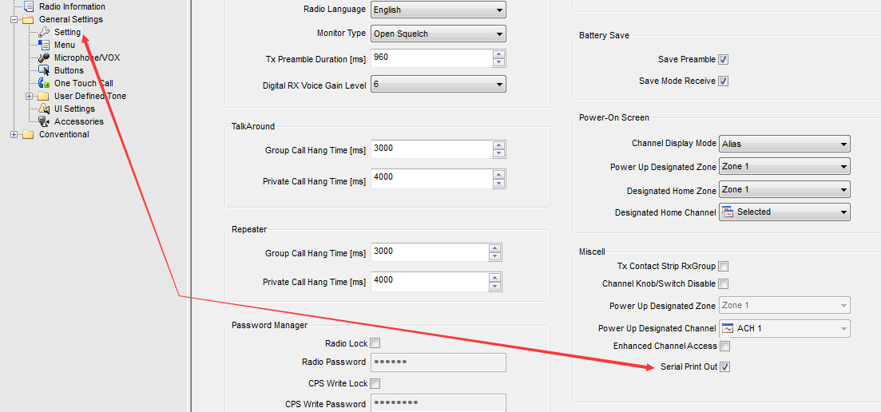

Use UART to set a new channel
Send AT Command:
AT+CHINFO=<X>\r\n
e.g. switch to channel 2 of the current zone. <X> = 1,2,3,…,15,16; If set an analog channel, it will only return the TX/RX frequencies.
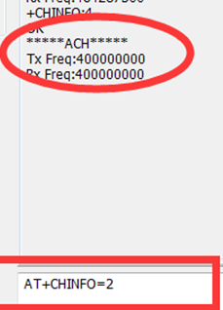

Use UART to request the current channel information
Send AT Command:
AT+CHINFO?\r\n
e.g. After sending AT+CHINFO?, the UART will return +CHINFO:4, means the current channel is the No. 4 channel of the current zone.
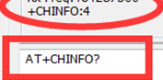

Use UART to report the current channel information automatically
When the mobile changes its channel, such as by press the UP/DOWN key of itself, it will report the detail channel information of current channel.
e.g. Change the channel 4 times by press the UP key of the mobile.
